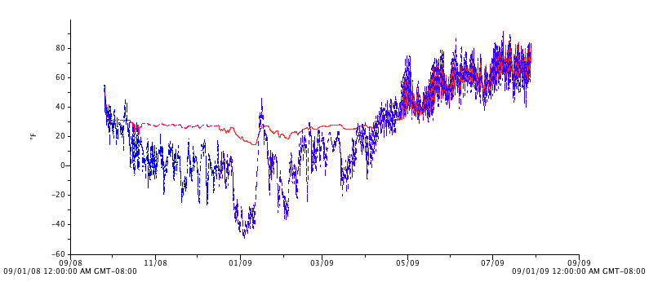
Figure 10. Soil (red) and air (blue) temperatures, exterior plots, Sept. 2008 – Sept. 2009.

