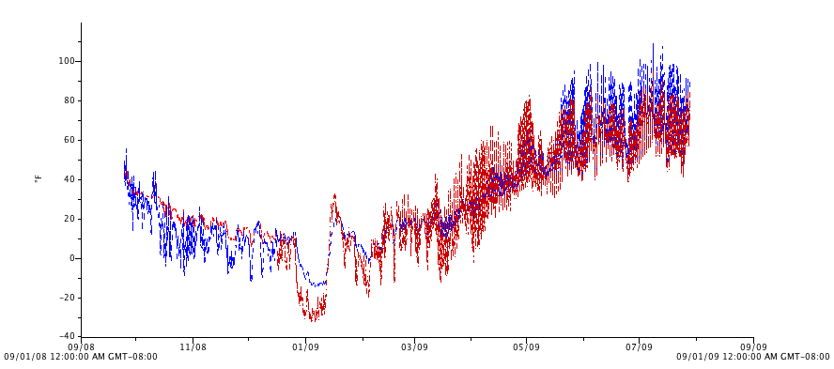
Figure 9. Soil (red) and air (blue) temperatures, high tunnel, Sept. 2008 - Sept. 2009

