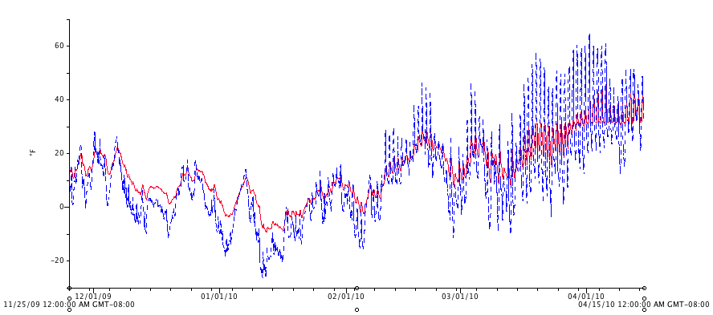
Figure 12. Soil (red) and air (blue) temperatures for the high tunnel during the 2009/2010 winter (December through April).

