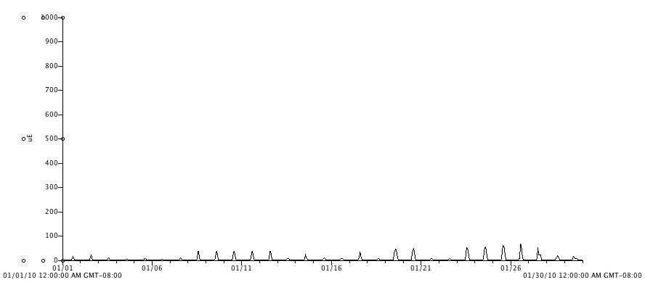

Figure 14. Photosynthetic active radiation (PAR, μmol⋅ m⁻²s⁻¹) within the high tunnel for the month of January, 2010.

