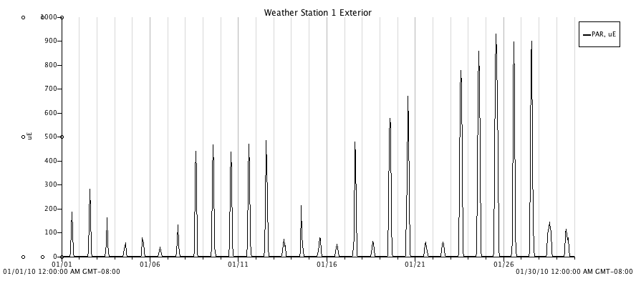

Figure 15. Photosynthetic active radiation (PAR, μmol⋅ m⁻²s⁻¹) from an exterior plot for the month of January, 2010.

