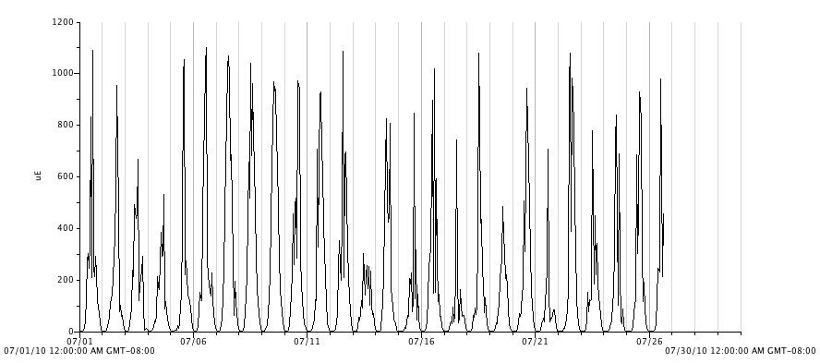
Figure 16. Photosynthetic active radiation (PAR, μmol⋅ m⁻²s⁻¹) inside the high tunnel for the month of July, 2010.

