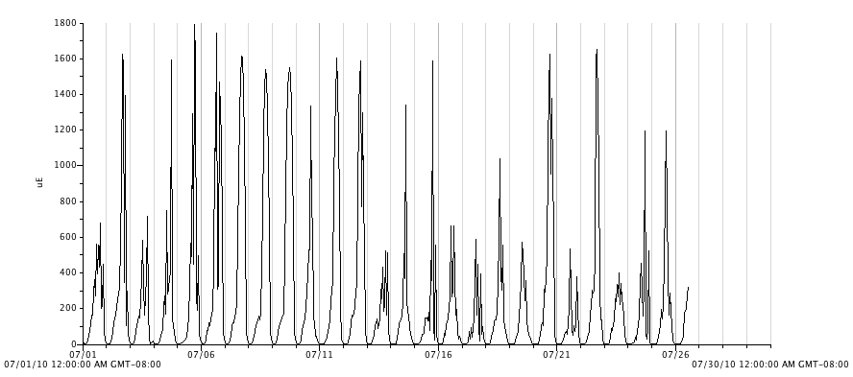
Figure 17. Photosynthetic active radiation (PAR, μmol⋅ m⁻²s⁻¹) in an exterior plot for the month of July, 2010.

