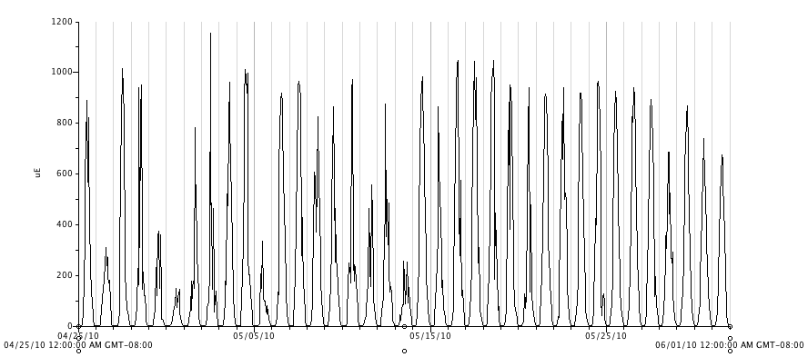
Figure 18. Photosynthetic active radiation (PAR, μmol⋅ m⁻²s⁻¹) in the high tunnel from April 25 through June 1, 2010.

