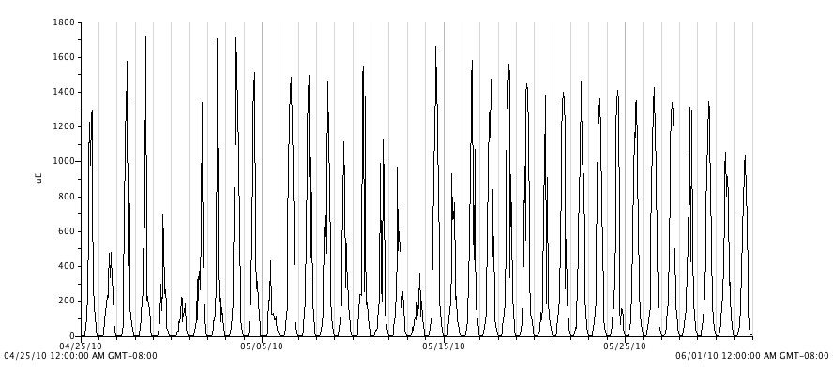
Figure 19. Photosynthetic active radiation (PAR, μmol⋅m⁻²s⁻¹) in the exterior plot from April 25 to June 1, 2010.

