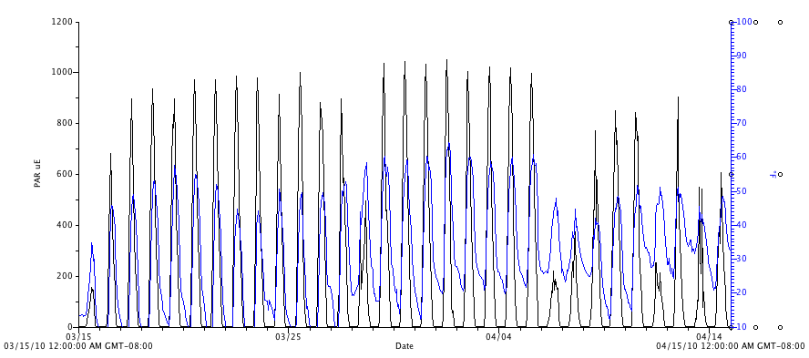
Figure 20. Photosynthetic active radiation (PAR, μmol⋅m⁻²s⁻¹) and air temperature (°F, blue, right axis) in the high tunnel for the month of April, 2010.

