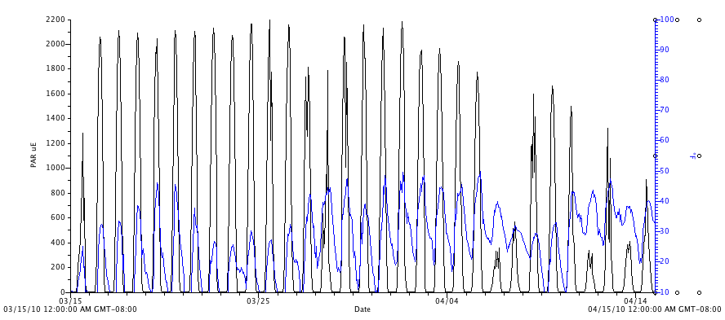
Figure 21. Photosynthetic active radiation (PAR, μmol⋅m⁻²s⁻¹) and air temperature (°F, blue, right axis) in the exterior plot for the month of April, 2010

