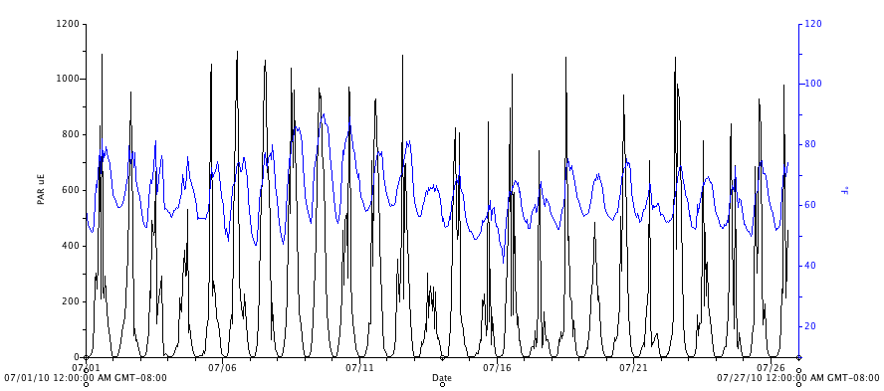
Figure 22. Photosynthetic active radiation (PAR, μmol⋅m⁻²s⁻¹) and air temperature (°F, blue), in the high tunnel, for July, 2010.

