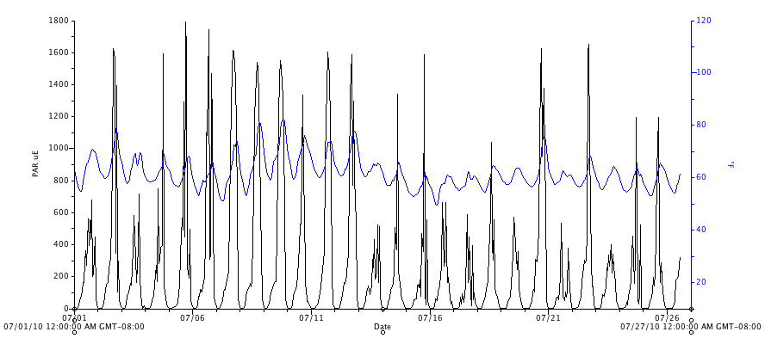

Figure 23. Photosynthetic active radiation (PAR, μmol⋅m⁻²s⁻¹) and air temperature (°F, blue) in exterior plot l, for July, 2010.

