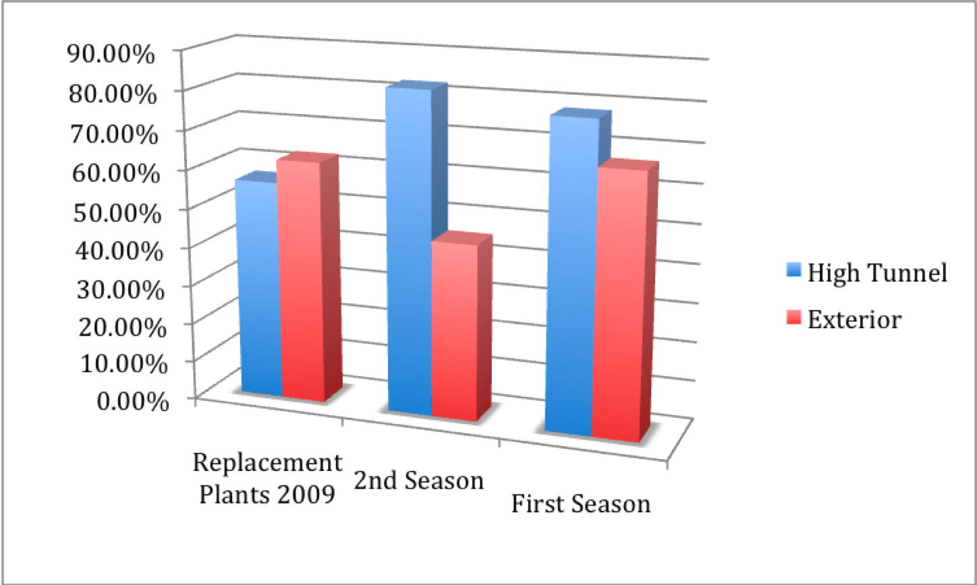

Figure 24. Survival percentages (alive/total planted) for replacement plants (2009), second season (2009), first season (2008) for high tunnels (blue) and exterior plots (red).

