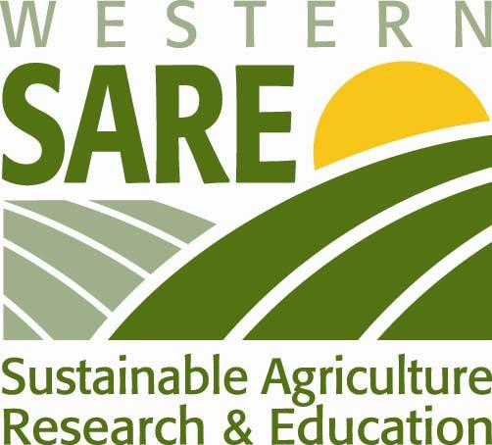

A San Joaquin Valley Quilt: Stitching together a
Region’s Prosperity, Nutrition and Sustainability

November 16, 2010
California State University, Fresno / CATI Conference Room
2910 E. Barstow Ave.
Barstow and Chestnut, Fresno

9:00 Registration

9:30 Welcome
- Why are we here?
  - Who are Sequoia Riverlands Trust and Western SARE?
- What is the end game?

Introductions
- “Foundation Farmers” – Meet the five farmers that are collaborators on the Western SARE grant.
- Why am I here? Short description of participant’s role in a sustainable food system.

10:15 Food System Related Resources and Activities Focused on Madera/Fresno/Tulare Counties – Michael Dimock, President, Roots of Change
- Roots of Change – Fellows and Activities
- Food System Alliance
- SNAP (Supplemental Nutrition Assistance Program) and Top – Up Program
- Urban Rural Roundtable – Foodshed Project
- RMA Grant – Hmong-American Farmers Association – Schools

10:45 Break

11:00 Challenges, Activities, Opportunities
Participants will share the challenges they face in the existing food system, the food system activities they are aware of and involved in, and the opportunities they see from their vantage point. The Opportunities will begin to form the Implementation Plan and answer the question, Where Do We Go From Here? Each participant will be asked to write down their challenges, activities and opportunities and briefly describe them to the group. We will be posting these so we can prioritize them in the session after lunch.

12:30 Lunch – Several items on the menu will be sourced from the Fresno State Farm
Networking Opportunity – take advantage of this time to meet others that are working in the local food and sustainable farming arena. Who knows, you may find someone to collaborate with!!

1:15 Prioritize Opportunities
Participants will prioritize the opportunities they identified in the morning session and determine which they wish to pursue. Identified activities will also be discussed related to incorporation and collaboration opportunities. Experts and resource people will be identified that have knowledge relative to the Opportunities. These people will serve as speakers at future meetings to educate and inform the group about that particular opportunity and assist in the development of an action plan.

2:15 Break

2:30 Interactive Discussion on Opportunities Identified by the Foundation Farmers
Below are the topics we will be addressing at this meeting. We are fortunate to have experts in each area joining us to share their perspectives, experiences and opinions. Once they have shared some insights, a facilitated group dialogue will take place among the speakers and participants. Come prepared to engage!!!

- Developing a Food Culture in the Central Valley
  - Ritz Guggiani, Sonoma Direct
  - Felix Muzquiz, Vineyard Farmer’s Market
  - Michael Dimock, Roots of Change
  - Tom Willey, T & D Willey Farms
  - Chris Shackelford, Trelio Restaurant

- Interacting with Schools
  - Clint Lara, Food Services Director, Earlimart School District (invited)

- How do we “Fix” the distribution system to serve the local food system needs
  - Loren Werth, Food 4 Thought
  - Ritz Guggiani, Sonoma Direct

And along the way, the following topics may creep in to the dialogue!!
- Collaborative efforts for farmers – what are some of the areas farmers can work together to “raise all their boats” collectively.
- Cultivate marketers in the farming community
  - Capitalize on those that can grow and those that can market and link them together.

4:00 Adjourn – but first, we need to pick dates for the remaining two meetings!

This project is sponsored by Sequoia Riverlands Trust and is made possible through a grant from Western Sustainable Agriculture Research and Education.

