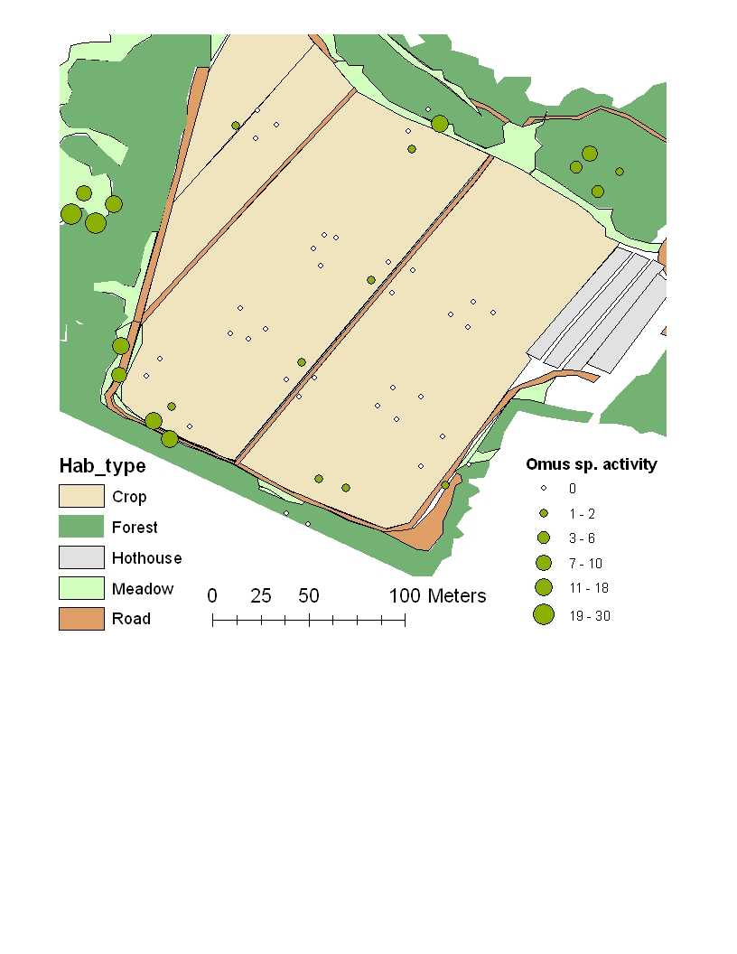

Figure 1. Habitat map and pattern of Omus sp. activity at Gathering Together Farm, Philomath OR. Activity is total beetle captures per pitfall trap from March-October 2010.

