Harvesting Greens

Molly Shaw, CCE South Central NY Ag Team
January 2011
This series of articles, “Clean and efficient harvest and washing practices for small scale vegetable farms,” was written from case studies involving 12 small scale NY vegetable farms. Thank you to Eric Yetter, Project Manager, to NE SARE for their support of this project, and to all the farmers who opened their farms to us. To see the case study videos, visit ________(website).

Farms sell greens as heads, loose as salad mixes, and as bunches. Greens tend to be one of the more perishable crops on a mixed vegetable farm, and the care they receive in harvesting and washing affects their shelf life. Greens are often eaten raw, and the past food-borne illness outbreaks associated with them merit special attention in their handling.

Field preparations: An efficient harvest starts way back with field preparations—preventing or keeping weeds under control (often with a stale seed bed), adequate soil fertility, low insect and disease damage, and a good thick stand of plants. A long rotation and adequate cover crops go a long way to accomplishing this.

Growing the mix: For mixed baby salad greens, species and varieties that will make up the mix are usually grown in separate blocks and mixed during the harvesting and washing stages. If one salad component is unexpectedly slow to grow or has a problem with quality it can be left out of the final mix, instead of lowering the whole mix quality. Alternatively, some farms plant more salad mix than they think they will need so they can be quite picky when it comes to harvesting, cutting only top quality greens at the prime stage of growth.

Quality of crop dictates harvest time: The biggest factor affecting the efficiency of harvest is the quality of the crop in the field. When the crop has imperfections that need to be picked through in the field (and/or later in the wash station), it slows down the harvest. In fact, any time a worker needs to make quality decisions during harvest rather than harvesting complete plants or beds, that decision-making process eats up time.

Cutting baby salad greens: Greens are often they are one of the first crops cut on harvest day, while temperatures are still cool and leaves well hydrated. Salad greens are typically cut with long, well-sharpened knives, dragging a harvest bin along next to the harvester, the bin on the opposite side of the body as the knife. Wide beds are harvested from both sides, or kneeling on the bed itself. Mid-sized farms sometimes use a “basket harvester” for baby salad greens. This harvester has a 48” saw blade held horizontally over the bed. As greens are cut, they fall into a bag attached to the blade (see figure 1).

Cutting heads: The most efficient farms will have one person selecting and cutting lettuce heads, as they are able to make quick authoritative decisions on size and quality. This quick worker sets the pace for those that follow to trim of wilted or damaged leaves and pick up the heads—jobs that take much less decision-making.
Farms vary quite a bit in the details of how they handle lettuce heads. Some farms have selected lettuce varieties with tight stems so one well-placed cut in the field gives a finished lettuce head, leaving behind lower yellowed or damaged leaves and eliminating a later trimming step. Others leave the trimming to workers picking up the heads in the field. Yet others opt to trim the butt ends of the lettuce at the wash tub. The fewer handling steps, the more efficient the process.
One farm has sharpened shovel blades that they use to cut the head off the root at ground level without bending over. Workers pick up the heads, then trim them in the comfort of the wash station
Bunching greens: The fastest harvests of kale, chard, etc, are the ones where the decisions are minimized—where all the good full-sized leaves are quickly stripped, yellowed bottom leaves are pushed to the ground, and there isn’t disease or insect damage to pick through (figure 2). Try not to handle each leaf individually, if possible. Having a sample bunch size for workers to follow helps avoid “bunch creep,” where bunches gradually get larger or smaller.

Counting bunches: Many farms count out the number of rubber bands required to make the number of bunches on the harvest list, wearing them on the wrists or fingers while harvesting rather than counting bunches as they are formed (figure 3). This avoids counting and recounting bunches.

Some farms establish a standard number of heads or bunches to pack into harvest bins. This can streamline the process of packing to fill orders later at the wash station.

It’s always more efficient to harvest a few extra bunches, pounds or heads rather than going back into the field to harvest more if the count comes up short in the packing stage.

Transporting to the wash station: Full harvest lugs are transported back to the wash station with a cart, truck, van, etc. Farms are quite creative with their transportation vehicles! Fresh cut greens are tender and need to be quickly protected from sun and wind. Some farms sprinkle the tops of harvested bins with a watering can to keep them fresh; others have harvest bins with lids.
Washing greens: Always use potable water to wash produce. Farms usually sell salad mix as rinsed, but with the suggestion that the customer wash it before eating.
Most small scale farms opt for dunk tubs for washing greens. Greens species or components are combined in the water where they can be gently mixed without bruising. Cleaner stuff gets to use the water first, while really dirty stuff (like spinach) is rinsed last. Multiple dunk tanks are ganged up in a line so by the last rinse, the greens are being removed from clean water. Rinses range from one to three, and also serve as a chance to remove weeds and bad leaves. Greens are moved from bin to bin with pool skimmers or fish nets (dedicated to the wash stand, of course). The more water drains from the scoop of greens before going to the next cleanest bin, the better.
One farm in our study (Pleasant Valley Farm in Argyle, NY) has installed a “bubbler” to wash greens. They installed pvc piping in the bottom of a repurposed milk tank (upper half removed) and greens are gently agitated by air blown through the piping by a Jacuzzi motor. This has allowed them to rinse even dirty greens like spinach in one wash tub as opposed to multiple dunk tanks, cutting greens washing time in half.
Commentary on dunk tanks: Dunk tank style washing doesn’t ensure that potential disease-causing contaminants brought in from the field don’t get moved from wash bin to wash bin and onto the ready-to-sell product. Water should always start out potable, but after the first dirty greens batch, that water doesn’t stay potable. Even if chlorinated, the soil in the water quickly binds up the free chlorine, rendering it inactive (you will still smell chlorine—this doesn’t mean it’s still active). There isn’t a scientific standard for how cloudy that rinse water can get before you change it—you’ll have to make up a personal standard for your farm. GAPs certification standards simply require that the farm change the water at a pre-determined interval, such as “after 10 bins of greens,” or even “as needed.”
The key to keeping produce pathogen-free is in the field. Don’t harvest product that is touching wild animal feces; be careful about manure applications (leave 120 days between fresh manure applications and harvest of crops that touch the ground); use fully composted (heated!) compost, and be aware of water run-off onto the field from that could contain manure or chemicals. Train workers seriously about personal hygiene and food safety, and set a good example yourself. As the large-scale greens industry has found out, no amount of sophisticated chlorinated rinses can reliably make field-contaminated greens safe again.
Drying the salad mix: Soggy greens don’t last as long as spun-dry greens. Some farms simply pack newly rinsed greens into containers with good bottom drainage and let them drip drain in the cooler. Lugs of various styles work, as long as the greens are kept from drying out in the cooler. Some farms remove water with an oversized salad spinner, while others spin greens (in a mesh bag or loose) with a washing machine set on the spin cycle (figure 4).
Packing greens mix: Some farms like to make individual packages in plastic bags that can be heat sealed or in plastic clamshell containers; these can be sold by weight (must have a registered scale) or volume. They are then labeled with what the item, date picked, weight or amount, and destination (labels critical in wholesale operations). Other farms opt to bring greens to market loose in a bin and let the customers pack their own quantities, a labor-saving practice.
Important note: NYS Ag and Markets considers packaging greens to be a food processing activity, requiring a 20-C licensed kitchen facility. Enforcement of this rule has thus-far been low for direct-market farms.
Packing head lettuce: When much of the water has been removed they can be packed for their next destination, upside down to continue draining (with the exception of buttercrunch varieties which drain right side up). They may go into large bins with holes drilled in the bottom to let excess water drain. Farms track quantities by counting the number of heads or number of bins (knowing the number of heads that fit in a bin).
Market influences degree of packing: Markets differ in the degree of packing or bunching required. One of the most efficient farms in our study has deliberately chosen to market only through a CSA because they can offer vegetables to their customers loose in bins and have them count or bunch their own shares.

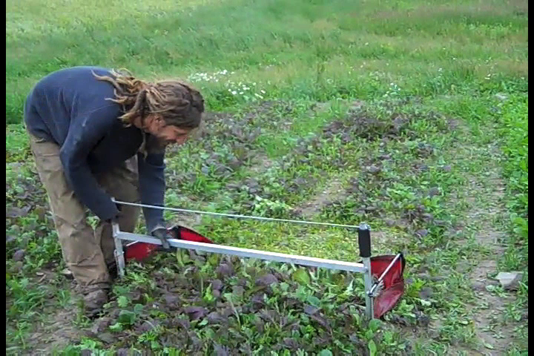
Figure 1. This basket harvester allows for a quick harvest of baby salad mix when crop quality is good.

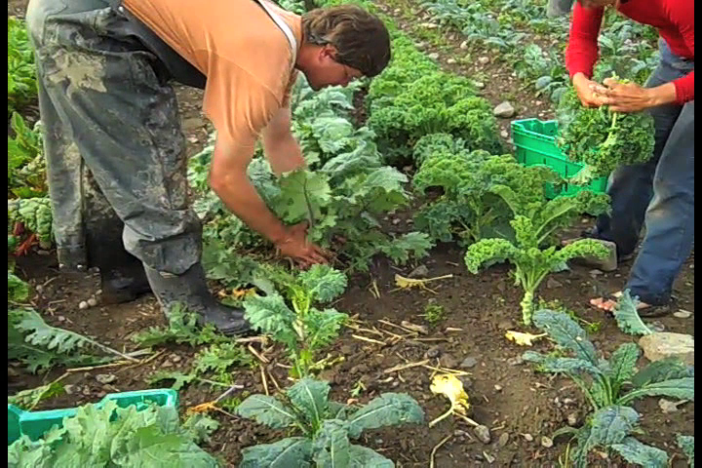
Figure 2. Harvest of bunched greens is quicker when crop quality is high and whole plants (or all the full sized leaves) are harvested. Here the farmer is setting the pace for the crew to follow.

Figure 3. Many farms count out the number of rubber bands required to make the number of bunches on the harvest list, wearing them on the wrists or fingers while harvesting rather than counting bunches as they are formed.

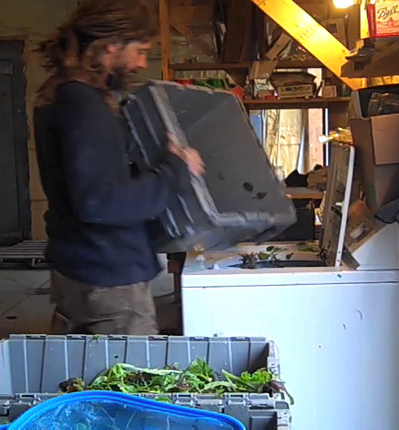
Figure 4. A repurposed washing machine set on the spin cycle is used to spin-dry larger quantities of salad mix.

