Harvest Containers

Molly Shaw, CCE South Central NY Ag Team
January 2011
This series of articles, “Clean and efficient harvest and washing practices for small scale vegetable farms,” was written from case studies involving 12 small scale NY vegetable farms. Thank you to Eric Yetter, Project Manager, to NE SARE for their support of this project, and to all the farmers who opened their farms to us. To see the case study videos, visit ________(website).

The containers used to hold harvested crops certainly affect the efficiency of the harvest. Most farms agree that it’s best to have uniform containers because organization is simplified, and containers that nest one inside another are favored because they take less storage space. When utility, price and longevity are considered, there isn’t one single container that is best for every farm or crop, and farms can be quite creative with the containers they use to hold harvested crops.

What follows is simply a “show and tell” of containers we saw used on vegetable farms this summer, with a brief listing of their pros and cons.

Repurposed containers:
5 gallon buckets, ~1/2 bushel, $5
Sometimes available for free
Handles allow lifting of loads without excessive stooping
Durable
No lids (usually)
No drainage holes
Nesting

Laundry baskets, ~ 2 bushel, “hip hugger design”, $12
Possible to carry against the hip with one hand
Durable
No lid
Side vents, but no bottom drain holes
Nesting

Home storage boxes, ~1.5 bushel, $10-12
Durability varies by brand; some can be brittle. “Roughneck” is reported to be among the most rugged
Has lid
Stacking (with lid)/nesting
No vents or drainage

55 gallon food grade barrel, cut in half with handles attached, ~3 bushels, $5-10 + labor
Durable
No lid
No vents or drainage
Nesting
Labor required to cut barrels and add handles
Rounded bottom easy to drag in field as you harvest

Produce Harvest containers:
Grape (fruit) lugs, ~1 bushel; $13, Belle Terre Produce
Very durable, polyethylene
Available with or without ventilation holes
No lid
Nesting/stacking

Apple picking bag/bucket, ¾-1 bushel (straps onto body); $32-80,
Leaves both hands free for harvesting
Transfers weight to shoulders when standing
Bottom opens to gently dump produce

General purpose 1.75 bushel rectangular plastic container; $15 Nolts Produce Supply
Very durable, polyethylene
Vented bottoms and sides
No lid
Nesting/stacking

Attached lid plastic shipping container (~1 bushel); $12-15 Global Industries
Very durable, polyethylene
Lids attached
Nesting/stacking
No ventilation/drainage holes
Available in different colors

Fruit/veg crates, ~1 bushel (also available with shorter sides); $10 Belle Terre Produce
(Also known as bulb shipping crates)
Polyethylene, but not as durable as other containers, 25 lb limit
Lids available, $2.50 extra
Stacking, but not nesting
Vented bottoms and sides

Different containers end up being ideal for different farms. Consider the following when making your choice:
- Many farms use the same type of container for harvest as they do for storage and transportation to markets.
- Often having drainage holes in a storage bin is important to get rid of excess wash water, where drainage in a harvest container isn’t as critical.
- Having a lid when harvesting and storing tender crops like greens can help prevent them from drying out.
- Consider the container size, especially when harvesting heavy crops like carrots and cucumbers. Sometimes smaller is better.
- Sometimes farmers can find repurposed containers locally for cheap or free

Note: Brands and suppliers are listed as examples only. Cornell Cooperative Extension doesn’t endorse one brand or supplier over another.

5 gallon food-grade buckets
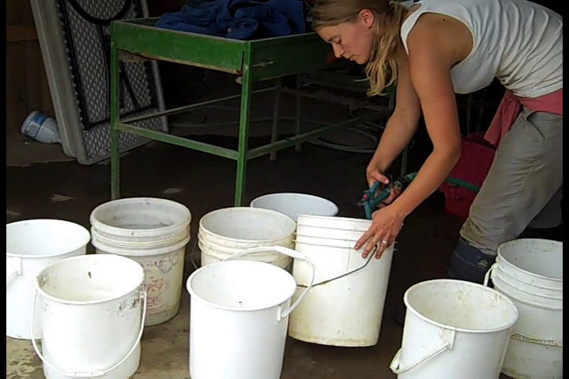

Laundry baskets

Home storage boxes
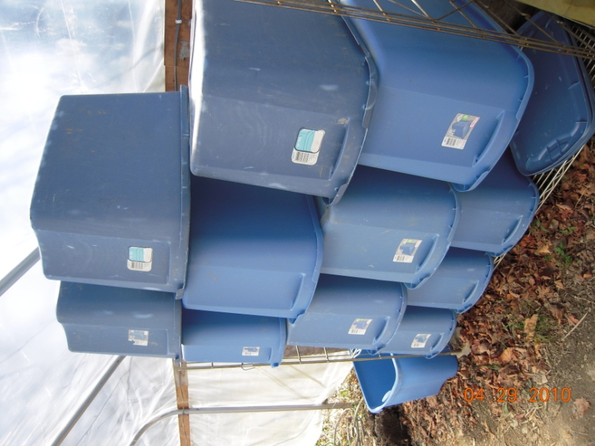

Repurposed 55 gallon food-grade drums

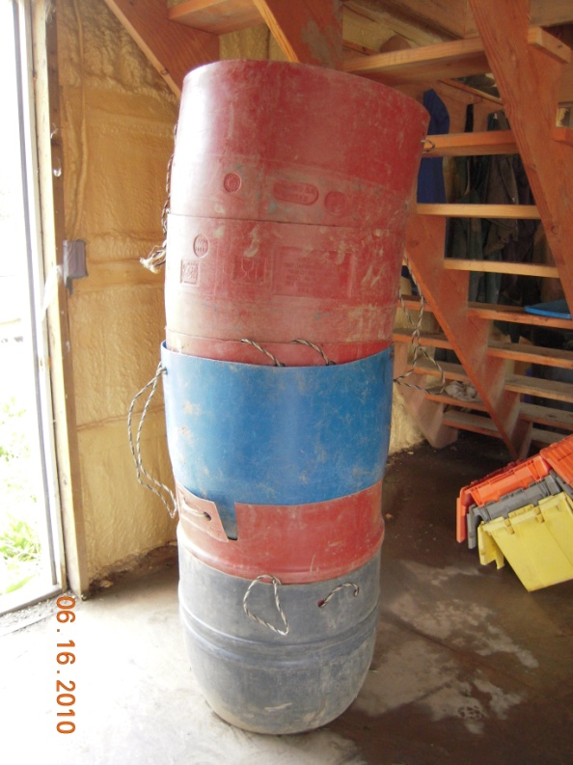
Shipping containers with attached lids along side smaller fruit lugs used for heavy crops.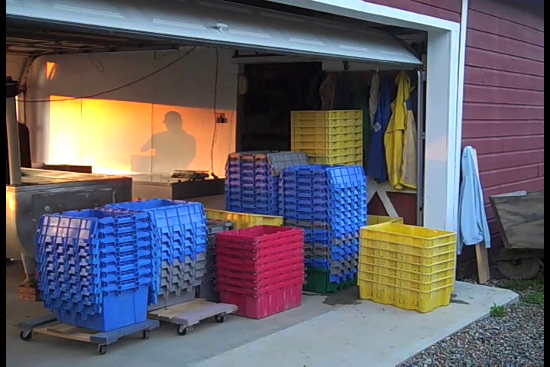

Apple picking bag/bucket

General purpose 1.75 bushel plastic container
Fruit/veg crates, often known as “bulb crates”
