Harvesting Root Crops

Molly Shaw, CCE South Central NY Ag Team
January 2011
This series of articles, “Clean and efficient harvest and washing practices for small scale vegetable farms,” was written from case studies involving 12 small scale NY vegetable farms. Thank you to Eric Yetter, Project Manager, to NE SARE for their support of this project, and to all the farmers who opened their farms to us. To see the case study videos, visit ________(website).

The root crop harvesting and washing process changes depending on whether roots are sold fresh with green tops or as the roots alone. In addition, some root crops are harvested throughout the season for weekly markets; others are harvested at the end of the season as storage crops. Root crops are dirty and heavy, so harvest practices focus efficient ways to remove lots of soil and move heavy loads.
Bunched root crops: For crops that are sold in bunches with the greens still attached like radishes, salad turnips, beets, etc, most farmers find it more efficient to harvest the roots loose, then bunch and wash them on a spray table. It’s easier to make bunches with uniformly sized roots with the whole harvest arrayed on a table at a comfortable working height than searching through the field to create uniform bunches during the harvest stage. When harvesting, it is helpful to keep the roots all facing the same direction in the harvest bin. When the crop is dumped out on the wash table, the roots are then already lined up to wash with a spray hose (figure 1).

It’s more efficient to harvest a whole bed of roots than to pick through looking for the biggest ones. Even seed spacing and/or good thinning can create faster harvest conditions because roots are more uniformly sized. When making bunches, having a sample bunch size for workers to follow helps avoid “bunch creep,” where bunches gradually get larger or smaller.

Some farms decide that the uniformity in bunches isn’t important for their market, or that their customers appreciate being able to choose between variable sized roots. CSAs are particularly forgiving in this manner.

Washing bunched roots: Always use potable water to wash produce. A spray table with a backsplash (to avoid produce rolling off the back) is often used to wash roots. A high-pressure water source helps this process move along more rapidly, and if roots are going to sit for a while before washing it’s helpful to keep them moist so the soil doesn’t stick as tightly. Some farms use a dunk tank to wash roots, but this generally takes longer, especially for roots that sink and have to be fished out of the bottom of a tub of cloudy water.

Many farms use rubber bands to bunch root crops, but consider using twist-ties to avoid fighting to get a band around bulbous roots or delicate leaves (figure 2).

Root crops without tops: Medium-sized farms can justify a specialized root harvesting machine that mechanically pulls and tops roots and dumps them into a big bin, but most small scale farmers either fork roots by hand or use an undercutter bar to loosen roots before pulling them by hand.

Forking roots is the way most small-scale farms start. It’s more efficient to have one worker loosen a whole bed with a fork and have other workers follow behind to pull roots rather than continually switching tasks. Some farms have had success using a subsoiler or single shank pulled between crop rows to loosen the roots before pulling, less expensive but less ideal than an undercutter bar.

An undercutter bar is a tool that makes harvesting roots more efficient. This tractor-mounted horizontal blade is well weighted, then dragged behind a tractor underneath the roots, loosening their connection with the soil (figure 3). When the green tops are still strong it is easy to pull big bunches out and lay them down in piles with the roots all facing one direction.

At this point, some farms opt to remove green tops in the field, while others opt to transport the plants back to the wash station to be topped there. In our observations, we weren’t able to tell if one method was more efficient than the other. Weather can play a role in the decision—no one wants to top carrots in the field in the rain. Topping in the wash station can be more comfortable, but requires the extra step of dumping the greens back into the compost pile.

Transporting to the wash station: Root crops are heavy, and picking/transport containers should reflect this. Harvest may be done into smaller bins or buckets, or in partially-filled bins. Small scale farms have found durable garden wagons or small utility vehicles like a ‘Gator’ to work well to transport root crops to the wash station. Walking bins to the nearest drive row and picking them up with a truck is also common—farms with adequate land to have ample drive roads have an advantage here. Sometimes a truck or tractor can drive right over the harvested bed to pick up full bins. A tractor-mounted fork is also a favorite tool for moving heavy loads around the farm.
When farms reach the size where palletizing is justified, they see a big jump in efficiency. Almost anything can be moved around the farm on a pallet. In the wash station, pallet jacks require a concrete floor to function and the cooler should be big enough to admit a pallet.
Washing roots without tops: Many farms still use a spray table for washing topped roots. A step up from a stationary table is a table with a moving top, called a “belt conveyor” in the packing house equipment world. They’re surprisingly reasonably priced. With the conveyor, produce can be gently tumbled with one hand and simultaneously spray-washed with the other hand, improving efficiency over a stationary table.

One step up from spray tables is a barrel washer. Roots are dumped in at the high end and gently tumbled against each other while being sprayed with water from above. The angle of the barrel can be adjusted to adjust the time the roots spend in the washer before they tumble out of the lower end clean. It’s a wonderful piece of equipment, among the favorites of farmers who have them. Farmers say they can wash 1000 lbs of carrots/hour with one person using the barrel washer, while 150 lbs/hour is a reasonable rate to expect washing carrots on a spray table.

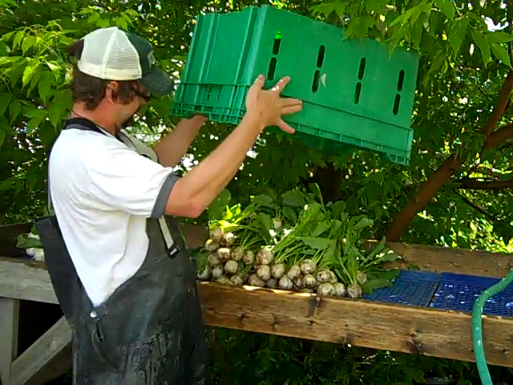
Figure 1. When harvesting, it is helpful to keep the roots all facing the same direction in the harvest bin. When the crop is dumped out on the wash table, the roots are then already lined up to wash with a spray hose.

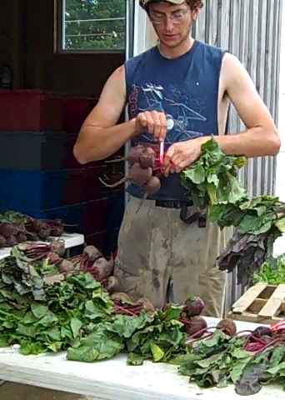
Figure 2. Many farms use rubber bands to bunch root crops, but consider using twist-ties to avoid fighting to get a band around bulbous roots or delicate leaves.

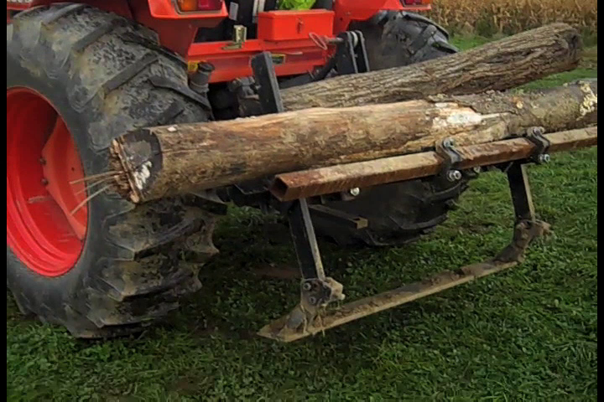
Figure 3. An undercutter bar loosens soil underneath crops like carrots, eliminating the need to fork roots to loosen them.

