Organizing the Farm for Efficiency

Molly Shaw, CCE South Central NY Ag Team
January 2011
This series of articles, “Clean and efficient harvest and washing practices for small scale vegetable farms,” was written from case studies involving 12 small scale NY vegetable farms. Thank you to Eric Yetter, Project Manager, to NE SARE for their support of this project, and to all the farmers who opened their farms to us. To see the case study videos, visit ________(website).

During our case studies we visited farms during the growing season and observed harvest and washing practices. While this snapshot view is valuable, it misses a whole big aspect of farm efficiency—the business decisions and planning. In the winter we followed up with farmers to learn about what they consider to be the biggest factors in farm efficiency.

Crop Quality: Again and again, we heard that having a high quality crop in the field is the biggest factor in efficient harvests. Any time the crew has to make a decision about whether a vegetable is up to snuff or not, the harvesting process is slowed down. Weeds, disease, insect damage… all take a labor toll as well as a have a yield impact. Having adequate land for good crop rotations and cover cropping is critical not only to lower pest levels, but also helps to increase soil fertility, providing crops with ample nutrients.

Related to having a high quality crop is the ability to do clear-cut harvests, where the crew harvests every plant in the plot, or every leaf on the plant. Again, reducing the decision-making requirement for harvesters makes harvest faster.

Market destination: The market the vegetables are destined for also dictates the level of sorting and packing needed. The way many farms run CSAs makes for less harvest labor because members pack and sort their own shares out of bulk bins. Some farms bunch/bag produce ahead of a farmers market to streamline the sales process, while others allow customers to pack their own quantities off the sales table, reducing up-front labor but requiring more time with for each sale. Wholesale customers usually require a higher level of uniformity in vegetable size, requiring more sorting at the farm level than retail customers.

Labor management: Not surprisingly, farm workers and how they are managed are central to labor efficiency. Farmers stressed the importance of being organized with harvest plans and directions ahead of the crew’s appearance. This means the farmer has taken time to scout the field and prepare a harvest list before the harvest day, and that harvesting supplies are clean and easy to find. It’s better to overestimate a little on the harvest quantities needed, rather than returning to the field at the end of the day because you’re short for an order. Sometimes farmers will set out harvest bins ahead of time at appropriate places in the field to save time on harvest day and guide the crew to the correct spot for harvesting.

Leadership: Many farms also designate crew leaders, who are paid a little extra to take responsibility for keeping the crew moving and productive in the field. Always having someone with the authority to answer questions and make decisions with the crew saves a lot of head-scratching time. In addition, minimizing the transition time between tasks is important—when a worker finishes one task, they should know their next job without having to waste time looking for the boss. Some farmers make a point to be out managing workers themselves, setting the pace and tone, and always thinking ahead about the upcoming tasks.

Instructions to the crew about harvesting techniques and quality control should be clear and easy to follow. When a new worker starts, take time to teach them the technique you have found to be the most efficient. Let them work a little while at the technique, then come back to give them guidance on pace. Returning to check on them is the critical step. Farmers with good crews are not shy about making corrections and helping employees understand that their contribution to the farm team is important for the overall farm success. It’s also good to encourage workers to think critically about how farm systems can be improved for better efficiency, and to be open to their suggestions.

Farmers have also found that workers have a relatively short attention span for tedious tasks (1 hour, in one farmer’s opinion). In the end it’s more efficient to send a large crew out to do an unpleasant job so that it gets done quickly than to send one or two workers out where they languish for hours on their own.

Experienced workers: Since training workers takes time, efficiency improves when workers stay for the whole growing season and return from season to season. Some farms encourage this with monetary incentives. One farm pays an extra stipend for every hour an employee worked if they stay through to the end of the season. Others pay workers returning for a second year a higher wage. Increasingly, farms are adopting winter growing so they can attract higher quality workers and keep key employees year round. Non-monetary niceties also help create a positive atmosphere attractive to workers. Some farms make farm produce for the worker and their immediate household part of the farm workers’ payment, above the regular salary. Others have group coffee breaks/meals potluck or provided by the farm. Still, in most cases, highly motivated workers aren’t satisfied to stay on a farm and do the same job for more than a few years in a row—they move on after a few years, either to start their own farm or to another career, so training new workers is a never-ending project.

Tracking labor cost: Several farms in our study compare harvest labor across crops by calculating the sales value that can be harvested per minute. Some farms use a minimum value (such as $60 in sales value harvested per hour) as a rule of thumb, and drop or reconsider crops below this threshold. Others rank their crops and get rid of the lowest performers, unless the rest of the production costs are unusually low. “The changes we make that pay off in labor savings are to drop crops that don’t pay,” says Seth Jacobs from Slack Hollow Farm.

Using volunteer labor: Some farms (such as CSA farms) have volunteer labor at their disposal. CSA members commonly help with washing crops once they are harvested. Another common practice is to offer particularly labor-intensive crops such as strawberries, peas, cherry tomatoes and flowers as you-pick to CSA members. Don’t expect volunteers to be as efficient as professional farm labor.

Speed and efficiency: Farmers emphasized that labor efficiency doesn’t come from working faster, it comes from working smarter by thoughtfully reducing repetitive movements, use of tools and well-thought-out procedures. Certainly there are some workers who need a pace reminder from time to time, but a worker’s pace needs to be sustainable for the day, not just 15 minutes. At many farms, transition from task to task is a place where labor efficiency could improve.

Field lay-out: When planning the field and bed lay-out, think about that transition time. It’s useful to plant crops close together that have similar harvest dates. Not only does it facilitate field preparations and cover-cropping plans, it also makes for less on-farm travel time when harvesting.

Drive rows can take up quite a bit of farm land, but having easy access to fields is very important for harvest efficiency, reducing the distance workers need to carry heavy containers.

Favorite equipment: We asked farmers about their favorite pieces of equipment that they’ve invested in over the years, items that gave a big boost to labor efficiency on their farm. Farms that had some method of record keeping to track labor were able to make informed decisions about equipment purchases, choosing the ones that would result in the most efficiencies for the farm.

Good cultivating equipment came out on top of the “favorites list” for many farms, even when talking about harvest labor efficiency, because weed-free fields are so much faster to harvest. Flame weeding to make stale seed beds for crops like carrots and baby greens was mentioned as a key practice on some farms.

Small farms may move heavy produce (as well as workers) around the fields with golf carts, “Gators,” trucks, vans, wagons, etc, all improvements in efficiency over carrying the harvest in by hand. A three-point-hitch-mounted fork also provided efficiency for moving heavy harvests out of the field. Using a hand truck for moving stacks of full harvest lugs in the wash station saves time and body wear-and-tear. When farms grew enough to use pallets and pallet jacks for organizing and moving the harvest, they see yet another efficiency boost.

In the wash station, having a simple conveyor table to help tumble spray-washed roots was an inexpensive addition that was well worth the investment. An undercutter bar and a barrel washer were key investments for root crop harvests (figures 1 and 2).

Farmers say that traveling to conferences and visiting other farms, particularly in different regions of the country, give them labor-savings ideas that they can adapt for their own farm.

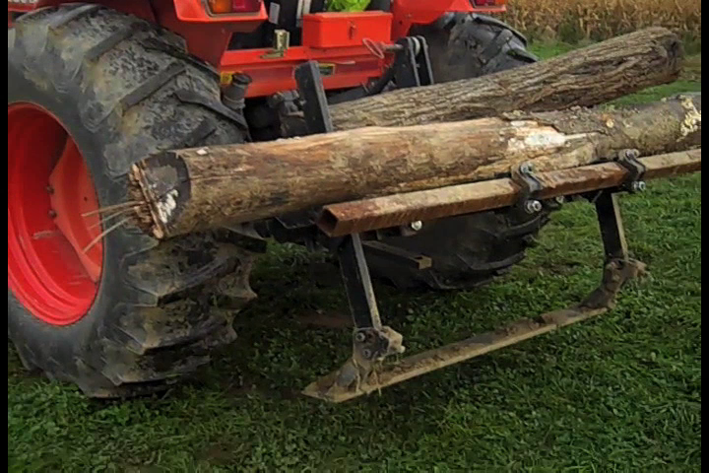
Figure 1. An undercutter bar loosens soil underneath crops like carrots, eliminating the need to fork roots to loosen them.

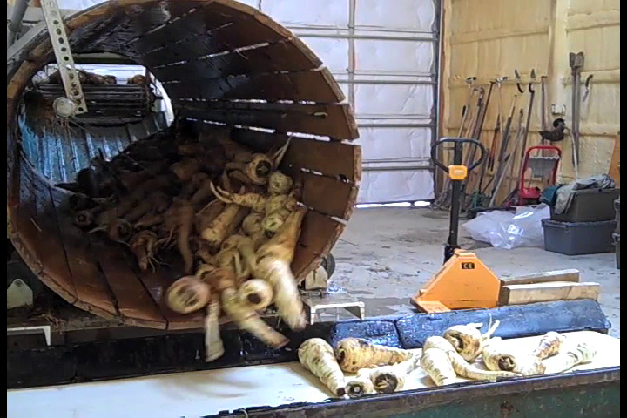
Figure 2. A barrel washer can wash approximately 1000 lbs of roots per hour (depending on root condition), while a person with a spray table washes approximately 150 lbs/hour.

