Set up an efficient vegetable wash station

Molly Shaw, CCE South Central NY Ag Team
January 2011
This series of articles, “Clean and efficient harvest and washing practices for small scale vegetable farms,” was written from case studies involving 12 small scale NY vegetable farms. Thank you to Eric Yetter, Project Manager, to NE SARE for their support of this project, and to all the farmers who opened their farms to us. To see the case study videos, visit ________(website).

Efficient washing/packing houses aren’t just for big growers; they’re critical for small scale diversified operations as well. In a diversified vegetable farm, it’s not unusual to spend 50% or more of your farm’s labor on harvest, washing and packing produce, so it stands to reason that efficiencies here make a big difference to the bottom line.

The produce washing/packing set-up is the hub of a farm’s harvesting activities. Each farm’s wash station is customized to their own crop mix, style, and resources, but there are several similar components of an efficient set-up.

Covered from the elements—you’ll be washing and packing in every possible weather condition, from 100 degree heat to 35 degree windy rain. Avoid misery. Some farms in our study used permanent buildings for this, while others used greenhouse structures set in the shade or covered with shade cloth. Greenhouses have the advantage of ample ambient light during the day, they are inexpensive per square foot compared to a building, and they are considered “nonpermanent structures” by the NY tax code (figure 1). Seth Jacobs from Slack Hollow farm says “We like a greenhouse as a wash station because it’s bright and cheerful. You can shade it in summer to keep it cool, then pull the shade cloth off for a nice place to go in spring and fall.”

Farms that were slightly larger tended to eventually construct permanent buildings with nifty features like walk-in cooler space and loading docks to minimize lifting heavy loads on and off pickup or box trucks. If you plan on handling vegetable in the winter, you’ll want your structure to be enclosed enough to heat.

Well lit—this can be ambient day-light, or electric lighting. Remember that it gets dark shockingly early (~6:00 pm) even in late October.

One-direction flow—Have you ever designed a new kitchen for your house? A wash station for your farm should be as carefully thought out as your $12,000 kitchen renovation, and with a similar logic. Your wash station, like a kitchen, should have work “zones” for washing in tubs, washing on a spray table, packing product that doesn’t need washing, and moving produce to the cooler. Additional “zones” are added for specialized washing equipment, like a barrel washer. Often the product flows in one direction—dirties in one end, cleans out the other, with dirty harvest lugs following their own path to cleanliness. Imagine how a head of lettuce (for example) would move through your station and make adjustments to avoid extra and retraced steps (figures 2-4.

Building flexibility into your wash station is also helpful. Some pieces of equipment are primarily used for short periods of time (washing big fall root harvests with a barrel washer, for instance), and farmers have said that making those components moveable makes better use of the wash station space, plus allows for changes as the farm grows and evolves.

Comfortable working heights-- Kitchen counters are set at 30 inches as a comfortable working height for the average person. If you’re stretching to reach your arms over the edge of your wash tub or stooping to rinse your taters, adjust your table height. You’ll spend many hours in the wash room, you might as well be comfortable. Many stations have benches that are lower than the washing surface, just at the right height to set a full harvest lug so the top of the lug is even with the top of the wash tub, minimizing bending and lifting (figure 5). Same principle on the clean end—pack into containers set lower than the table but still up off the ground. Many wash tables have a backsplash to keep produce from rolling off the back end.

Water sources and drains—All water used in washing vegetables should be potable, and lots of water is going to run into and out of your wash station. Think about how to make it drain away so you aren’t sloshing around in mud. Many beginning farms start with bare dirt, and use pipes or gutters to guide water out and downhill from the wash station. Eventually farms tend to construct gravel or concrete floors for their wash stations. Concrete floors allow for the use of dollies, hand trucks, and pallet jacks for moving heavy crops.

Small vegetable farms tend to rely heavily on hoses with spray tables and dunk tanks for washing produce, while more specialized equipment is added over time. Ideally your wash tubs will have bottom drains to empty them. If your wash tubs don’t have drains at the bottom, you can use a wide piece of plastic hose to siphon water out until the tub is light enough to easily tip and rinse. Many growers find it useful to hang water supply hoses and/or to have hooks for hose ends so they aren’t dragging heavy hoses over the ground and dropping nozzles in the dirt. A float valve on a wash tub can help save time; other duties can be done while it is filling without risk of overflowing (figure 6).

Organization-- Marking full containers so you know what is in the container how much of the product, the date, and for what market can reduce time when looking for the products in the cooler. Some farms use different colored bins to code where products are bound for. Some use chalk as a temporary label on produce bins, others use writing on tape or labels. The best farms have a system worked out so they can quickly locate product in the cooler and get it on its way to the correct market.

Most farms know that better record-keeping would help their business, but it’s hard to make time for even simple notes. Placing harvest and market record sheets in the wash station can make the difference between keeping records and not getting around to it. On the marketing end, documenting what was sold, for what prices and what market was like that day in terms of weather or other events that may help or hurt sales can inform the harvest plans the next week, and planting plans in the future.

Creature Comforts-- Music or a radio nearby can help keep workers happy and motivated. Floor mats on concrete surfaces are useful to reduce back and leg soreness. GAPs (“Good Agricultural Practices” food safety standards) require that there is a separate area for employees to eat and drink, distinct from where produce is washed and packed.

All too often farms don’t feel like they have time and money to set up a really good wash station. But remember that the components of a good wash station need not be expensive, and consider that the typical mix fresh vegetable farm spends 50% or more of their labor on harvesting and washing. The reality is that farms can’t afford NOT to pay attention to their wash station set-up.
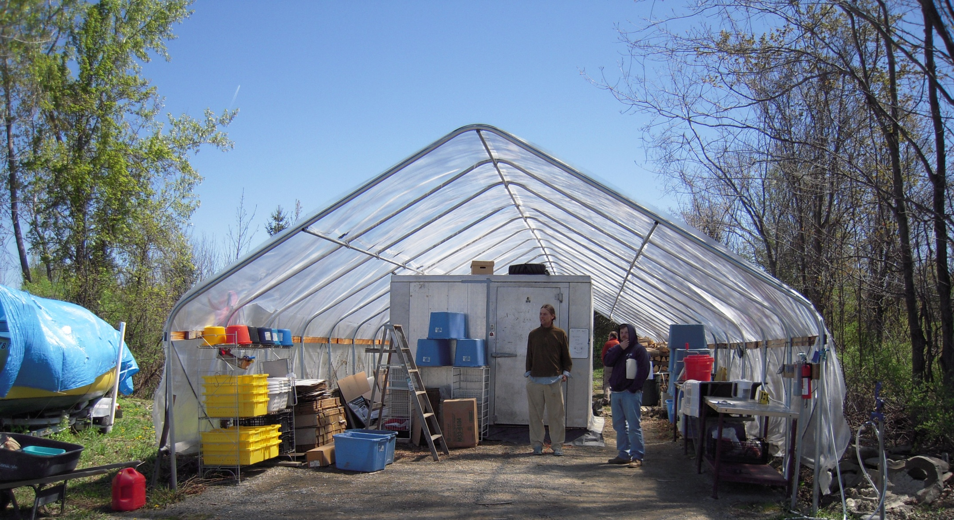
Figure 1. Using a greenhouse as a wash station has the advantage of ample ambient light during the day and inexpensive construction per square foot compared to a building. In addition, they do not add to the property taxes according to the NYS tax code.

Figure 2. This packing shed is set up under a greenhouse structure. A photograph can be seen in figure 1.

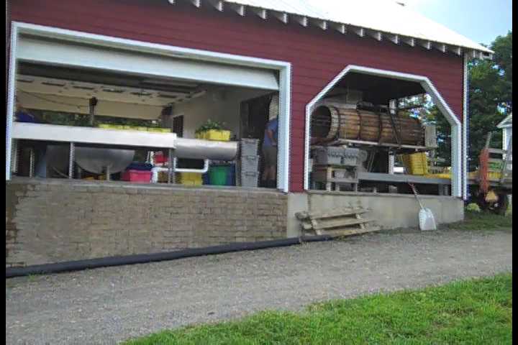
Figure 3. This packing shed (diagram above, photo below) has a concrete floor, washable walls, and is able to be closed up and heated during the winter.

Figure 4. This very simple packing shed is under the shelter of a moveable car port. Workers reach produce from both sides of the line of tables.

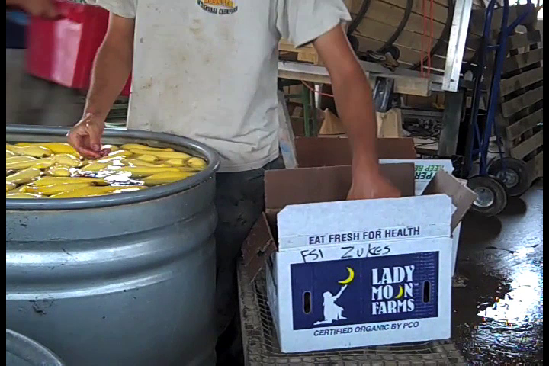
Figure 5. Setting up tables with comfortable working heights is simple and goes a long way towards making the washing process more efficient.

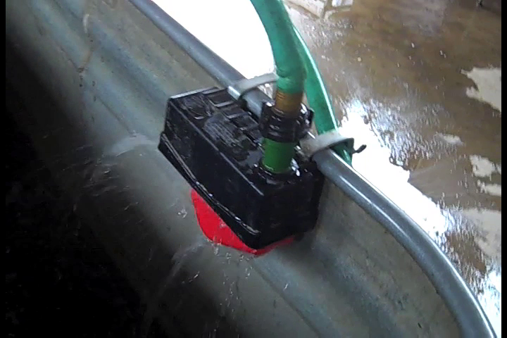
Figure 6. A float valve on a wash tub can save time; other duties can be done while it is filling without risk of overflowing.

