What’s Happening with the Kaw Permaculture Collaborative?

As many of you know three members of the KPC received a USDA SARE Farmer Rancher grant to create demonstration sites for broad acre permaculture. The project involves emulating natural ecosystems in the establishment of forest gardens for the production of fruit and nut crops.

At the Hjersted farm near Linwood, Kansas, we developed a permaculture plan to establish a food forest of walnuts, pecans, chestnuts, hazelnuts, paw paws, apple, pear, peach and a variety of other fruit and berries. The site for our project consists of about two acres of pasture land on a 4% slope that had been used to organically graze a combination of a few cattle, sheep, pigs and free range chickens. The soil of the acreage consists of two different types in transition moving down slope. At the top there is a Pawnee clay-loam that is classified as moderately well drained and near the bottom half there is a Sibleyville silt-loam soil that is moderately-high drained. What does this mean for growing nut and fruit trees? A moderate degree of water runoff, and difficulty holding nutrients in the soil. Pecans love a moist well drained soil.
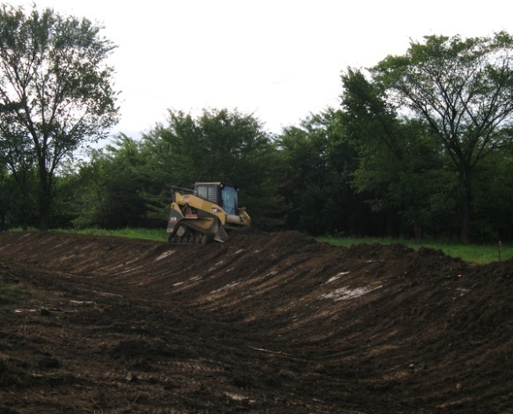
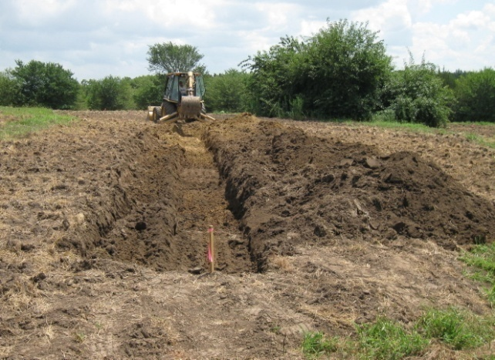

In order to better hold nutrients and moisture in the soil we planned to create three large swales on the landscape. In theory the swales collect the water and allow it to slowly percolate into the soil as opposed to running off into a creek basin below the area. With funds provided by our SARE grant we hired an excavator to dig the swales on contour. In late July we broke ground. We surveyed the area and pegged out the keylines on contour. Then a 1 ½ ft trench was excavated with a back hoe and the soil piled on the downhill slope. To finish the swale the uphill lip of the trench and the downhill berm were smoothed with a skid loader. During the excavation we did encounter a surprise. In a portion of the top two swales we encountered areas of hardpan in the soil. Fortunately we were able to punch through a 2 -3 inch layer of fine sandstone-like material. Breaking the hard pan will allow water to move in the subsoil to nourish tree roots.

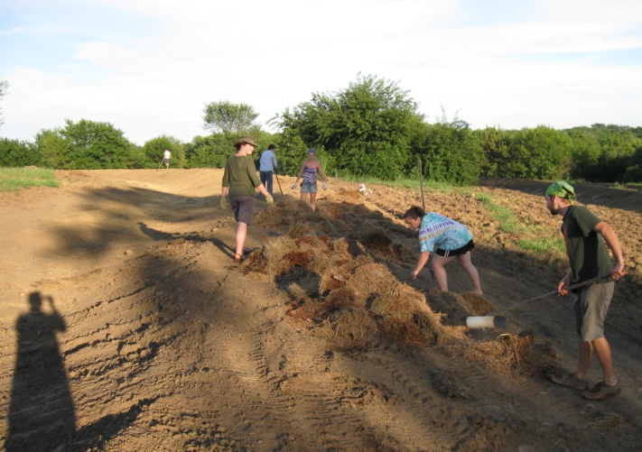
The swales were completed by the 1st of August , and a team of permaculture students set out to cover the swale lip and berms with red clover seed and straw. Our plan is to plant as many nitrogen and carbon fixing short lived perennial cover crop species to build up the soil in preparation and support of fruit and nut tree species that will be planted in the spring.

Our next step in the process is to wait for rain to learn how well the swales hold water and how quickly it percolates into the soil. On Aug. 31 the farm received about 4 inches of rain over 24 hours and the swales filled with about a foot or more of water. In two days the water receded about six inches, indicating a good perc rate. To fully understand the value of the use of swales for conserving and holding moisture on the landscape see Geoff Lawton’s “Water Harvesting” on YouTube video clip: http://www.youtube.com/watch?v=kPrfNVzDNME
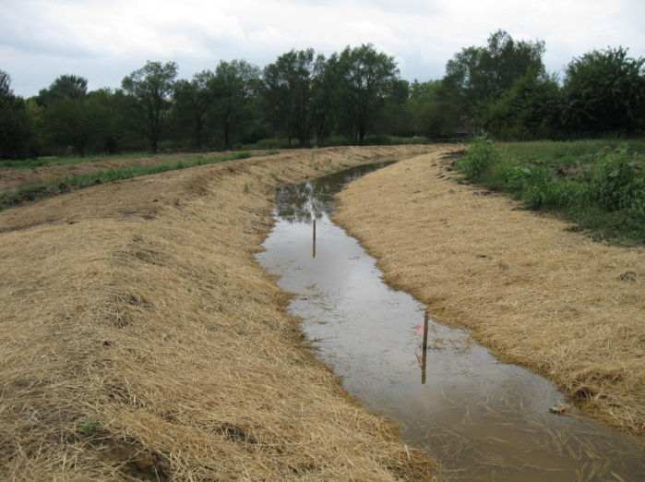
As the fruit and nut tree forest grows through phases of succession from nitrogen fixing species to mature bearing trees the amount of material and energy input will decline and the productivity of the food forest will increase.

In 15 to 20 years the food forest may look from above like this layout design with fruit trees on top of the swale berm and pecan and walnut trees below. Paw Paws will be nestled under the walnut trees and berry bushes in the understory. We are planning for hazelnut hedges on the upper edge of the swales (not shown in diagram) and insect nectaries of wildflowers in open spaces between.
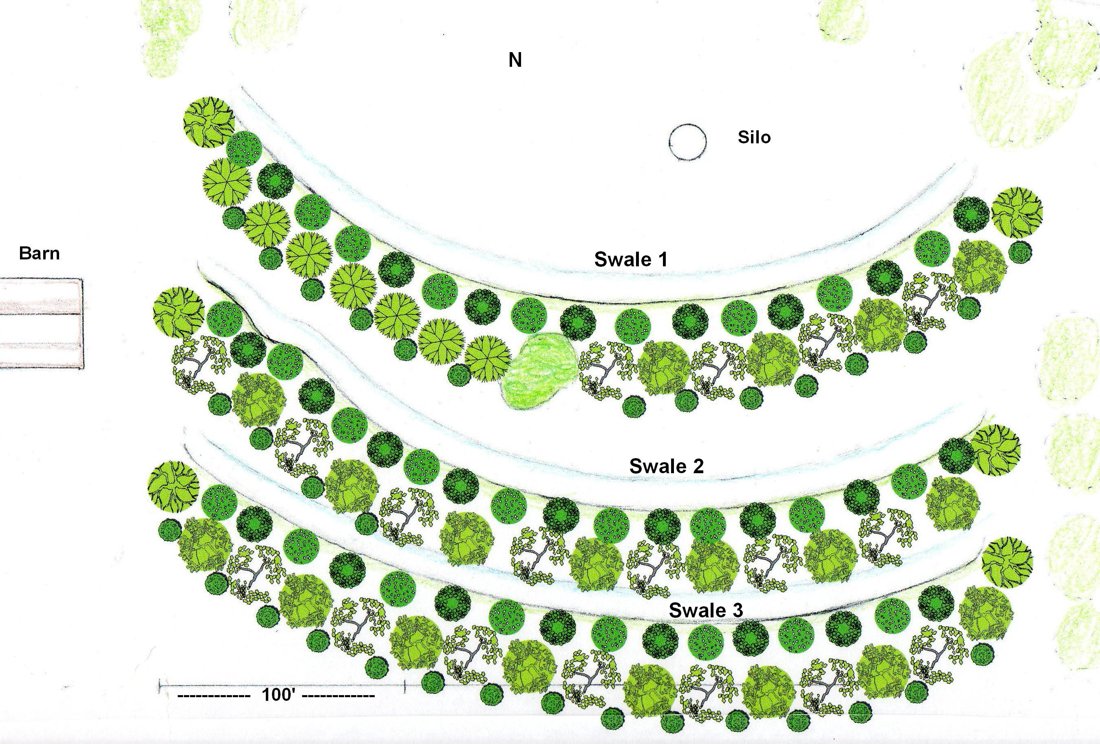
To learn more about the ethics, principles and methods of permaculture consider attending the Kansas City Fall Permaculture lecture series, “Introduction to Permaculture Ethics, Principles and Design” with Steve Moring of Vajra Farm. The course consists of a series of 9, three hour sessions with lectures and video screenings held every Thursday beginning September 23 from 6 – 9 pm at the Matt Ross Community Center, 8101 Marty St. Overland Park, KS.

For more information on course content, meeting times and locations go to websites: http://groups.google.com/group/kpc-dev/web/kpc-event-postings or
http://kawpermaculture.wordpress.com.
One can also contact Steve Moring at smoring@grasshoppernet.com or 785-691-7305

