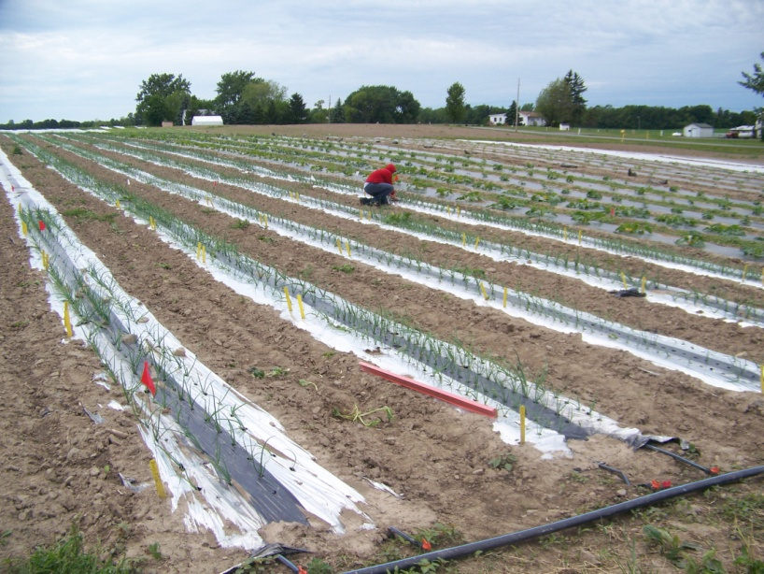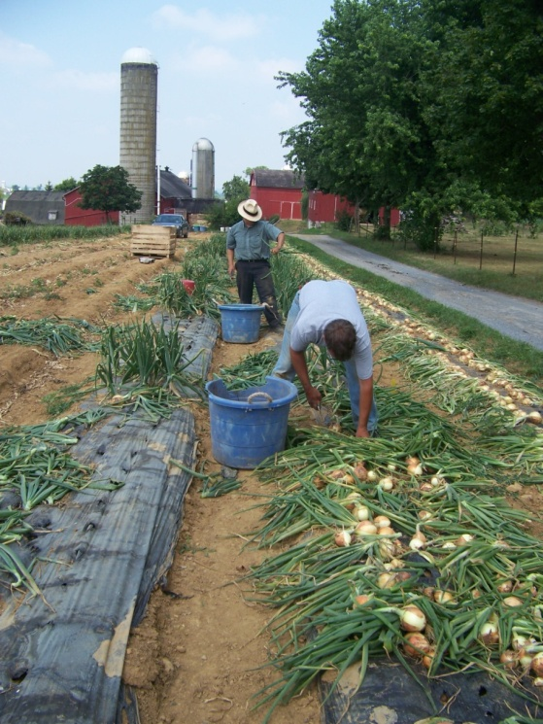
Figure 1. Small-scale intensive onion production on plastic in Interlaken, NY (left) and New Holland, PA (right: showing hand-harvest).

