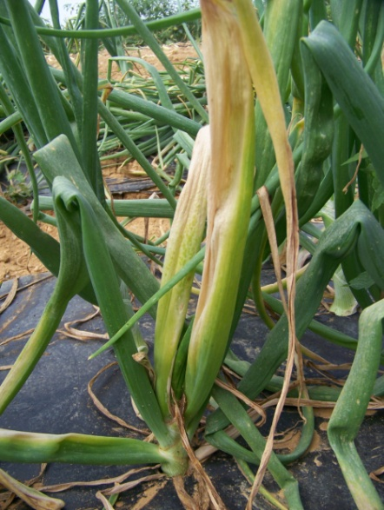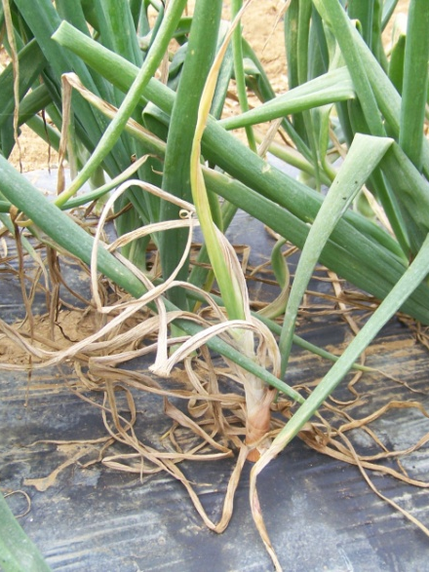
Figure 2. Left and Middle – above-ground symptoms of bacterial diseases of onions showing yellowing, bleaching and wilting of inner leaves. Right – bacterial bulb decay (pathogen not identified).

