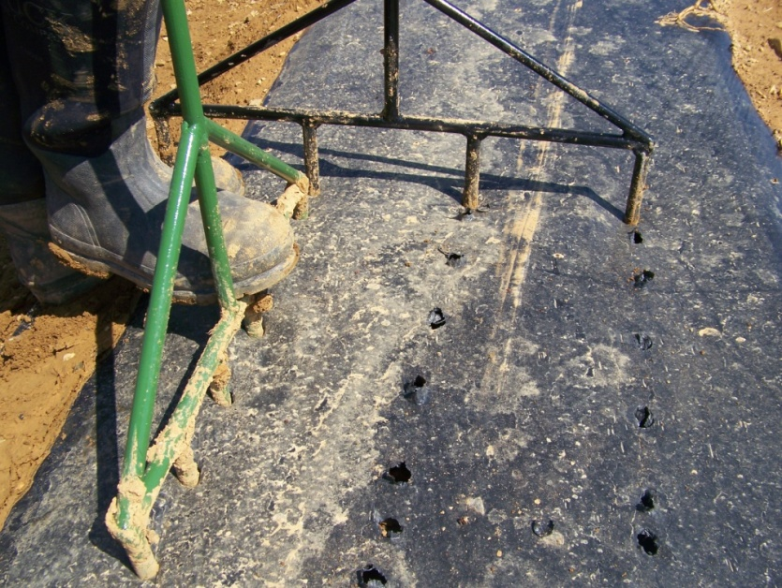
Figure 4. Fabricated hole-poking tools punched at right angles to establish different plant and row spacing configurations in small-plot on-farm research trials, New Holland, PA, 2009.

