Tables and Figures

Table 11. Solarization and brassicaceous seed meal trial at WSU-Mount Vernon (WA) in 2008-2009.
Treatment and rate/A | P. rubi root rot rating^{z} |  |  | # of P. penetrans/50 g soil
 |  | Root weight  (g) | Aerial weight (g) | Jul  08 | Jan  09 | Apr  09
Control……………………. | 4.9 c^{x} | 3.2 | 3.1 ab | 14.6 | 2.4 bc | 2.4
Solarization...…………….. | 5.3 bc | 3.0 | 3.0 ab | 16.8 | 24.4 a | 2.4
InLine™ 35……………….. | 6.2 a | 2.5 | 2.1 c | 9.0 | 0 c | 0
S. alba (1% w/v) ………….. | 4.6 c | 3.1 | 3.3 a | 9.6 | 7.2 bc | 2.4
Solarization + InLine… …… | 6.1 a | 2.9 | 2.6 bc | 12.8 | 1.2 c | 0
Solarization + S. alba………. | 5.7 ab | 2.9 | 2.7 b | 7.4 | 7.2 bc | 4.8
Solarization + linseed meal (1%w/v) | 5.7 ab | 3.1 | 2.7 b | 19.4 | 14.6 ab | 8.8
LSD (P < 0.05)……………… | 0.71 | NSD | 0.5 | NSD | 12.36 | NSD
¹ P-values less than or equal to 0.05 is significant.
² Means followed by the same letter within a column are not significantly different as determined by Fisher’s protected least significant difference. NSD=No significant difference.
³Averaged over three bioassay plants per plot.
⁴Averaged over four bioassay plants per plot.

Table 12. Soil properties of brassicaceous seed meal field trial at WSU-Mount Vernon (WA) 2009-2010.
Treatment | %OM | NH4-N  (ppm) | N03-N (ppm) | S  (ppm) | pH
Control. | 4.5 | 4.8 b | 46.8 c | 12.4 d | 5.7 a
Solarization | 4.3 | 4.2 b | 58.6 c | 12 d | 5.5 ab
B.juncea (1% v/v) | 4.3 | 4.6 b | 29.6 c | 19 cd | 5.6 a
S. alba (1% v/v) | 4.8 | 6.4 b | 43.2 c | 30.1 cb | 5.2 cb
Solarization + B.juncea | 4.2 | 15.8 a | 103 b | 34.2 b | 5.2 c
Solarization + S. alba | 4.4 | 16.2 a | 116 b | 50 a | 5.2 c
Solarization + linseed meal(1%v/v) | 4.5 | 8.8 b | 153.6 a | 17.8 c | 5.1 c
LSD (P<0.05) | NSD¹ | 5.6 | 29.2 | 14.5 | 0.27
¹ P-values less than or equal to 0.05 is significant.
² Means followed by the same letter within a column are not significantly different as determined by Fisher’s protected least significant difference.NSD=No significant difference.
³Soil samples (2.5 cm diam., 15 cm deep) were collected in March 2010 and analyzed at A&L Laboratories West, Portland, OR.

Table 13. Response of nematode community to seed meal applications in two different grower fields soils in a microplot field study.
 | Total Number | P. penetrans | BI³ | SI | EI | CI | Bacterial  (prop) | Fungal  (prop) | Omn/Pred (prop) | Plant  (prop)
Pretreatment
Soil A¹ | 1245 a | 277.2 a | 25.4 | 51.1 | 65.1 | 6.9 | 0.56 | 0.05 | 0.12 | 0.26
Soil B² | 315.5 b | 32.2 b | 29.1 | 44.5 | 62.1 | 8.4 | 0.60 | 0.07 | 0.10 | 0.22
LSD (P<0.05) | 373.7 | 128.1 | -- | -- | -- | -- | -- | -- | -- | --
1 week
Soil A | 409.8 a | 81.2 a | 24.9 | 54.9 | 31.3 | 7.2 a | 0.66 a | 0.06 a | 0.14 | 0.20
Soil A + B. juncea | 3.5 b | 0.75 b | 26.9 | 0 | 48.2 | 0 b | 0 b | 0 b | 0 | 0.25
Soil A+ S. alba | 77.8 b | 21.2 b | 0 | 25 | 0 | 0 b | 0.33 ab | 0 b | 0.25 | 0.18
LSD | 136.1 | 47.8 | -- | -- | -- | 5.2 | 0.4 | 0.05 | -- | --
Soil B | 385.8 a | 121.2 a | 30.1 | 18.9 | 66.6 | 6.6 | 0.60 | 0.07 | 0.04 | 0.34
Soil B + B. juncea | 2 b | 15.1 b | 8.3 | 0 | 16.7 | 0 | 0.19 | 0 | 0 | 0.06
Soil B + S. alba | 60.5 b | 0.5 b | 48.5 | 0 | 26.5 | 26.5 | 0.50 | 0.09 | 0 | 0.26
LSD | 68.5 | 57.3 | -- | -- | -- | -- | -- | -- | -- | --
5 week
Soil A | 389.3 | 52.4 | 27.5 | 52.7 a | 51.9 | 3.4 | 0.67 | 0.03 | 0.17 a | 0.14 a
Soil A + B.junceae | 570.3 | 4.8 | 17.9 | 2.9 b | 81.9 | 5.1 | 0.89 | 0.10 | 0.004 b | 0.02 b
Soil A+ S.alba | 1820.0 | 31.5 | 19.2 | 40.6 a | 77.5 | 15.8 | 0.65 | .024 | 0.09 ab | 0.02 b
LSD | -- | -- | -- | 31.0 | -- | -- | -- | -- | 0.12 | 0.08
Soil B | 470.3 | 83.2 | 41.5 a | 44.0 a | 36.0 b | 29.2 | 0.60 c | 0.03 | 0.12 a | 0.26
Soil B + B. juncea | 1769.8 | 0 | 10.9 b | 5.9 b | 88.6 a | 0.2 | 0.98 a | 0.007 | 0.01 b | 0
Soil B + S. alba | 2335 | 47.7 | 16.5 b | 32.0 a | 81.9 a | 3.3 | 0.84 b | 0.08 | 0.05 ab | 0.03
LSD | -- | -- | 16.1 | 21.5 | 25.4 | -- | 0.04 | -- | 0.07 | 0.09
¹ Skagit County (Briscot fine sandy loam) collected in June 2010.
² Whatcom County (Kickerville silt loam) collected in June 2010.
³ Ferris and Bongers, 2001.
⁴ Means followed by the same letter within a column are not significantly different as determined by Fisher’s protected least significant difference.NSD=No significant difference.

Table 14. Results of plant back experiment using B. junceae and S.alba over time.
 | B. juncea | S.alba | CT | LSD (P<0.05)
1 week
% Plant Damage TC² | 0 b | 48.3 a | 0 b | 7.8
No. germinated seeds-radish³ | 20 | 20 | 20 | NSD⁵
No. germinated seed-lettuce⁴ | 18 | 15 | 16 | NSD
4 week
% Plant Damage TC | 0 | 0 | 0 | NSD
No. germinated seeds-radish | 20 | 20 | 20 | NSD
No. germinated seed-lettuce | 16 | 13 | 12 | NSD
6 week
% Plant Damage TC | 0 | 0 | 0 | NSD
No. germinated seeds-radish | 3 | 7 | 3 | NSD
No. germinated seed-lettuce | 17 | 17 | 13 | NSD
¹Data from Test 1 and Test 2 are combined
²Tissue culture raspberry plant ‘Meeker’
³’Cherry Belle’ from Burbee Seed Co. (seed lot 3)
⁴’Black Simpson’ from Burbee Seed Co. (seed lot 8)
⁵ Means followed by the same letter within a row are not significantly different as determined by Fisher’s protected least significant difference. NSD=No significant difference.

Figure 10. Quantitative real-time molecular assay for Phytophthora rubi for the Lynden, WA field trial.

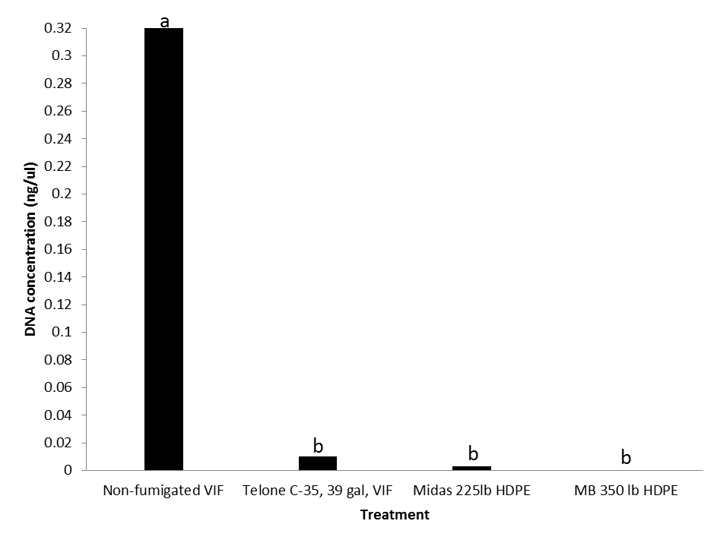

Figure 11. Phytophthora rubi inoculum evaluation bioassay for root rot (0-9 scale) from brassicaceous seed meal field trial 2009-2010. Columns identified by the same letter are not significantly (P<0.05) different according to least significant difference.

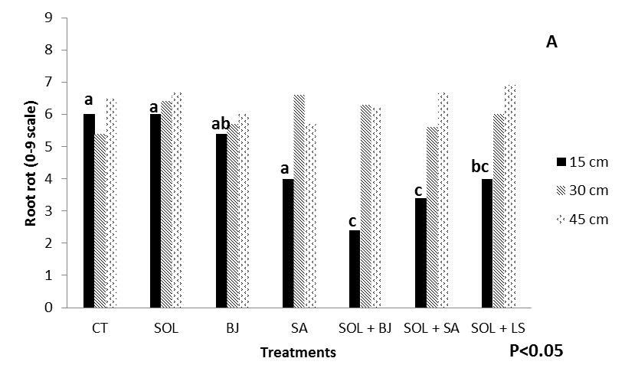
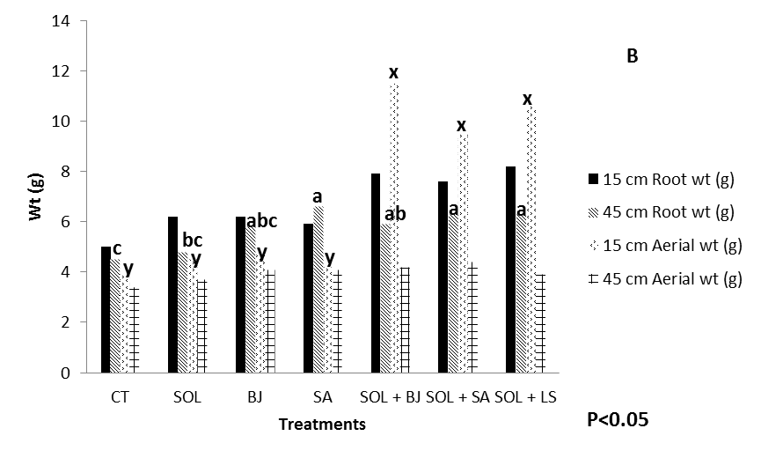

Figure 12. Results root rot and root and aerial weight for seed meal rate greenhouse trial for P.rubi.

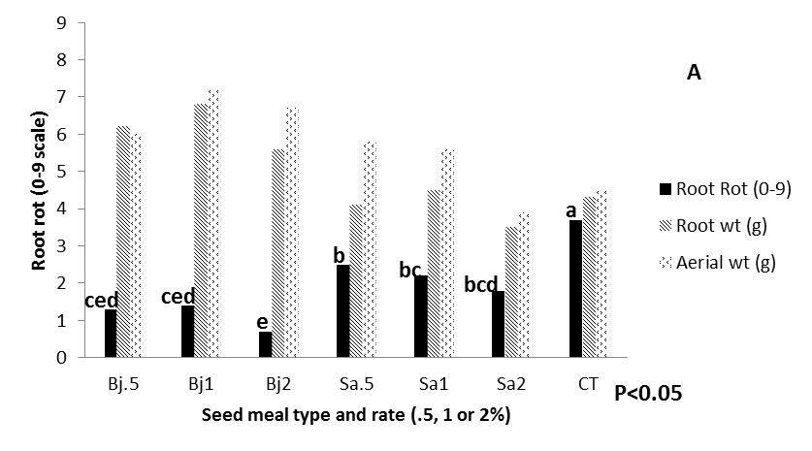

Figure 13. Results nematode number (A) and root and aerial weight (B) for seed meal rate greenhouse trial for P.penetrans.

