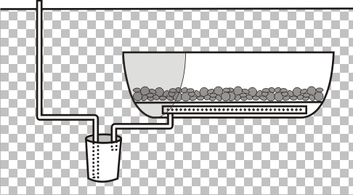Access box

PVC Pipe w/
3/8” tubing
inside for
pump-out
Ground level

One half of a 55 g drum

River Rock / Pebbles

5 gal pail
Inlet from catch basin
PVC 1½” Perforated w/
mesh screen over it

Figure 1. General schematic of drainage lysimeter construction.

