Table 2. Percent mortality and final midgut spore counts 23 days after caging. Bees were either inoculation with 40,000 Nosema spores or left healthy. One of four compounds may have been used as treatment or they may have been left untreated.
 | % Mortality 23 days post inoculation | Midgut spore counts 23 days post inoculation Nosema apis | Midgut spore counts 23 days post inoculation Nosema ceranae
Uninfected control | 11.6% | None Detected | None Detected
Treated with thymol | 9.7% | 20 Million | 110 Million
Honey-B-Healthy | 14.7% | 170 Million | 169 Million
Fumagillin | 38.9% | 0.4 Million | 2.5 Million
Nozevit | 73.9% | 78 Million | 116 Million
Infected, Untreated | 60% | 153 Million | 158 Million

Figures 1-3. Results of survival analysis on the mortality of honey bees. The dashed lines indicate a 95% confidence interval.
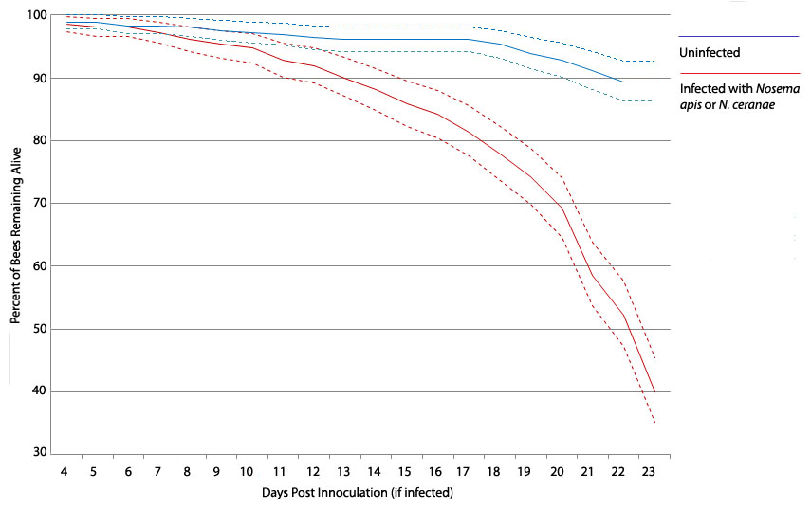

Figure2.
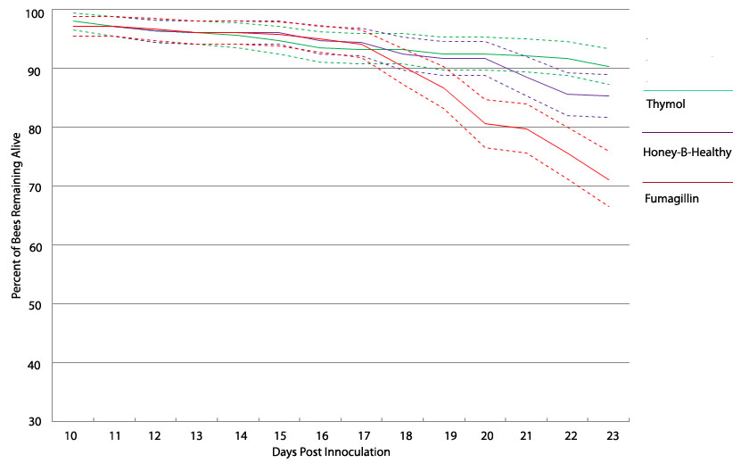

Figure 3
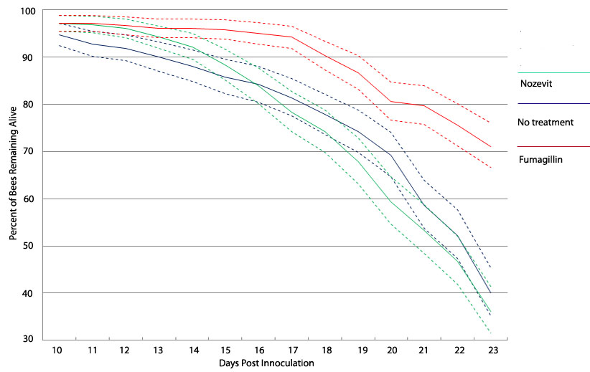
Figure 4. Spore counts of 10-15 honey bees 23 days after inoculation with either Nosema apis or N. ceranae and treatment with one of four compounds.

