METHODS:
Field preparation:
Four bean fields at the OSU Vegetable Research Farm and 4 bean fields at the OSU Lewis Brown farm were planted to 91G snap beans in July 2009, inoculated with white mold using the straw inoculation method, irrigated regularly to develop disease, and flailed at maturity in September, leaving many white mold sclerotia evenly distributed across the soil surface.
Sclerotial management:
Contans (1.5 lbs per acre) was applied to the 4 fields at the vegetable research farm (Cm treatment) on November 4 2009; the 4 Lewis Brown fields (control) remained untreated. In May 2010 sclerotia were collected from the field surface from all fields, bagged in the laboratory, and placed in the Lewis Brown (LB) and OSU Veg Farm (OS) fields on July 8 and July 12, respectively. Bags were collected from fields on Sept 21 2010.
At both sampling dates (May and September), sclerotia or bags were collected from the field and sclerotia were surface-sterilized in 20% bleach for 10 minutes and rinsed with DI water. All sclerotia were plated on PDA w/streptomycin and observed for development of Ss sclerotia, Cm pycnidia, and mycelia of other fungi.

Field snap bean experimental design and management:
Snap beans 91G and OR-6230 were planted in a randomized complete block design (6 plots of each variety in each of the 8 fields) on half of each field on June 29 and July 1 at OS and LB, respectively (the other half of each field will be planted to the same experiment in 2011).

Bean foliage and pod evaluation at harvest:
Beans were evaluated and harvested at LB and OS on Sept. 8/9 and Sept. 9/10, respectively. Bean aboveground biomass was harvested from two 4 ft row sections per plot and weighed. Of the plants in the 8 ft of row, twenty randomly selected plants were evaluated for white mold disease severity on a scale of 0-5 (0=healthy; 1=1-10% foliage necrotic; 2=11-30% foliage necrotic; 3=31-60% foliage necrotic; 4=61-80% foliage necrotic; and 5=91-100% foliage necrotic). Pods were stripped from all 20 bean plants and weighed. Two hundred beans from each plot were weighed and evaluated for pod white mold incidence. Diseased beans were also weighed.

RESULTS:
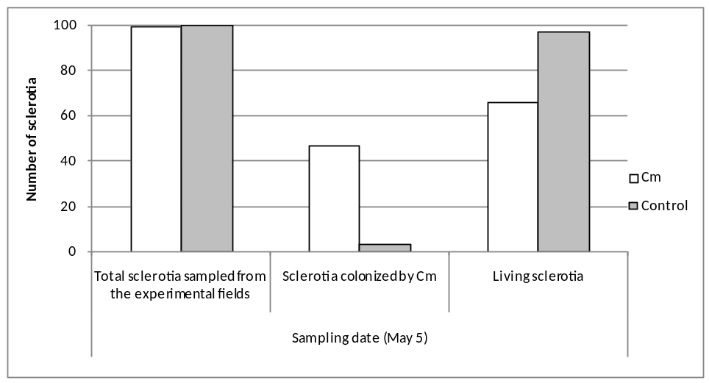
Fig. 1. Viability and Cm infection of sclerotia sampled from the soil surface in May 2010.

In May 2010, sclerotia generated on the previous year’s bean crop were collected from the soil surface in all fields and evaluated for viability and Cm colonization. In fields in which Cm was applied, mean Cm colonization of sclerotia was 47%. In control fields, mean Cm colonization was 3% (Fig 1). Mean sclerotial viability in Cm and control fields was 67% and 98%, respectively (Fig. 1).

Sclerotia collected in May were bagged in the laboratory and the bags were placed in the field after bean planting. Bags were collected in September for evaluation. At this time, approximately 7% of buried and 10% of surface-incubated sclerotia were alive in Cm treatment fields. In contrast, approximately 74% of buried and surface-incubated sclerotia were alive in the control fields (with no significant effect of burial; p = 0.13)(Fig. 2). Viability of sclerotia in the Cm treatment fields declined from 67% in May to 7 and 10% (for surface and buried sclerotia, respectively) in September. In contrast, viability of sclerotia in control fields declined during that same period from 95 to 74%. (Figs.1 and 2) There were almost 9 times more living sclerotia in the control fields than in the Cm treatment fields 10 months after Cm application (Fig.2). Interestingly, in both Cm and control fields, sclerotia incubated on the soil surface were much more likely to be colonized by other fungi than sclerotia from any other treatment; this is in contrast with past years’ data in which during the summer, buried sclerotia were more likely to be colonized by other fungi than surface sclerotia.

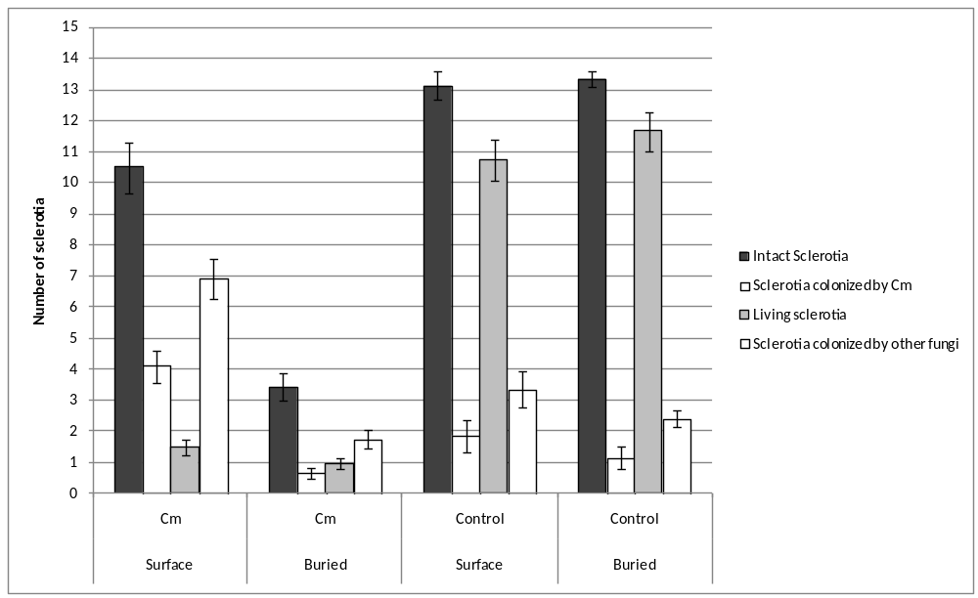
Fig. 2. Viability and colonization of sclerotia bagged in May and evaluated in September.

At harvest, foliar white mold severity was approximately 23 and 7.5%, respectively, for 91G and OR-6230 in the control fields, and 7 and 1%, respectively, in the Cm treatment fields. The lowest disease severity was observed in OR-6230 plants grown in Cm -treated fields (Fig. 3).

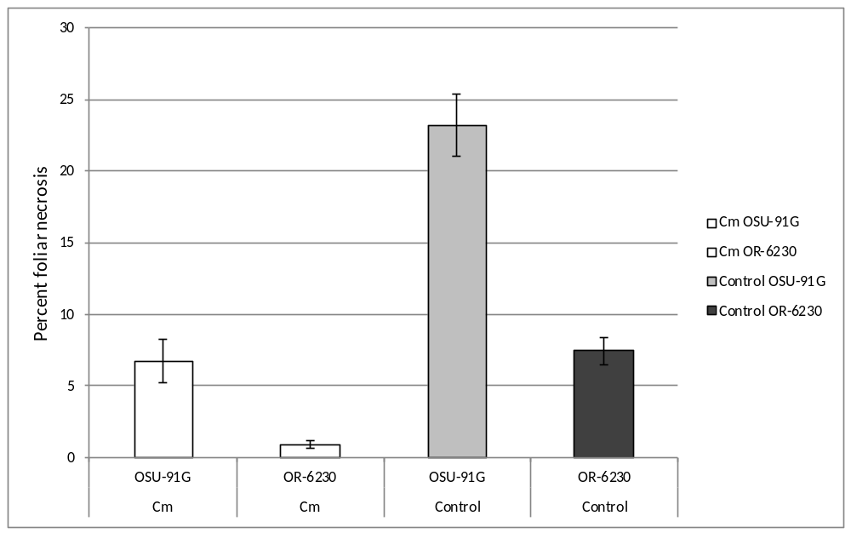
Fig. 3. Effect of Cm application and plant resistance on foliar white mold severity.

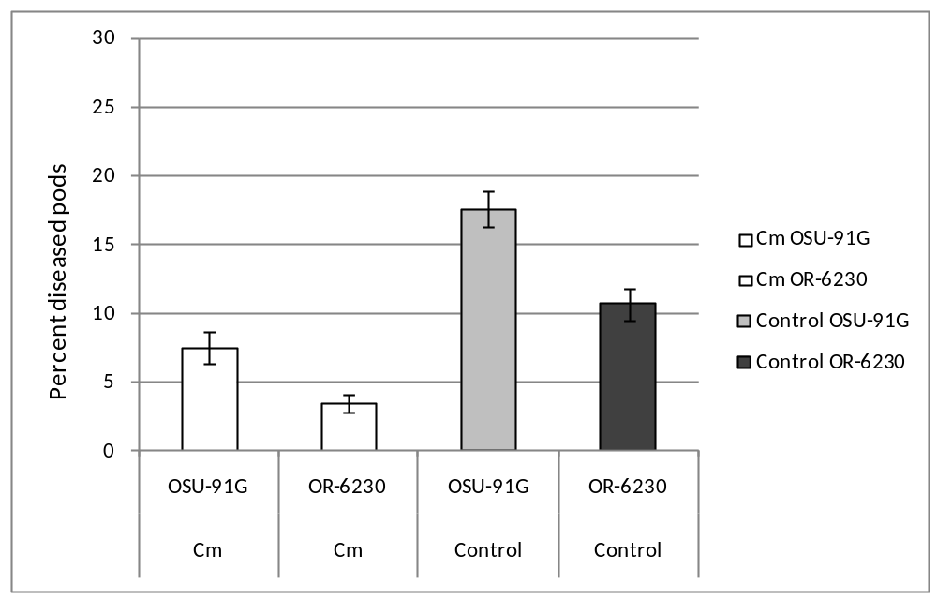
Fig. 4. Effect of Cm application and plant resistance on pod white mold incidence.

At harvest, pod white mold incidence in the control fields was approximately 17 and 11% in 91G and OR-6230, respectively, and 7 and 3%, respectively, in the Cm treatment fields. Pod disease incidence was 37% lower in 6230 than in 91G in the control fields and 60% lower in OR-6230 than in 91G in the Cm-treated fields. The lowest pod disease incidence was observed in the OR-6230 plants grown in Cm-treated fields (Fig. 4).

Bean marketable yields were not significantly different in the Cm and the control treatments (p = 0.16), but OR-6230 yielded less than 91G (p < 0.001) in both Cm and control fields (Fig.5).
There were significantly more diseased beans in the control than in the Cm treatment fields, and in the 91G than in the OR-6230 treatments.

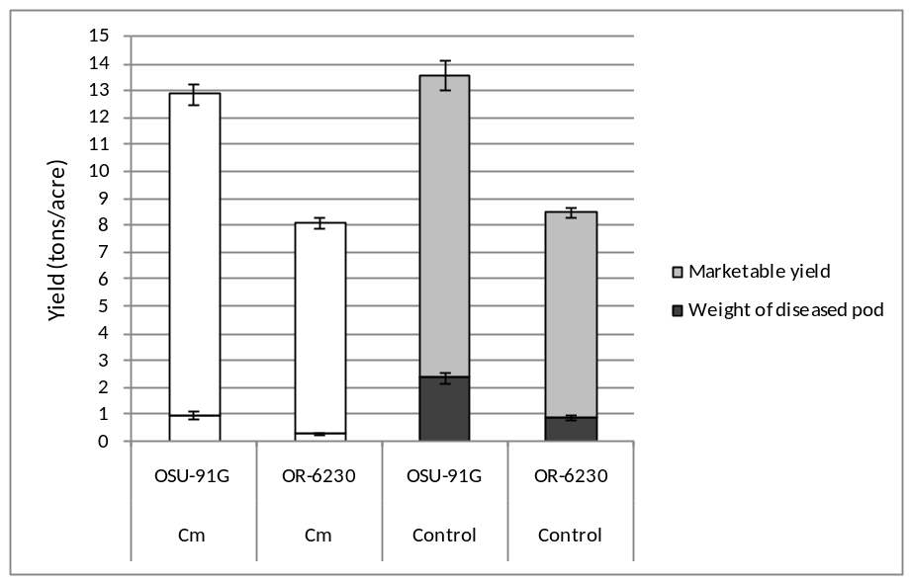
Fig.5. Marketable and diseased bean yields (tons/acre).

