Native Farmers Gather – Form Seed Library

Winona LaDuke with Lauren Scott
Maawamji’idiwag Ji Gizhaadaadamowaad Miinkaanan,, White Earth Reservation early March 2011:

They are gathering to protect the seeds. Indigenous farmers and gardeners from the region and beyond gathered at the 8th annual Great Lakes Indigenous Farming Conference to share knowledge, stories, and of course- their seeds.

More than 100 native people, organic farmers, students, and community members participated in the conference hosted by the White Earth Land Recovery Project held on the White Earth reservation in Northern Minnesota. The Maplelag resort was an ideal venue for the conference, cooking up traditional meals including walleye, manomin (wild rice), squash, buffalo, hominy, and other locally crafted foods. Eating traditional foods together affirmed the importance of the gathering as the dining hall became a place for furthering connections and story telling.

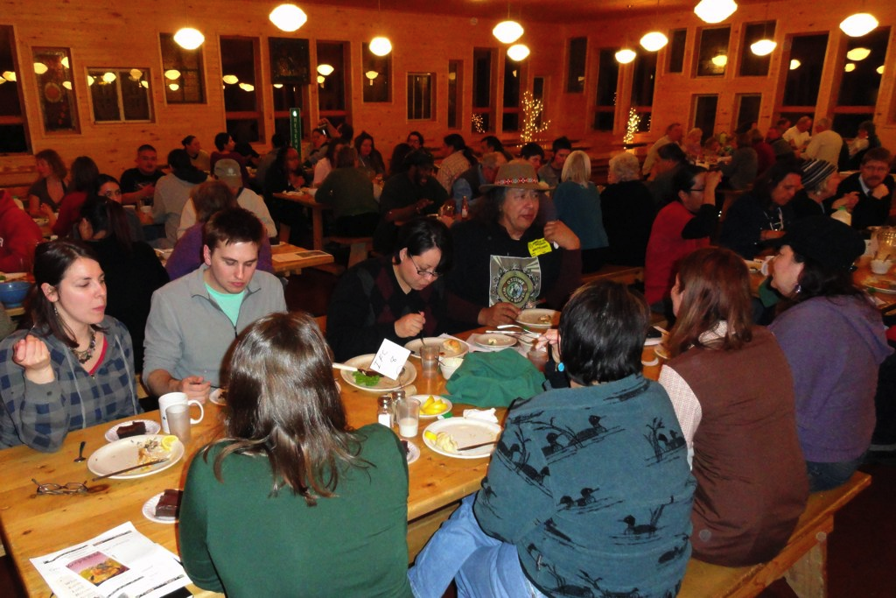

“I had a Hopi Squash run up a tree last year,” Frank Kutka, USDA Sustainable Agriculture representative told a small group. Describing the squash’s prolific vines he explained, “Sometimes that third sister doesn’t hang back, she just moves ahead.” Many farmers like Frank told their stories, finding a 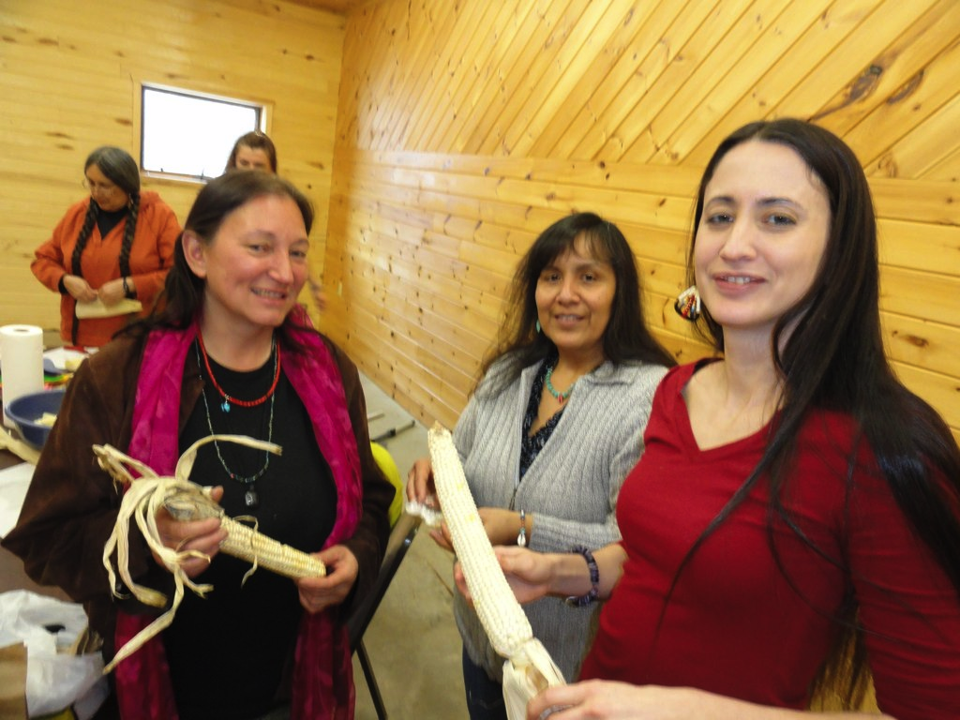

collective experience in their efforts to revitalize indigenous seeds; predominantly the three sisters- corn, bean, and squash.

The seeds also told stories, such as how native varieties have been kept alive by only a few farmers. For fourteen years, Caroline Chartrand has been looking for heritage seeds of the Metis people of Canada. It is believed that in the 1800s the Metis grew some 120 distinct seed varieties in the Red River area. Of those, Caroline says, “We ended up finding about twenty so far.”

“We found a few of them through the Canadian Seed Bank. We found some more through Seeds of Diversity Canada, the Canadian Seed Exchange, and the US Seed Saver’s Exchange. I really miss my seeds, I don’t get to grow out enough of them any year. “

The Canadian seed story is sobering: Three quarters of all the seeds that existed before the 20th century are extinct. And, out of the remaining quarter, only l0% are available commercially from Canadian seed companies. Over 64% of the commercially held seeds are offered by only one company, which means, that if the variety is dropped the seeds may be lost. The rest are held by backyard gardeners and families.

A recent article by a prominent Canadian writer suggested that agriculture in Canada began with the settlement of Europeans. Caroline had to ask her, “ What about all that agriculture before then?” Despite the overwhelming evidence that indigenous peoples established agriculture throughout the world, some still fail to recognize these achievements.

Caroline is one collaborator in the effort to recover northern Ojibwe corn varieties, which once grew l00 miles north of Winnipeg Canada. The Northern most cultivated corn on the continent. “That’s some adaptable corn”, one of the participants said. “And”, Betsy McDougall of Turtle Mountain commented, “ those Ojibwes, Metis and Crees must have been really good farmers”.

“Those seeds are the old ways. They gave our ancestors life for all those years. I’m totally for preserving the old ways.” Frank Alegria Sr told us. As the son of migrant farm workers, Frank has been gardening since he could walk and farming on the Menominee reservation in Wisconsin since he was sixteen. Now an elder, he continues to grow out native varieties including an 850 year old squash variety found in an archaeological dig near the Wisconsin border.

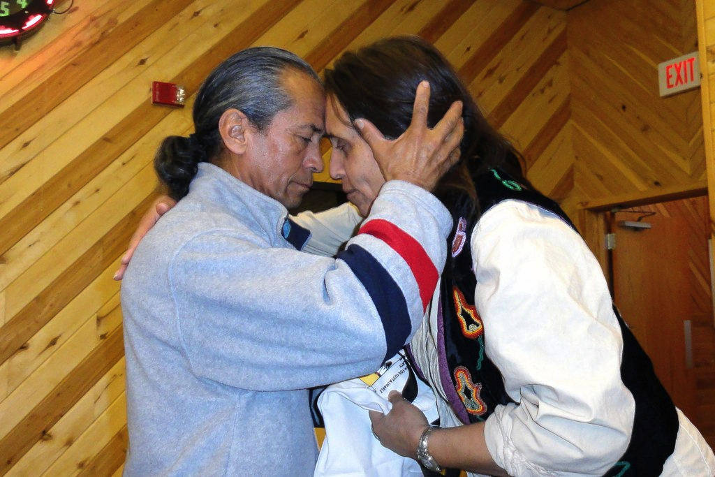

Deb Echohawk told the story of the sacred corn seeds of the Pawnees. Varieties thought to be lost forever are now finally recovering for her people. By combining efforts with the descendants of settlers who live in the traditional Pawnee homelands in Nebraska, the Pawnee identified keepers of the seeds, including Deb.

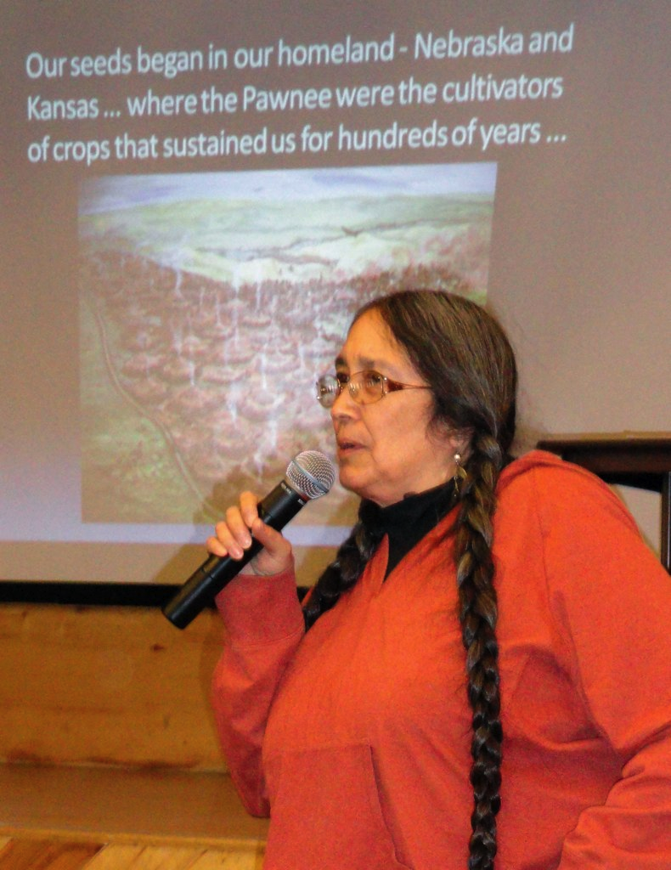

Indigenous farmers from Nebraska shared their story of genetically modified organisms (GMOs) encroaching on their fields, threatening to alter and potentially sterilize open-pollinated corn. While native corn varieties are more rich in protein and much more resilient to climate change, they are not immune to GMO contamination. The advice shared amongst farmers was to eat from the edges and save seed from the middle where it is least likely to be affected by cross pollination.

Despite the challenges to maintaining native varieties, organizations such as Seed Savers Exchange have triumphed in maintaining a diverse seed catalog. John Torgrimson, Executive Director of Seed Savers Exchange, talked about the organizations’ humble beginning in 1975 starting as a camp out by a small group of committed individuals in Decorah, Iowa. Over 35 years later, they now preserve and grow out over 25,000 varieties of unique vegetables, fruits, grasses, and even a heritage cow breed at their 890 acre Heritage Farm. They continue to camp out on the farm for their annual conference, this year to be held July 15-17th.
Likewise, the White Earth Land Recovery Project is working with a number of tribal members and local farmers to grow out five or six corn varieties adapted for this region. The North Dakota State University also contributes to this project. The first variety is a Bear Island Flint from nearby Leech Lake reservation and has grown well in the region for the past five years. White, pink, and black varieties are also being grown out. One of the greatest challenges today for heritage corn growers is competing with raccoons, bears, and deer for the fruits of their labor. A farmer at the conference chuckled as he mentioned seeing the animals strut past the more abundant GMO corn to feast on the native variety.

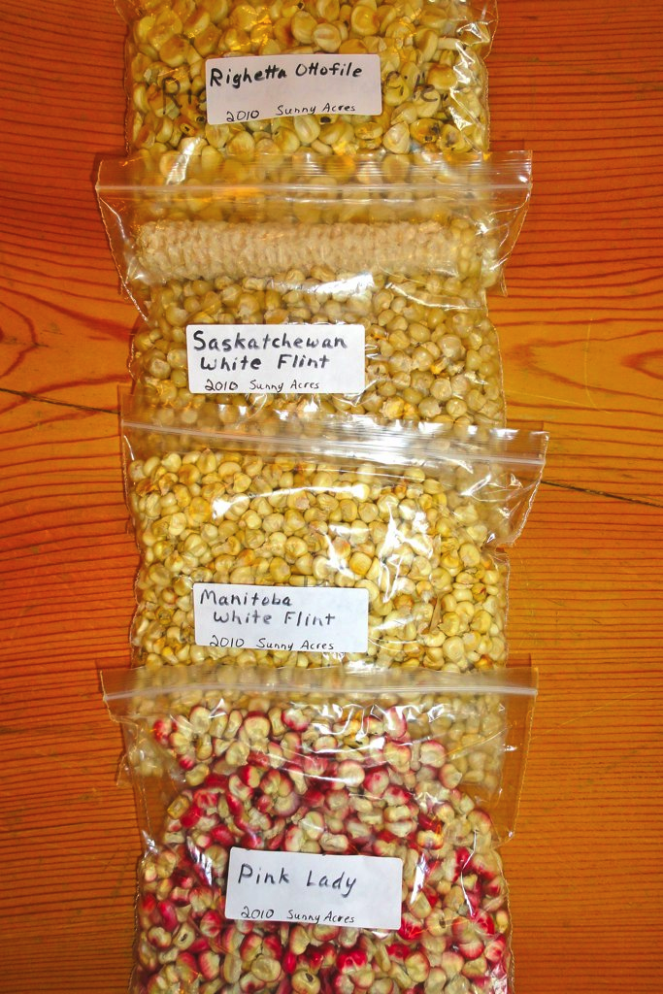

All participants were invited to join a working group that gathered several times throughout the weekend to envision a regional seed library and map out a plan for co-creating the library. At the table were tribal members from

White Earth, Red Lake, Leech Lake, Bad River, Menominee, Standing Rock Lakota, as well as the Winnebago of Nebraska and other reservations. Also involved in the discussion was the keeper of seeds for the Pawnee tribe, and the executive directors of Seed Savers Exchange and Seeds of Diversity (Canada). Many others joined the discussion including a Midwest coordinator for USDA’s Sustainable Agriculture Research and Education Program, local allied growers, representatives from University of Minnesota, and various tribal colleges.
If you are interested in taking part in the ongoing discussion and visioning of a Great Lakes Seed Library, join the Northern Indigenous Seed Sovereignty group by emailing northern-indigenous-seed-sovereignty@googlegroups.com.

