Figure 1. Bean leaf containing either adult female or juvenile T. pyri.

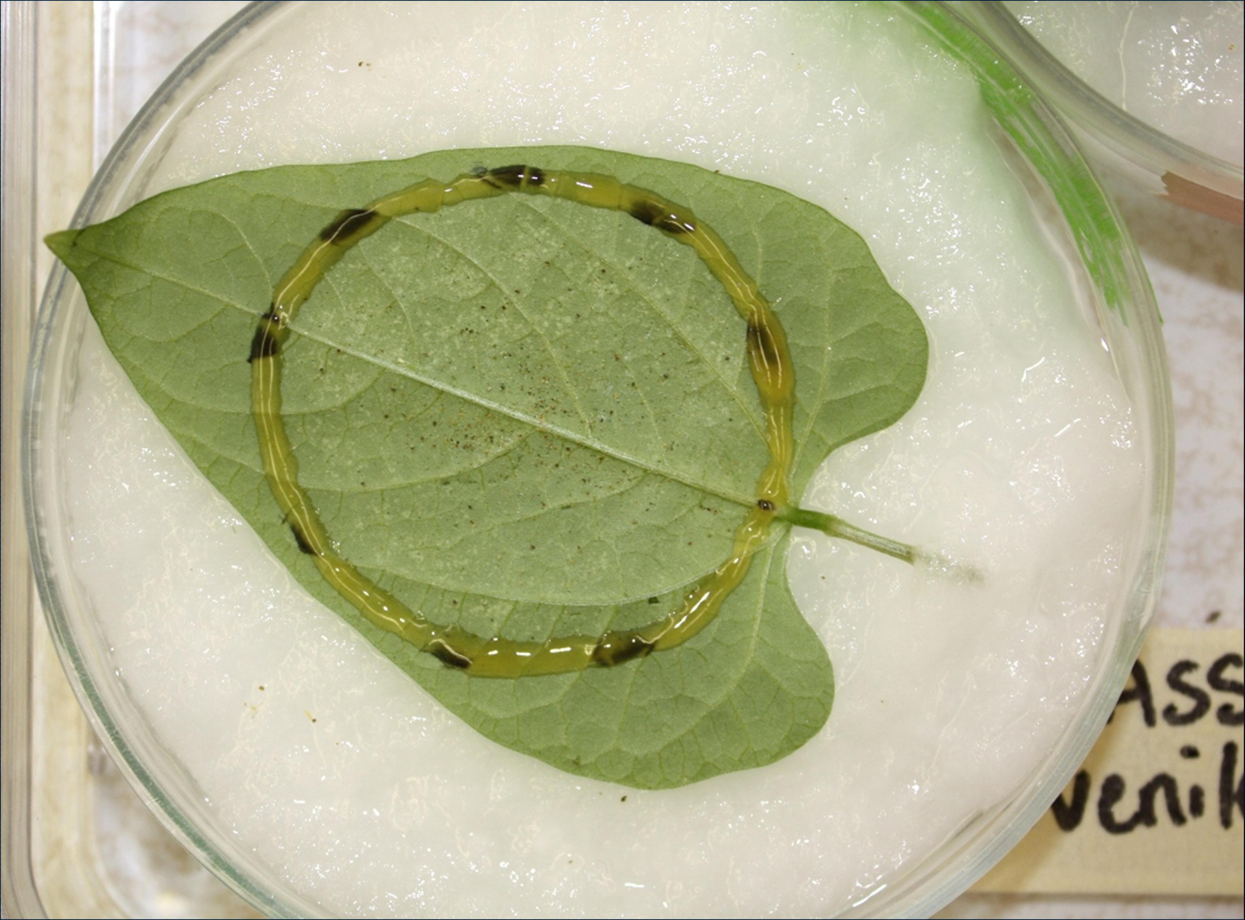

Table 1. List of pesticide compounds and rates tested on T. pyri for treatments.
 |  |  | Rate¹
Pesticide | Tradename® | % a.i. | 1× | 2×
Micronized sulfur WP | ProNatural | 92 | 4lbs | 8lbs
whey powder | Tillamook Dairy | n/a | 10lbs | 20lbs
boscalid (+pyraclostrobin) | Pristine | 25 + 13 | 12.5 oz | 25 oz
myclobutanil | Rally 40W | 40 | 4 oz | 8 oz
paraffinic oil | JMS Stylet-oil | 97.1 | 1.5 gal | 3 gal
ethylene bisdithiocarbamate (mancozeb) | Manzate | 75 | 2 lbs | 4 lbs
¹ Pesticide concentrations sprayed in laboratory bioassays were based on rates per acre per 100 gallon water volume.

