SARE RESEARCH & EDUCATION GRANT: LNE07-265

FINAL REPORT

TITLE: An Integrated Approach to Developing Nutrient Management Schemes for Container-Grown Nursery Crops

Image 2: Ectomycorrhizal root tips of oak.

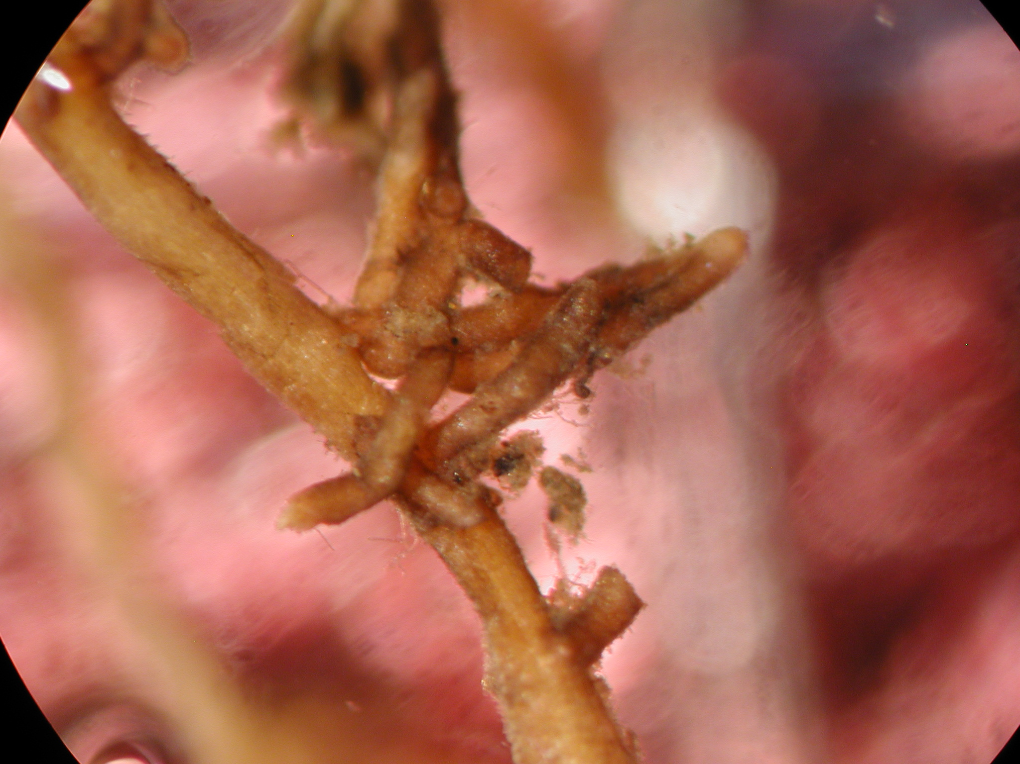
Photo Credits: Dr. John Dighton
Ectomycorrhizal root tips of oak

SARE RESEARCH & EDUCATION GRANT: LNE07-265

FINAL REPORT

TITLE: An Integrated Approach to Developing Nutrient Management Schemes for Container-Grown Nursery Crops

Image 3: Germinating spore of ericoid mycorrhiza in azelea root.

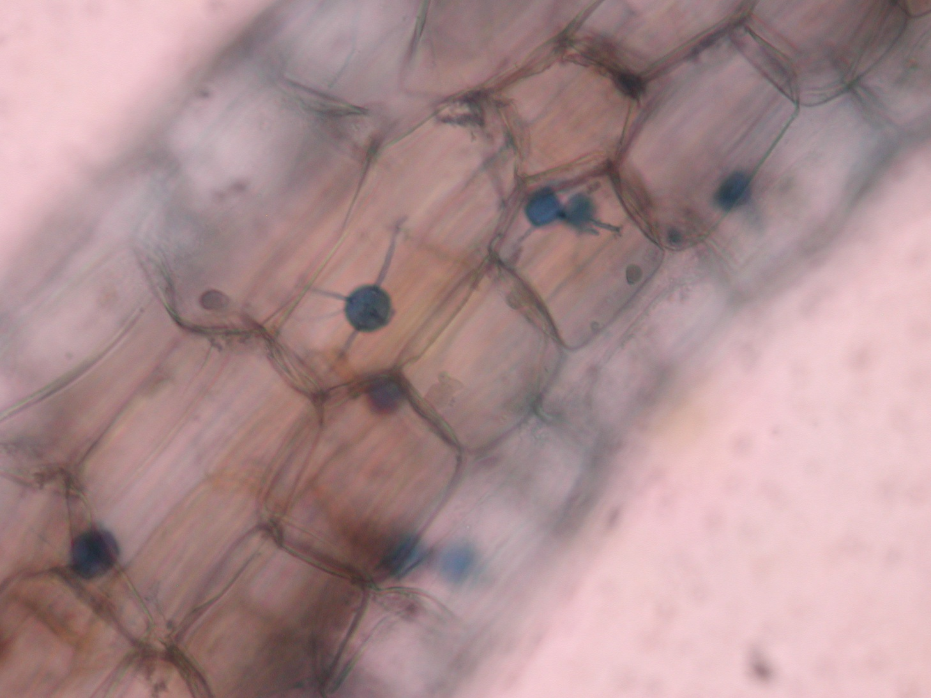
Photo Credits: Dr. John Dighton

SARE RESEARCH & EDUCATION GRANT: LNE07-265

FINAL REPORT

TITLE: An Integrated Approach to Developing Nutrient Management Schemes for Container-Grown Nursery Crops

Image 4: Arbuscule, hyphae and spore of arbuscular mycorrhiza of thuja.

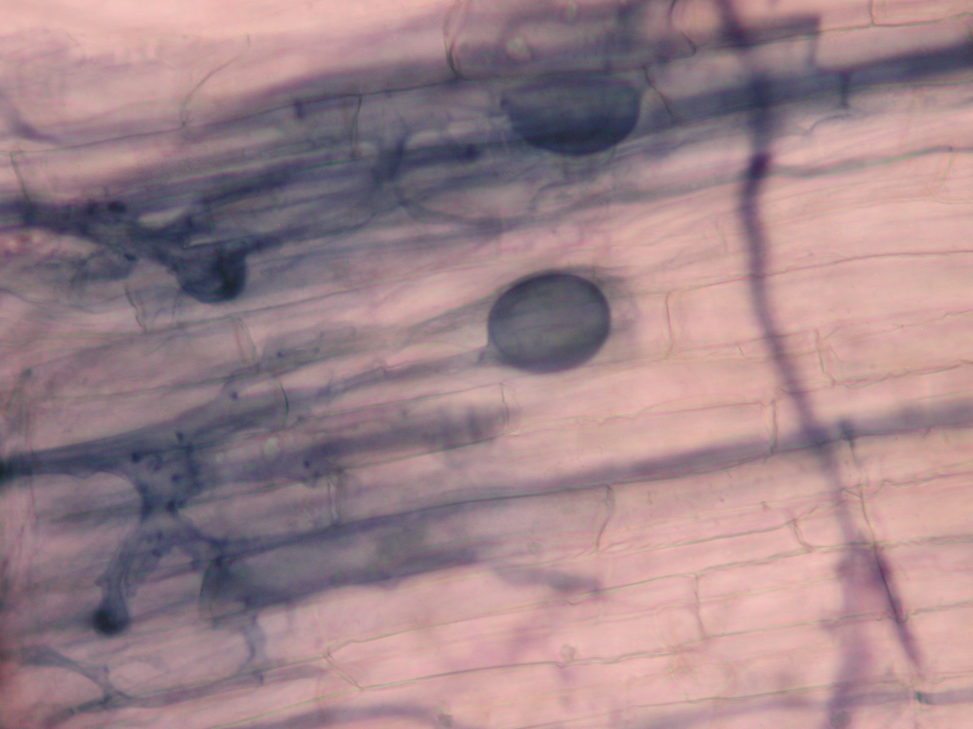
Photo Credits: Dr. John Dighton
hyphae
Arbuscules
spore

SARE RESEARCH & EDUCATION GRANT: LNE07-265

FINAL REPORT

TITLE: An Integrated Approach to Developing Nutrient Management Schemes for Container-Grown Nursery Crops

Image 5. Nursery growers, Extension Agents, and NJNLA representatives evaluating plant material (just before harvesting) of the 2007 research study at the Rutgers University Fruit and Ornamental Research and Extension Center, Cream Ridge, NJ.

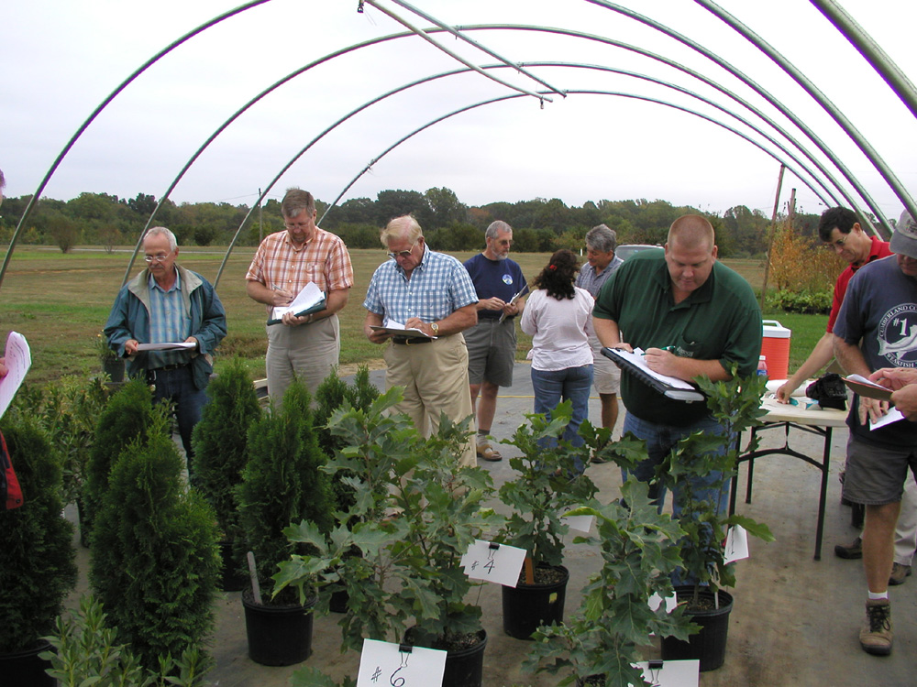

SARE RESEARCH & EDUCATION GRANT: LNE07-265

FINAL REPORT

TITLE: An Integrated Approach to Developing Nutrient Management Schemes for Container-Grown Nursery Crops

Image 6: Sharing results of the 2007 experiment during the hands-on workshop, June 25, 2008.

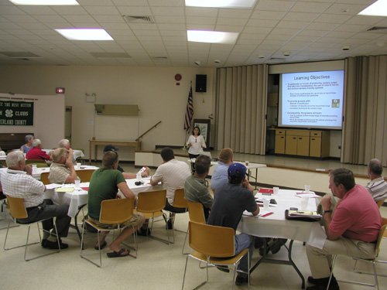

Photo Credits: Dr. John Dighton

SARE RESEARCH & EDUCATION GRANT: LNE07-265

FINAL REPORT

TITLE: An Integrated Approach to Developing Nutrient Management Schemes for Container-Grown Nursery Crops

Image 7: Dr. John Dighton demonstrating to the nursery growers on how to collect the natural mycorrhizal fungi inoculum from a natural site.

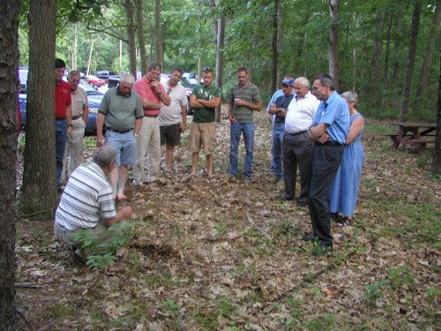
Photo Credits: Dr. Gladis Zinati

SARE RESEARCH & EDUCATION GRANT: LNE07-265

FINAL REPORT

TITLE: An Integrated Approach to Developing Nutrient Management Schemes for Container-Grown Nursery Crops

Image 8: Nursery growers examining slides, prepared by Dr. John Dighton, that show mycorrhizal spores and arbuscules from 2007 experimental study during the hands-on training workshop, June 25, 2008.

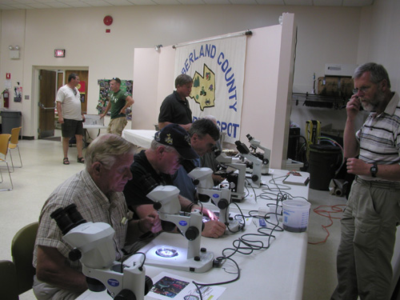
Photo Credits: Dr. Gladis Zinati

SARE RESEARCH & EDUCATION GRANT: LNE07-265

FINAL REPORT

TITLE: An Integrated Approach to Developing Nutrient Management Schemes for Container-Grown Nursery Crops

Image 9: Participated nursery giving it thumbs up for producing healthier and attractive Echinacea plants by using natural soil mycorrhizal inoculum in 2008.

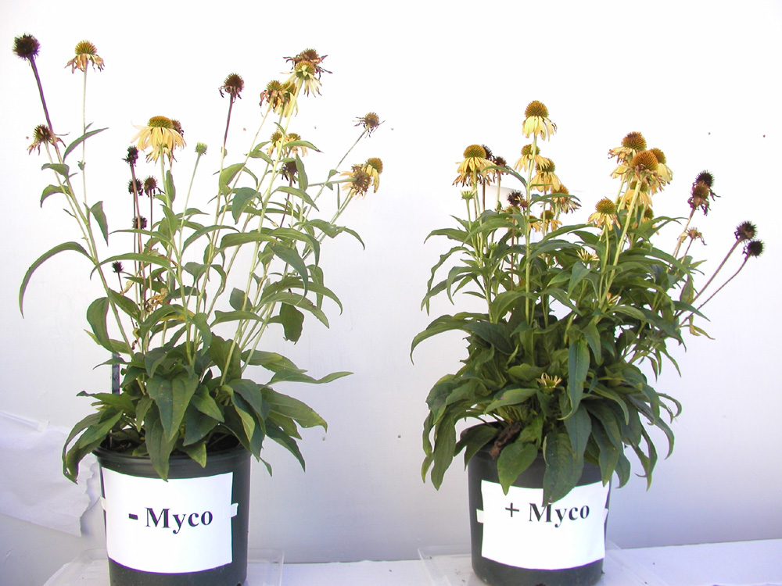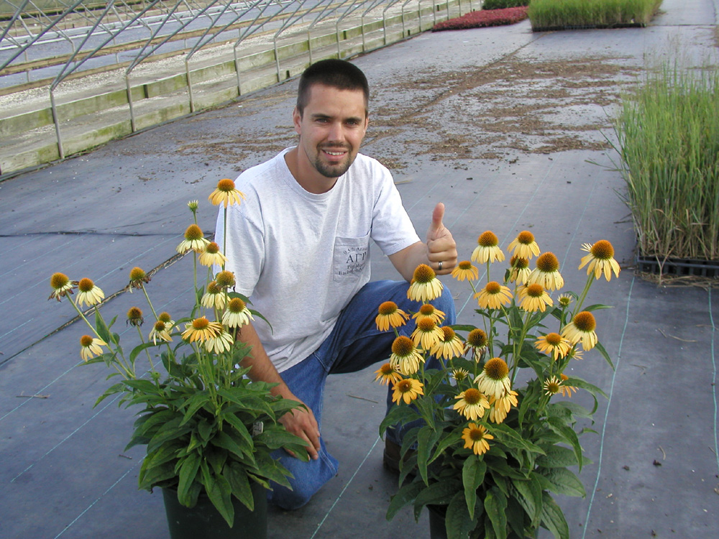
Photo Credits: Dr. Gladis Zinati
- Myco
+ Myco

SARE RESEARCH & EDUCATION GRANT: LNE07-265

FINAL REPORT

TITLE: An Integrated Approach to Developing Nutrient Management Schemes for Container-Grown Nursery Crops

Image 10: A greener and compacted azalea plant grown at nursery site by using natural soil mycorrhizal inoculum in 2008.

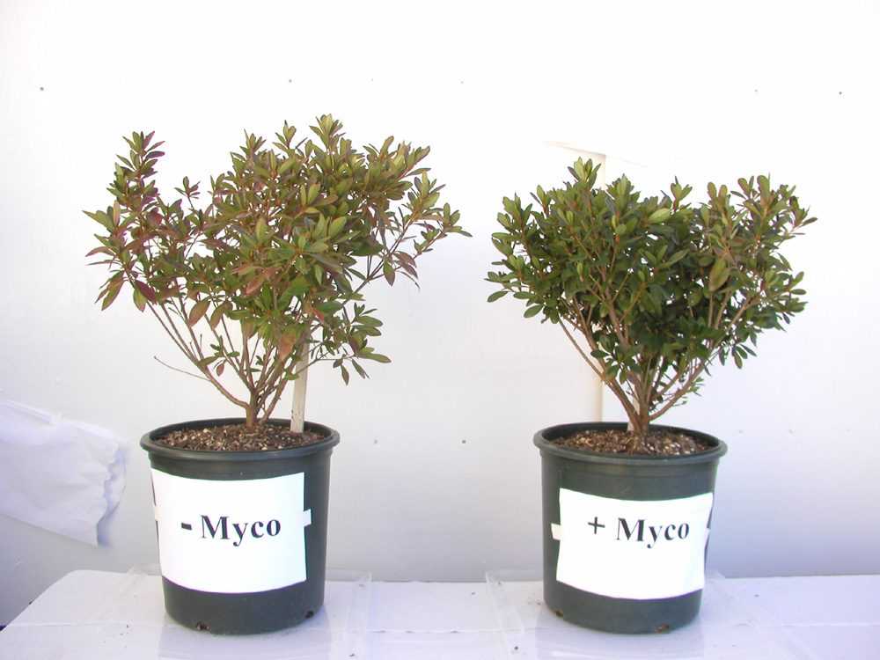
Photo Credits: Dr. Gladis Zinati

SARE RESEARCH & EDUCATION GRANT: LNE07-265

FINAL REPORT

TITLE: An Integrated Approach to Developing Nutrient Management Schemes for Container-Grown Nursery Crops

Image 11: Oakleaf Hydrangea ‘Pee Wee’ grown at nursery site by using natural soil mycorrhizal inoculum compared to non-inoculated in 2008.

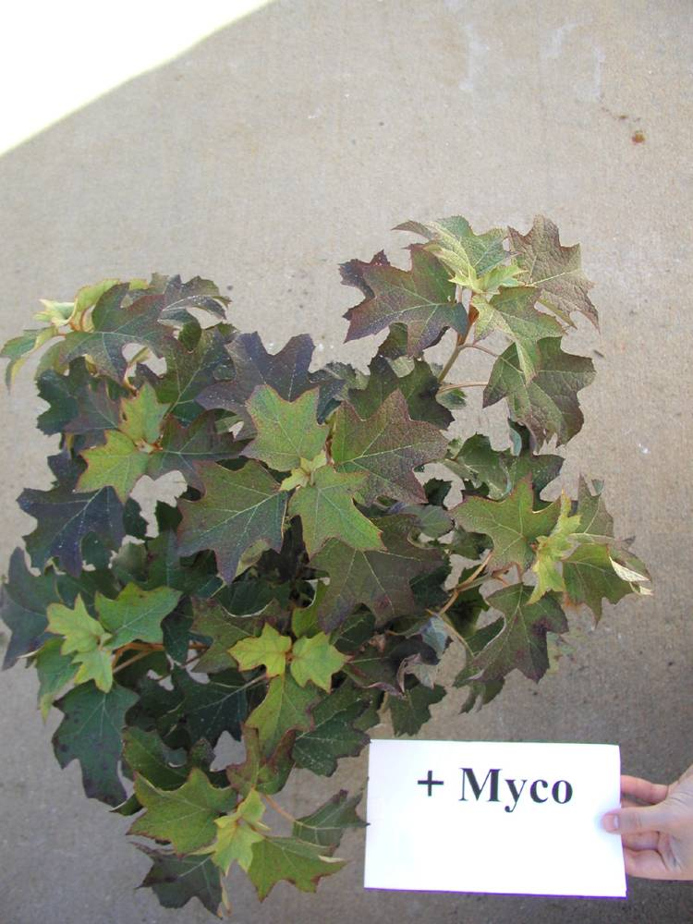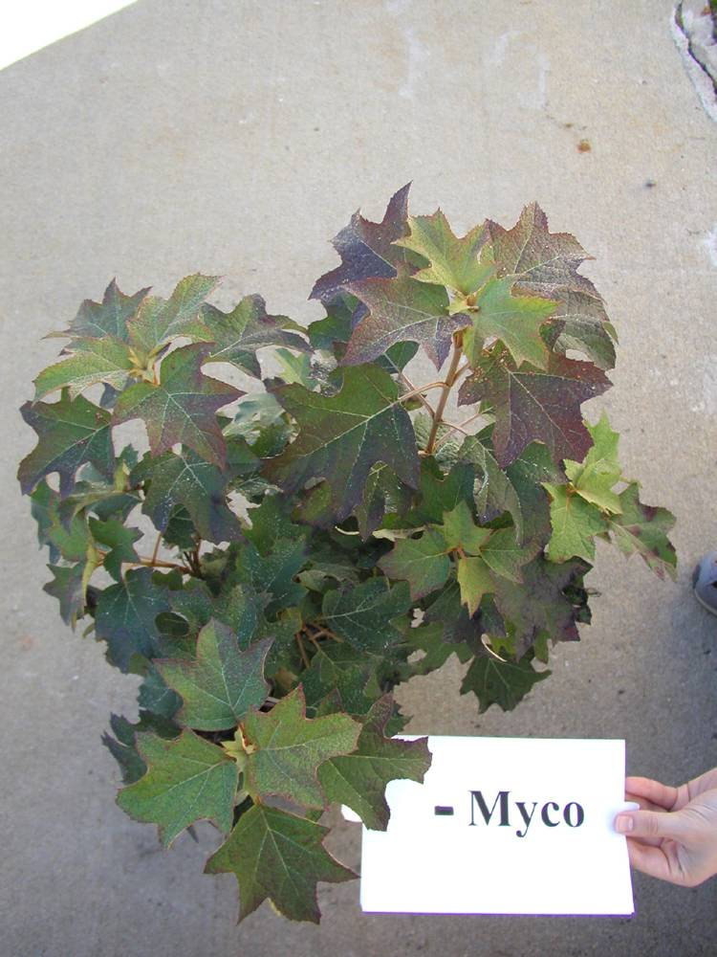
Photo Credits: Dr. Gladis Zinati

