Title Page:

Project Title
Bumble bee and honey bee pollination of cucumbers.

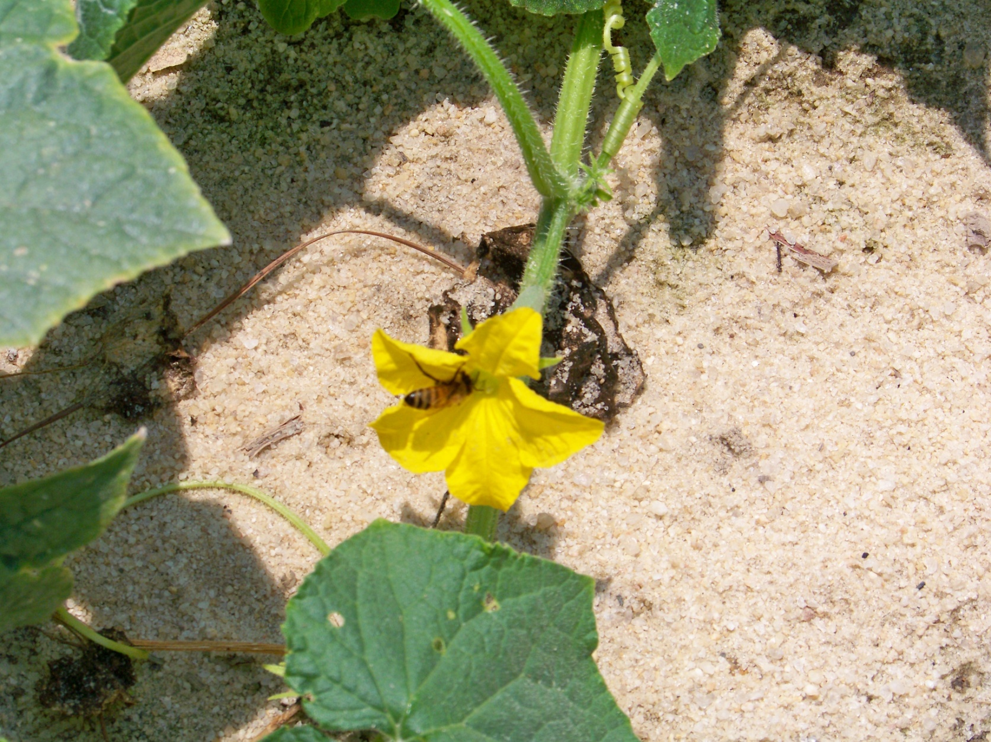

Figure 1: Honey bee pollinating a cucumber (Cucumis sativus) bloom.

Producer (Farmer or Rancher)
Clayton Rawl Farms, Inc.
Contact Person: Chris Rawl
Address: 747 Calks Ferry Road, Lexington, SC 29072
Phone Number: (803) 359-4415
E-Mail: chris@rawlfarms.com
Description of Business: Grower and shipper of fresh vegetables year round.

RAWL VEGGIES™ from CLAYTON RAWL FARMS, the freshest variety of Bell Pepper, Beets, Cilantro, Collards, Corn, Eggplant, Green Onion, Hot Pepper, Kale, Mustard, Parsley, Radish, Spinach, Squash, Turnip, Zucchini, and more.

Project Duration

Two years, 3/2011 – 8/2012

Producer (Farmer or Rancher) Organization

Clayton Rawl Farms, Inc.
Contact Person: Chris Rawl
Address: 747 Calks Ferry Road, Lexington, SC 29072
Phone Number: (803) 359-4415
E-Mail: chris@rawlfarms.com
Description of Business: Grower and shipper of fresh vegetables year round.

RAWL VEGGIES™ from CLAYTON RAWL FARMS, the freshest variety of Bell Pepper, Beets, Cilantro, Collards, Corn, Eggplant, Green Onion, Hot Pepper, Kale, Mustard, Parsley, Radish, Spinach, Squash, Turnip, Zucchini, and more.

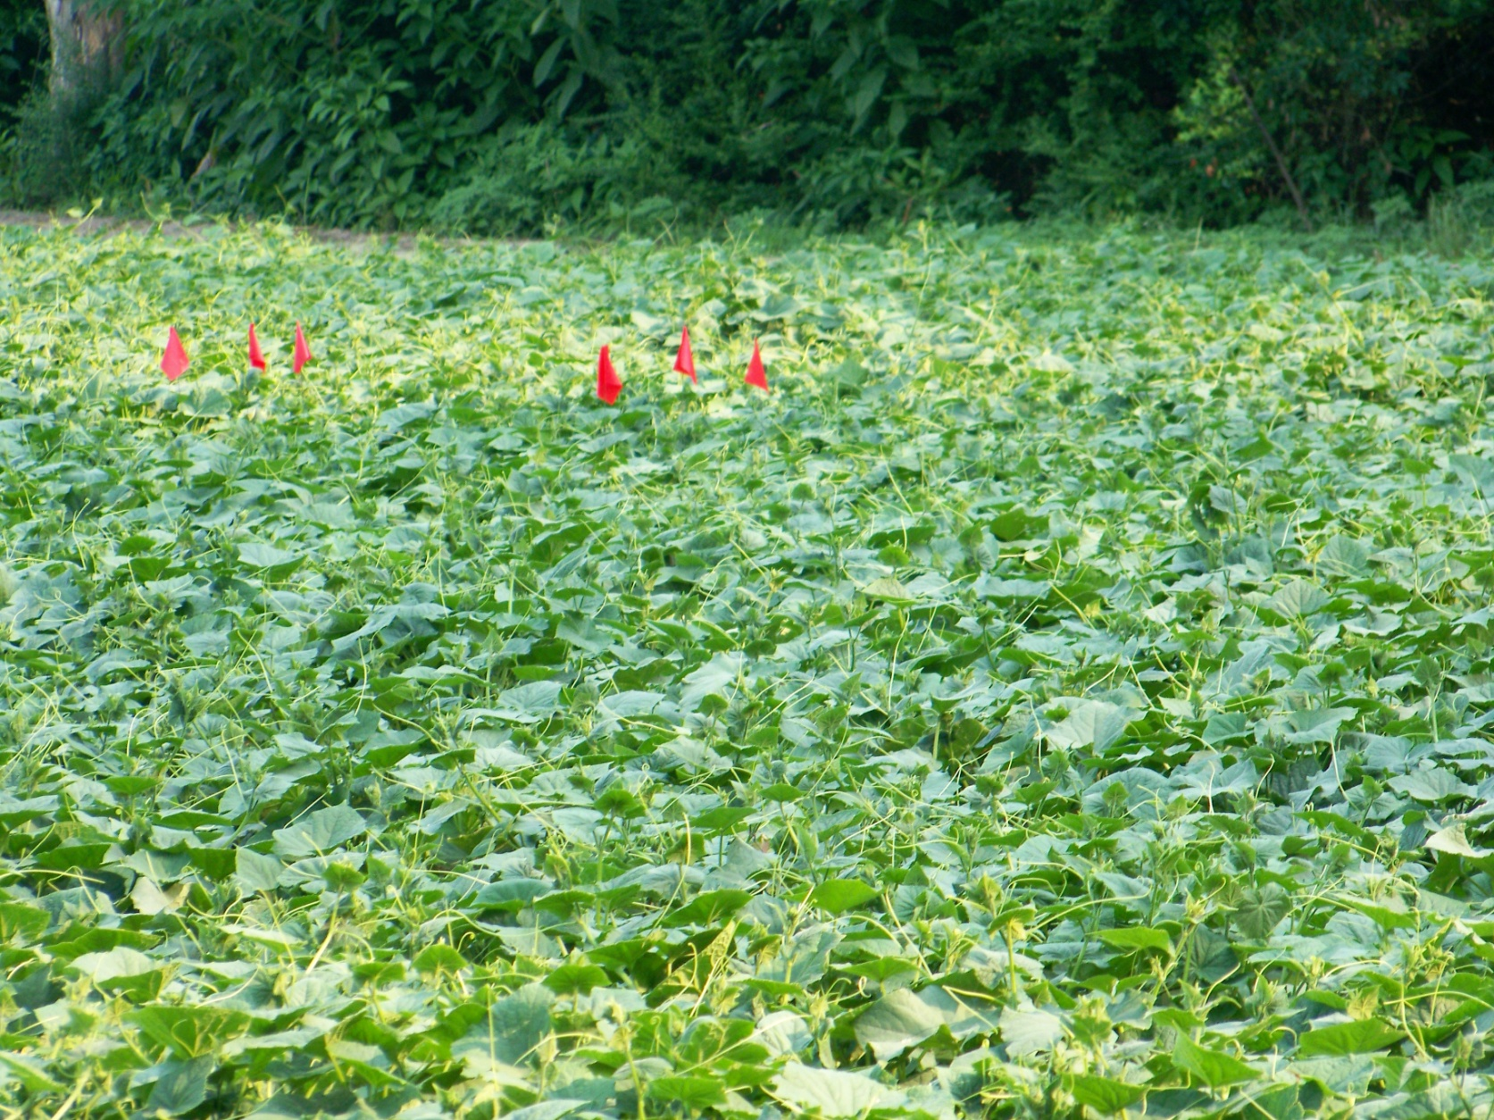
Figure 2: Upper cucumber (Cucumis sativus) “honey bee” field with red flags denoting one 10 foot test section

Body of Proposal

Statement of Problem

Wild pollinator numbers have diminished over the last 30 or so years in the Lexington, SC area and worldwide. Farmers previously relied on wild pollinators to provide a substantial amount of pollination for their crops. Honey bees have in recent years been used to pollinate crops such as squash, cucumbers, and melons due to the large number of bees per hive. Honey bee colonies may have 30,000 honey bees whereas a bumble bee nest may have only 300 bumble bees. However, honey bees do not fly in inclement weather that includes lower temperatures and wind ⁽¹⁾. Honey bees also tend to go down rows whereas bumble bees tend to go across rows or are more erratic in their foraging ⁽¹⁾. Farmers are becoming more interested in having alternative pollinators to ensure proper pollination for their crops.

This research will assess the value of bumble bees (Bombus impatiens), in addition to honey bees, for pollination of cucumbers (Cucumis sativus) in the Lexington, SC area. We will be comparing fields pollinated with introduced honey bee colonies to fields with introduced bumble bee colonies. We know that in both cases there will be pollination from extraneous pollinators that we did not introduce, but we assume that it will be either negligible or equal and our differences will come from differential pollination efficiencies of our introduced pollinators.

- Mader, Spivak, Evans, “ Managing Alternative Pollinators, A Handbook for Beekeepers, Growers, and Conservationists,” SARE / NARES, February, 2010 ISBN 978-1-933395-20-3
Statement of Proposed Solution
What is your answer to the problem? No more than 500 words (fewer is OK).

It is proposed that one 2-5 acre field be pollinated with three honey bee colonies per acre (approximately 20,000 – 30,000 honey bees per colony), and one 2-5 acre field be pollinated by four bumble bee colonies per hectare (one hectare = 2.4711 acres). The yields from the two fields will be assessed to determine the difference between honey bee pollination and bumble bee pollination. Previously, 1.5 honey bee colonies were utilized rather than three honey bee colonies. Recent reports indicate the production value of 3 honey bee colonies per acre rather than one. (http://www.extento.hawaii.edu/kbase/reports/cucumber_prod.htm). The same cucumber variety will be planted within days of each other in the early May time frame, in anticipation of pollination and picking the end of May to first part of June. We will be assessing the use of bumble bees as compared to honey bees, and a doubling of honey bee colonies.

Approach and Methods
How will you show or demonstrate that your answer or solution works? What will you measure? No more than 500 words (fewer is OK).

Cucumbers (Cucumis sativus): Honey bee hives and bumble bee colonies will be moved into the field when there is 15-20% bloom ⁽²⁾. Pollination will continue for about a week prior to harvesting. Flowers pollinated less than two hours prior to overhead irrigation fail to produce fruit if water enters the corolla. In addition, it will be determined the length of time that a bumble bee nest is strong enough to provide adequate pollination services, i.e. how many crops. Bombus impatiens recommendations indicate they should last approximately 8 weeks.

In 2- 5 acre fields (this is the minimum size field that is economically viable due to the size of the farmer’s equipment):

Honey bee colonies containing 20,000-30,000 bees will be placed in groups of four colonies around the edges of the field in quantities of 3 colonies per acre rather than the historic 1.5 colonies per acre.

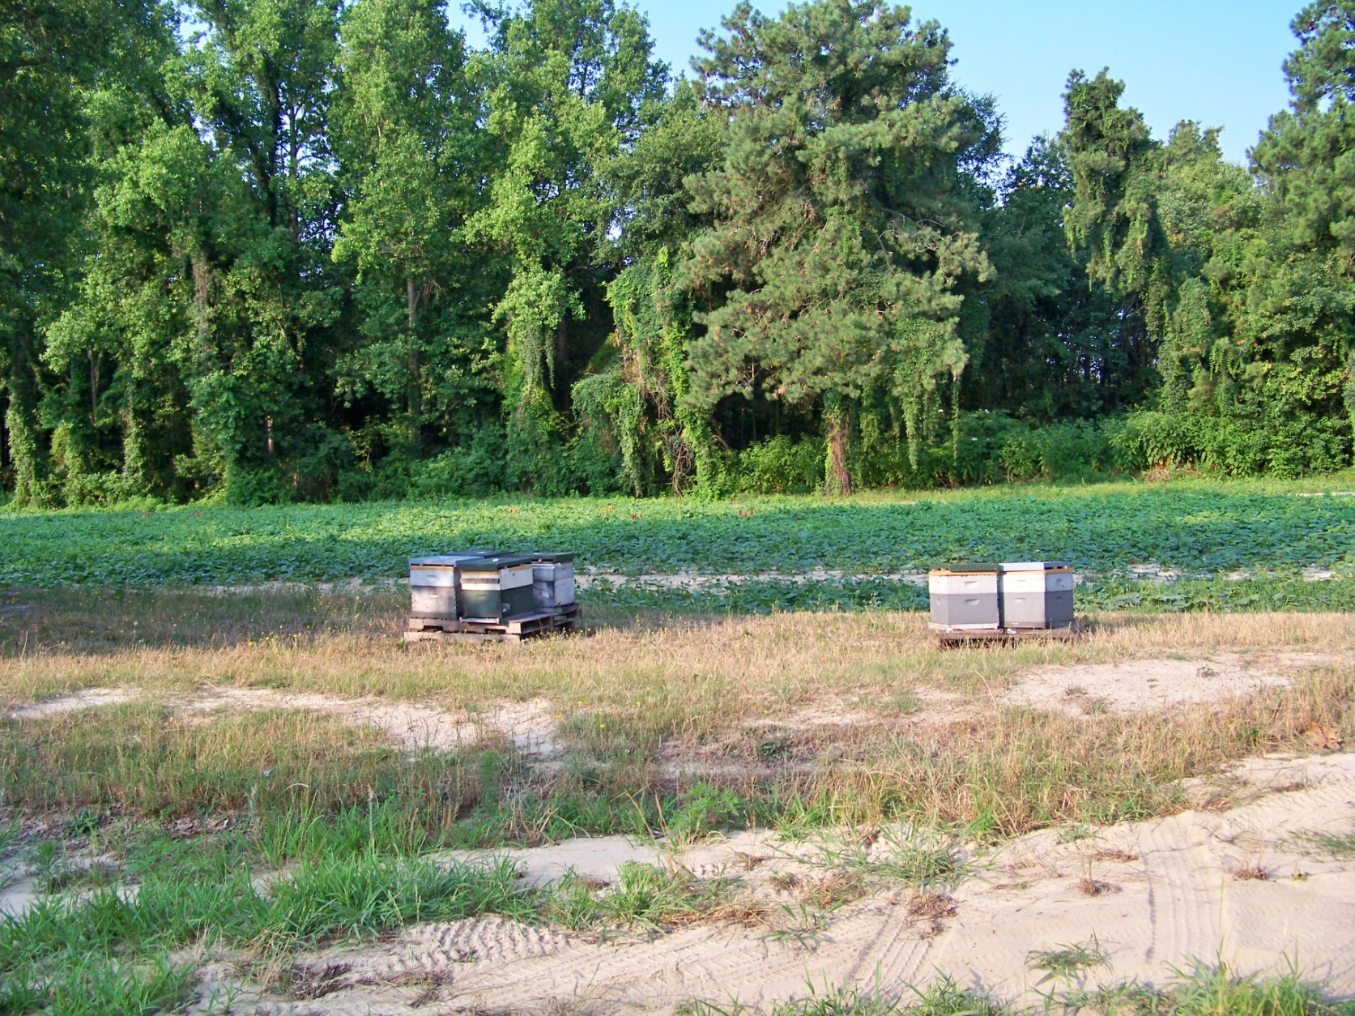
Figure 3: Six honey bee colonies placed around the perimeter of the “honey bee” cucumber field

Bumble bees will be placed in cool, shaded locations around field #2 at a density of 4 bumble bee colonies per 2.5 acres. The two fields will be located approximately 2-3 miles apart. Three subplots of similar size will be established in each of the fields.

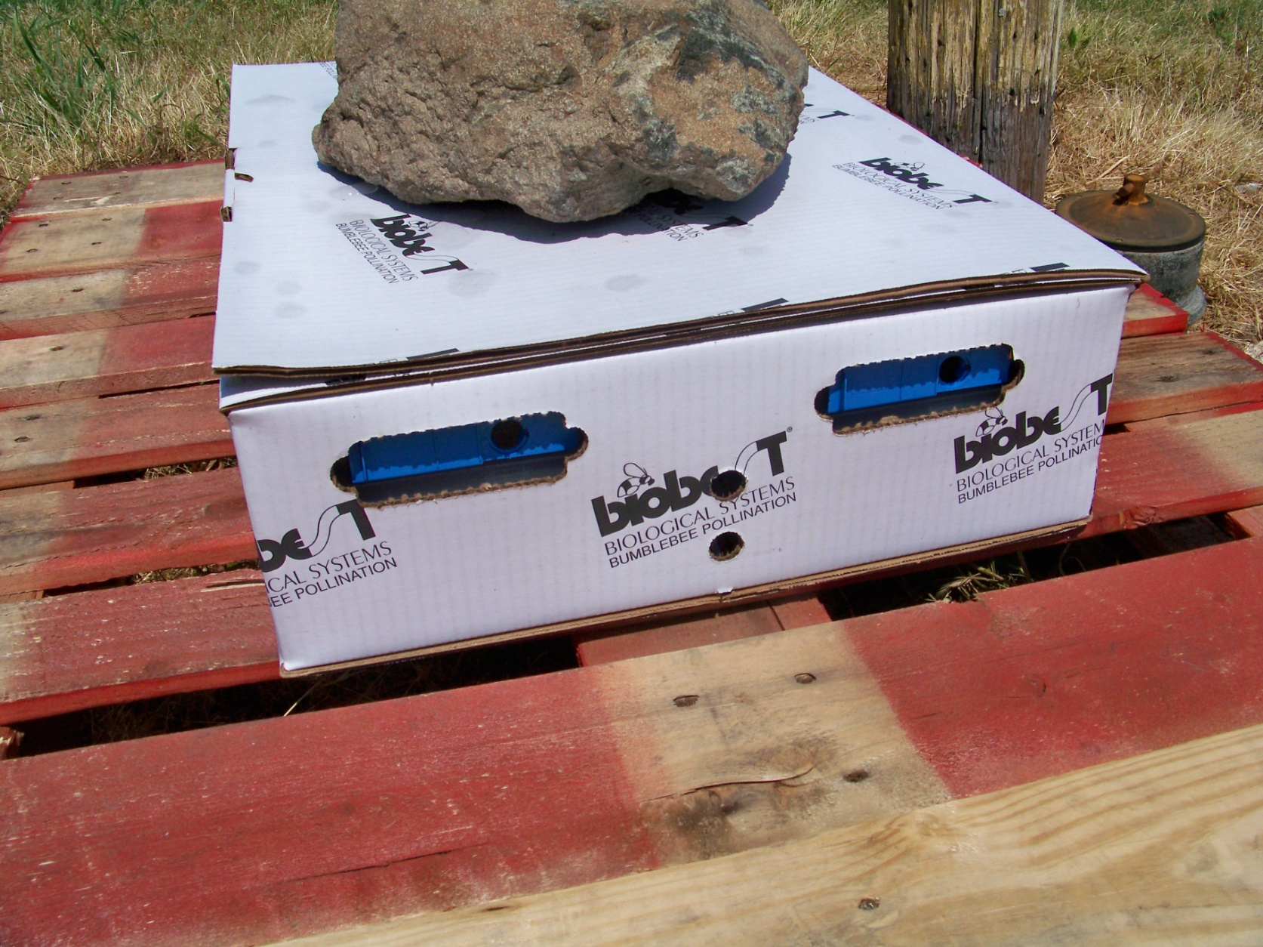
Figure 4: Four bumble bee colonies placed around the perimeter of the “bumble bee” field

The bee visits and yields from the subplots in each field will be recorded. One person will be hired to count the honey bee visits and bumble bee visits for each field, for a total of two people for two fields over the crop blooming period. Ten flowers will be watched for 10 minutes and the number of honey bees and bumble bees visiting the blooms will be counted. This will be repeated with different flowers for a total of 30 minutes of counting per field. Thirty minutes of counting will occur each day for one week after the honey bees and bumble bees are moved into the field. The following table will be consulted ⁽²⁾ to determine adequate bloom bee visits for cucumbers ( this table was generated in Michigan and may be different for the Lexington, SC area, i.e. bees typically do not visit booms in the middle of the day due to the heat but they still need approximately 10-15 bee visits per bloom per day) :

Time of count Min # bees/30 flowers/30 minutes
8:00-9:00 1
9:00-10:00 3
10:00-11:00 9
11:00-12:00 13
12:00-1:00 16
1:00-2:00 13
2:00-3:00 11
3:00-4:00 7
4:00-5:00 5
Table 1: adequate bloom bee visits for cucumbers

The cucumbers from each plot will be counted, weighed, and graded based on current grading standards. A comparison of the mean yields and their variances from the two fields will be conducted. Based on the statistical analysis, a financial analysis looking at the yields with respect to the variable cost will be conducted to determine the payback for just honey bees, and just bumble bees.

- Joe M. Graham, “ The Hive and the Honey Bee,’ 1992, ISBN 0-915698-09-9, pp 1060-1062

Timetable
When will you do the parts of your project? Give us a timetable and the steps you will take to complete your project. No more than 250 words (fewer is OK).

The bumble bee colonies will be ordered in March / 2011or as soon as the grant is awarded. The pollination field work and counting of the three subplots in each field will be conducted in May thru August of 2011. The analysis and write up will occur September, 2011 thru February, 2012. Outreach will occur March thru July, 2012.

Outreach Plan
Where and how will you tell others (producers, extension and/or researchers) about your results? What is your outreach plan? Outreach plans may include workshops, field days, fact sheets, articles, presentations at agriculture meetings and more. No more than 250 words (fewer is OK).

The results will be presented at the South Carolina or other South Eastern state beekeeper’s meetings in March, 2012 thru July, 2012. The results report will also be used by Clemson Extension. The results will be disseminated through Clemson Extension production meetings and regional educational conferences. Opportunity exists to present the results as posters for the 2011 Southeastern Fruit and Vegetable Expo (Dec 2011) and the Southeastern Fruit and Vegetable Conference (Jan 2012).

Cooperators
Please list any major cooperators and who they work for—or if they are a farmer--who has agreed to participate in your project. Briefly explain the role, in the project, of each cooperator. No more than 250 words per cooperator (fewer is OK). Do not list more than six cooperators

Chris Rawl: Grower / Farmer located in Lexington, SC. chris@rawlfarms.com Chris will provide the vegetable fields, manage the labor counting the bees on the blooms, counting and grading the crop.

Wesley Boomer, 403 Edisto Lake Road, Wagener, SC 29164, 803-564-6487, wesgardens@aol.com , will provide the honey bees. Wesley is a Journeyman Beekeeper. He will assist with the counting and grading of the crop. In addition, he will help with outreach.

David MacFawn, 205 Ridgecreek Drive, Lexington, SC 29072, 803-957-8897, dmacfawn@aol.com , will provide overall coordination, and outreach. He will also provide information on where to get the bumble bees. David is a Master Craftsman Beekeeper, has a BS Electrical Engineering and a MBA with concentrations in finance and operations research. He will also assist with the counting and grading of the crop, and do the financial analysis.

Clemson extension: Outreach. Provide guidance on scientific procedure and report write-up.
J. Powell Smith, Ph. D.
Extension Associate - Vegetable Crops and Small Fruits
CUCES-Lexington County
605 W. Main St. Ste. 109
Lexington, SC 29072 USA
Phone(s): Off: 803-359-8515 ext: 122; mobile: 803-603-2618
FAX: 803-359-4245

Budget
Make sure you understand what a SARE Producer Grant will and will not pay for (see page 3). Make sure that your budget is at least as detailed as the sample budget provided. For example, if you request funds for labor, you must show the number of hours and the amount to be paid per hour, who is being paid and what they will be doing. Make sure that you value farmer labor (yours or hired) for what it is worth. Make sure you’re complete and thorough in your budget justification.

Budgetary Details
Completely explain all budgetary information in the budget justification. See, sample budget page for budgetary detail required.

BUDGET CATEGORY | FUNDS REQUESTED
PERSONNEL (LABOR)
Chris Rawl (farmer) labor management, bumble bee ordering, counting, grading and harvesting, outreach, 100 hrs @ $20 hr | $2,000.00
Wesley Boomer ( Journeyman Beekeeper, provide honey bees , research write-up, outreach) 100 hrs @ $20/hour | $2,000.00
David MacFawn ( overall coordination, research write-up, Master Craftsman beekeeper, bumble bees ordering information, analysis, outreach) 100 hrs @ $20/hour  2 bee & cucumber counters over bloom period (3 hrs/day bee counting* 5 days)+(2 days*8hours/day cucumber counting*3days) * $10/hour | $ 2,000.00  $ 630.00
Personnel (labor): SUB-TOTAL | $6630.00
OPERATING AND SUPPLIES
Expense Borne by Chris Rawl, Honey bee Colony rental 5 acres total * 3 hives/acre * $ 50 /hive = $750 | $ 000.00
Expense Borne by Chris Rawl, Bumble bee purchase 5 acres total * 4 colonies/2.5 acres * $370/4 colonies= $740 ( $120 shipping costs/4 pack) | $ 000.00
Siding to make covers for bumble bee shipping containers | $100.00
Concrete blocks to place bumble bees nests on (16*$1) | $16.00
 | $
 | $
 | $
Operating and Supplies: SUB-TOTAL | $116.00
TRAVEL
12 trips to fields to check on status ( 30 miles * $0.44/mile) | $158.400
2 trips to Clemson (360 miles * $0.44/mile) | $ 316.80
2 trips to State Bee Meetings for Outreach (500 miles * $0.44/mile)  Motel expense 4 nights @ $80/night | $440.00  $320.00
Travel: SUB-TOTAL | $ 1235.20
OUTREACH
See travel | $
 | $
 | $
Outreach: SUB-TOTAL | $
MISCELLANEOUS
Statistical analysis package | $ 400.00
Telephone calls (10 long distance calls@$5/call) | $ 50.00
Miscellaneous: SUB-TOTAL | $ 450.00
PROJECT TOTAL | $8431.20

Pollination Counting Worksheet:
Day/Date: _____________________________________
Time: ________________________________________

Ten flowers will be watched for 10 minutes and the number of honey bees and bumble bees visiting the blooms will be counted. This is repeated with different flowers for a total of 30 minutes of counting. A total of three countings, for thirty minutes total of counting, will occur each day for one week after the honey bees and bumble bees are moved into the field.

First 10 minute period on ten flowers:
Number of honey bees: __________
Number of bumble bees: ___________

Second 10 minute period on ten flowers:
Number of honey bees: __________
Number of bumble bees: ___________

Third 10 minute period on ten flowers:
Number of honey bees: __________
Number of bumble bees: ___________

Total number of honey bees: _______
Total number of bumble bees: ___________
Total number of honey bees and bumble bees: ____________ (use to look at below table to determine if you have adequate pollination of this field)

The following table is consulted ⁽²⁾ to determine adequate bloom bee visits for cucumbers (need 10-15 visits per bloom per day min):

Time of count Min # bees/30 flowers/30 minutes
8:00-9:00 1
9:00-10:00 3
10:00-11:00 9
11:00-12:00 13
12:00-1:00 16
1:00-2:00 13
2:00-3:00 11
3:00-4:00 7
4:00-5:00 5
Table 1: adequate bloom bee visits for cucumbers

Results

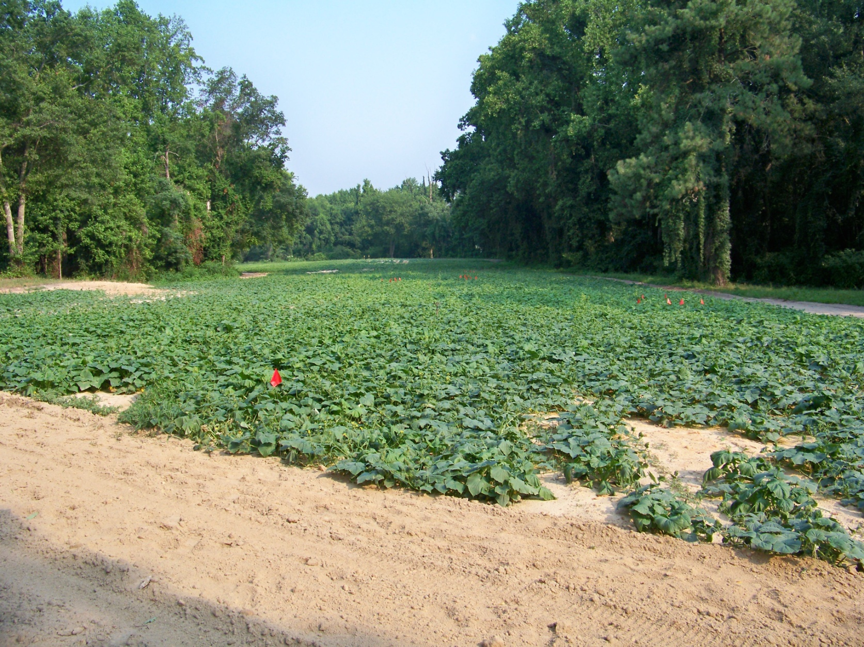
Figure 5: The upper “honey bee” cucumber field with the red flags denoting the ten foot test sections

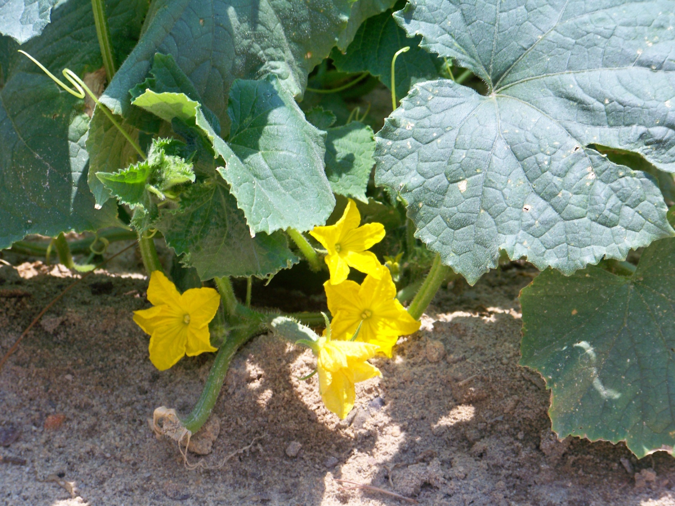
Figure 6: Cucumber blooms on a cucumber plant in the upper “honey bee” field

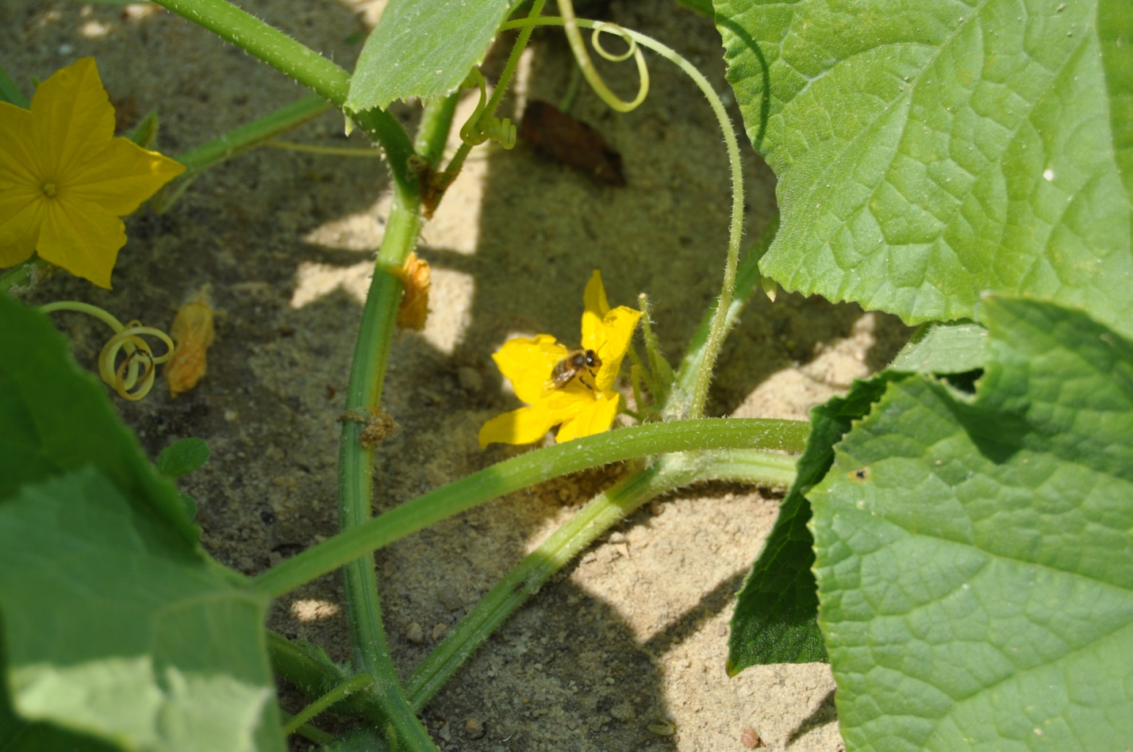
Figure 7: A honey bee pollinating a cucumber bloom

Two, two acre cucumber fields (Cucumis sativus) were planted the first week of May, 2011. We planted the two fields as far apart as we could but this still resulted in the fields being 1.5 miles of each other on this farm. Honey bees typically travel a 2-3 mile area and bumble bees forage in a ¼ to ½ mile range. We were concerned about the honey bee isolation of the bumble bee field and found there were other beekeepers with honey bee colonies within 2-3 miles of the bumble bee field. In addition, we had eight honey bee colonies about 1.5 miles in another field for pollination of other crops. However, this was as far apart the fields could be planted for isolation as possible on this grower’s farm.

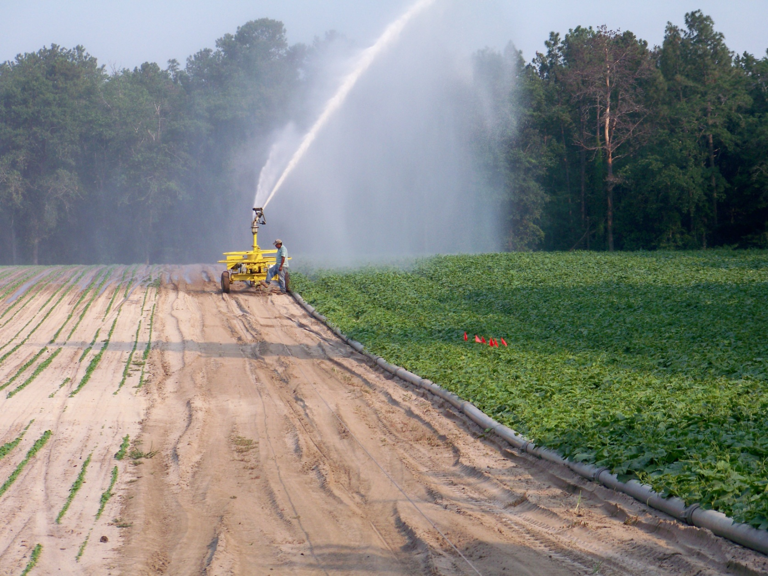
Figure 8: Watering the lower “bumble bee” cucumber field

The main honeybee nectar / honey flow was over for approximately two weeks prior to the onset of cucumber blooming. There is typically a honey bee nectar dearth beginning mid June in the Lexington, SC area with the cucumbers, in this case, being one of the few nectar sources available. Hence, we had excellent honey bee pollination of the cucumber fields; the cucumbers were one of the main plants blooming in the area.

The bee counts are included in the attached excel spreadsheet and show (using an Excel dual t test) the honey bee visits between the fields are not statistically independent (α=0.05 level). The number of bumble bee visits was insignificant and did not meet the following table bee visit requirements.

The following table is consulted ⁽²⁾ to determine adequate bloom bee visits for cucumbers (need 10-15 visits per bloom per day min):

Time of count Min # bees/30 flowers/30 minutes
8:00-9:00 1
9:00-10:00 3
10:00-11:00 9
11:00-12:00 13
12:00-1:00 16
1:00-2:00 13
2:00-3:00 11
3:00-4:00 7
4:00-5:00 5
Table 1: adequate bloom bee visits for cucumbers

If it was not for the honey bee visits and extraneous other pollinators, the cucumber crop in the bumble bee field would have had insufficient pollination due to the extremely low number of bumble bee visits. There was an increase in the number of visits in the honey bee field due to six honey bee colonies being placed on the perimeter of the honey bee cucumber field; however, when the honey bee visits were compared between the two cucumber fields the results were statistically insignificant (α=0.05 level). As recommended by the bumble bee supplier, four bumble bee colonies were placed on the perimeter of the bumble bee field.

Feral bee counting occurred prior to placing the bumble bee colonies and honey bee colonies on the field perimeter:

Monday June 5, 2011
upper honey bee field In 3- 10' plots counted :
09:45-10:01 38 honeybees in 16 minute period observed - 2.4 bees per minute

lower bumble bee field - down road on right next to trees
10:09- 10:19 - 10 minutes - 39 honeybees - 3.9 bees per minute

June 7, 2011
Upper honey bee field back in the woods:
12:00-12:11 14 bee visits in 11 minutes = 1.27 bee visits per minute

Lower bumble bee field down the road:
12:22-12:27 21 bee visits in 7 minutes = 3.0 bee visits per minute.

These were all honey bee visits and no bumble bee visits. In the lower field we did notice some alternative unidentified pollinators. This feral bee visit data indicated there were significant honey bees in the area.

Six honey bee colonies were moved into the “honey bee” field on Thursday, June 9, 2011. Four bumble bee colonies were placed in the bumble bee field on Tuesday evening, June 7, 2011. Bee counting started on Friday, June 10, 2011 and continued on the following days:

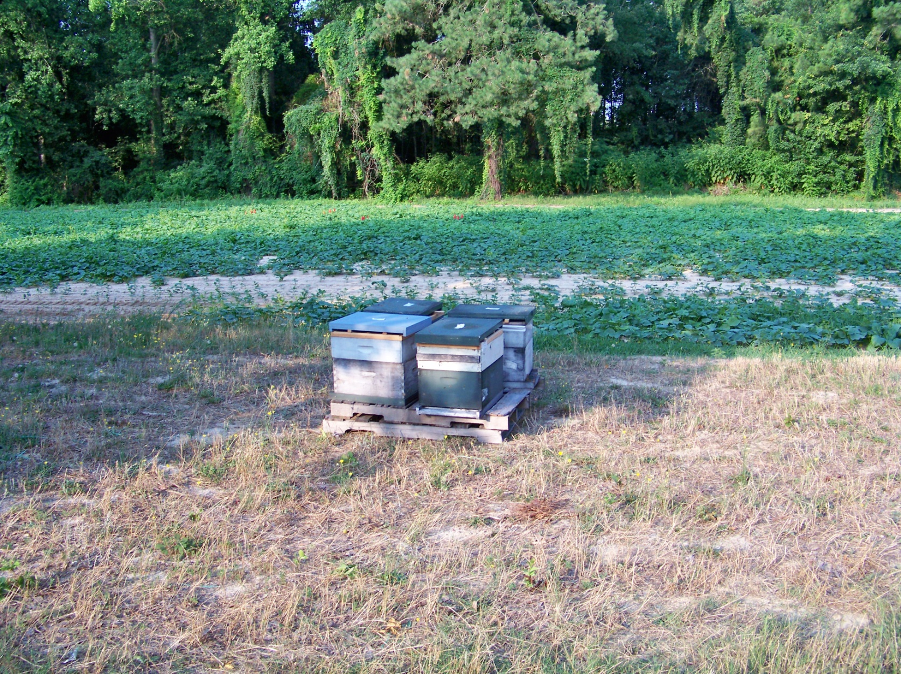
Figure 9: Honey bee colonies in the upper “honey bee” cucumber field

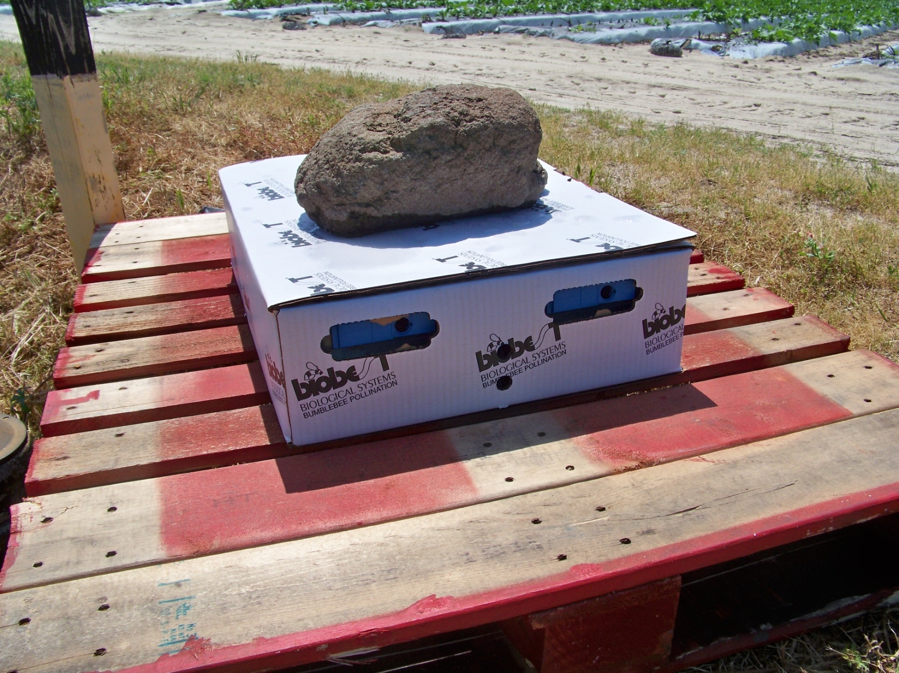
Figure 10: A bumble bee colony four pack

Bumble bee and honey bee counting occurred after the four bumble bee colonies and six honey bee colonies were placed on the respective fields’ perimeter. The bee counting was done after the four ten foot sections were flagged in each of the cucumber fields within the same four ten foot sections that were picked.

David MacFawn
Bee Counting
Friday June 10, 2011
Sunday June 12, 2011
Monday June 13, 2011
Wednesday June 15, 2011

Wes Boomer
Bee counting
Saturday June 11, 2011
Tuesday June 14, 2011
Thursday June 16, 2011
Friday June 17, 2011
Saturday June 18, 2011

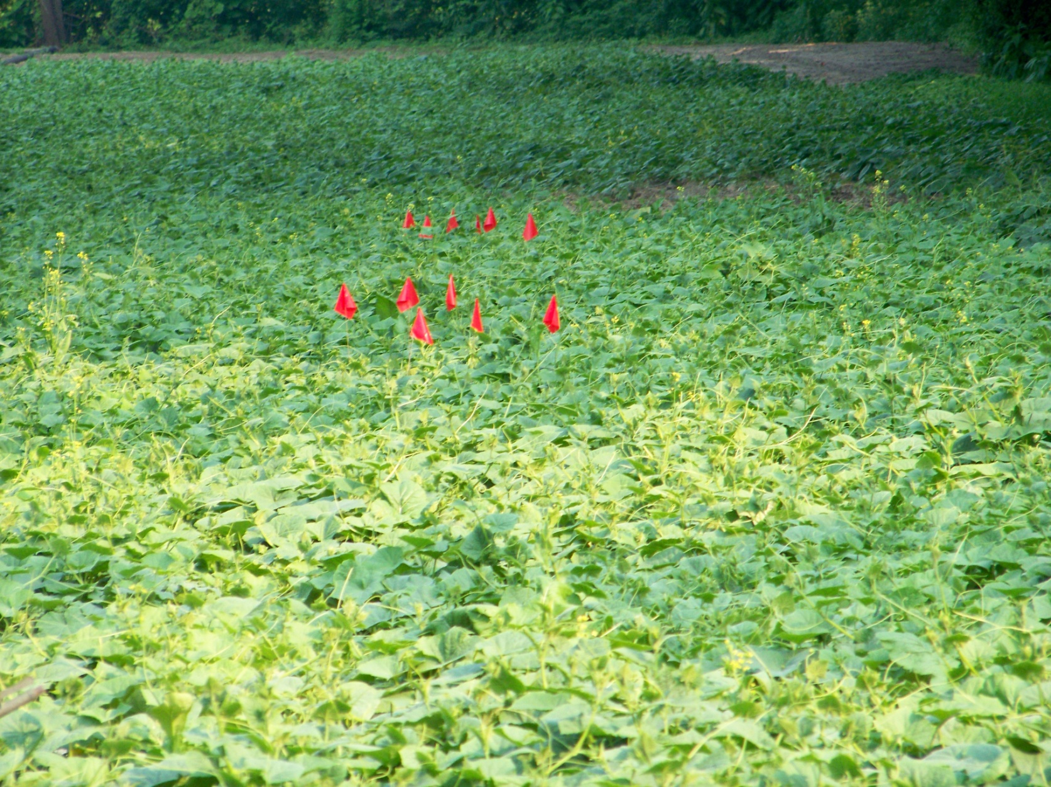
Figure 11: Red flags marking the ten foot test sections in the upper “honey bee” field.

Cucumber picking started on June 20, 2011 and continued for two pickings per week until June 30, 2011.

Bee Counting Results

There were insignificant number bumble bee visits ( zero to one visit per counting of the four 10 foot sections) in the bumble bee cucumber field when Table 1: adequate bloom bee visits for cucumbers table was consulted. The number of honey bee visits between both fields, while numerically quite different, was not statistically different using a paired t test at the α=0.05 level. Using bumble bees (Bombus impatiens) for pollination of cucumbers in the Lexington, SC area in an open field did not work during the middle of June. There were not enough bumble bees interested in the cucumber blooms in an open field to provide adequate cucumber fruit pollination. The bumble bees were going elsewhere. The bumble bee colonies lasted about one cucumber bloom period.

Cucumber Yield Analysis

Honey Bee vs. Bumble Bee Pollination of Cucumbers
Clayton Rawl Farms – Summer 2011
Powell Smith, Clemson Extension Service

Four 10-foot subplots were randomly selected from different rows in two cucumber fields; one with honey bee hives and another with bumble bee colonies. Plots were harvested twice weekly for two weeks (20 – 30 Jun). Cucumbers were graded into Fancy and No. 1 and pollination culls; numbers in each category and weights of each category were recorded.

Table 1. Numbers and marketable yields of cucumbers from honey bee plots vs. bumble bee plots over four harvest dates.

Harvest date | Bumble bee plots [#/wt (lb)]* | Honey bee plots [#/wt (lb)]*
20 Jun 11 | 34/23.7 | 16/7.3
23 Jun 11 | 9/4.2 | 6/3.4
27 Jun 11 | 17/8.7 | 11/6.5
30 Jun 11 | 11/6.4 | 8/4.3
*Average of four 10-foot subplots

Yields and numbers compared using paired t-test @ α=0.05; no significant differences in yield or number, number ρ=0.13, yield ρ=0.27.

Table 2. Numbers and weight of pollination culls from honey bee plots vs. bumble bee plots over four harvest dates.

Harvest date | Bumble bee plots [#/wt (lb)]* | Honey bee plots [#/wt (lb)]*
20 Jun 11 | 5/3.3 | 2/0.8
23 Jun 11 | 3/1.4 | 3/1.1
27 Jun 11 | 5/2.0 | 2/0.8
30 Jun 11 | 4/1.4 | 3/1.5
*Average of four 10-foot subplots

Yields and numbers compared using paired t-test @ α=0.05; no significant differences in yield or number, number ρ=0.10, yield ρ=0.18

Table 3. Comparison of pollination cull percentages from honey bee and bumble bee cucumber plots over all harvest dates.

 | Honey bee | Bumble bee
%-pollination culls | 21.3 | 21.1

These data are not analyzed, but I would not expect any difference. To analyze, you would transform to arc sine square roots, but I felt it unnecessary. Obviously, since bumble bee sightings were so few, other pollinators were doing the job. The outcome of this study shows that there were no significant differences (α=0.05) in either marketable yield or number of cucumbers nor yield or number of culls (due to pollination). Also, although unanalyzed, the percentage of pollination culls was almost identical when averaged over all harvest dates.

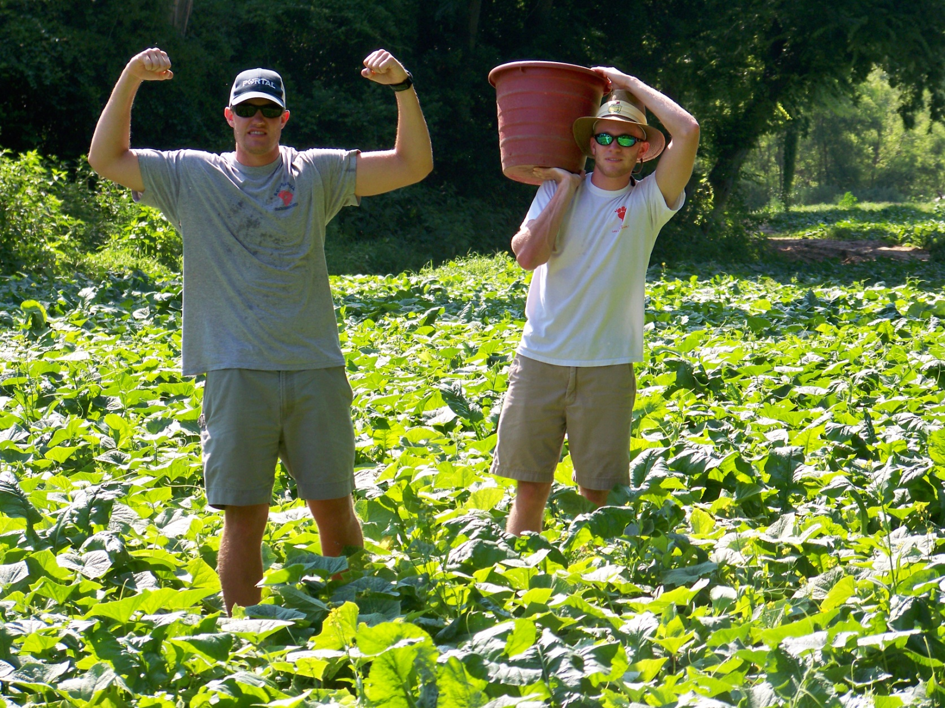
Figure 12: Test picking in the upper “honey bee” cucumber field

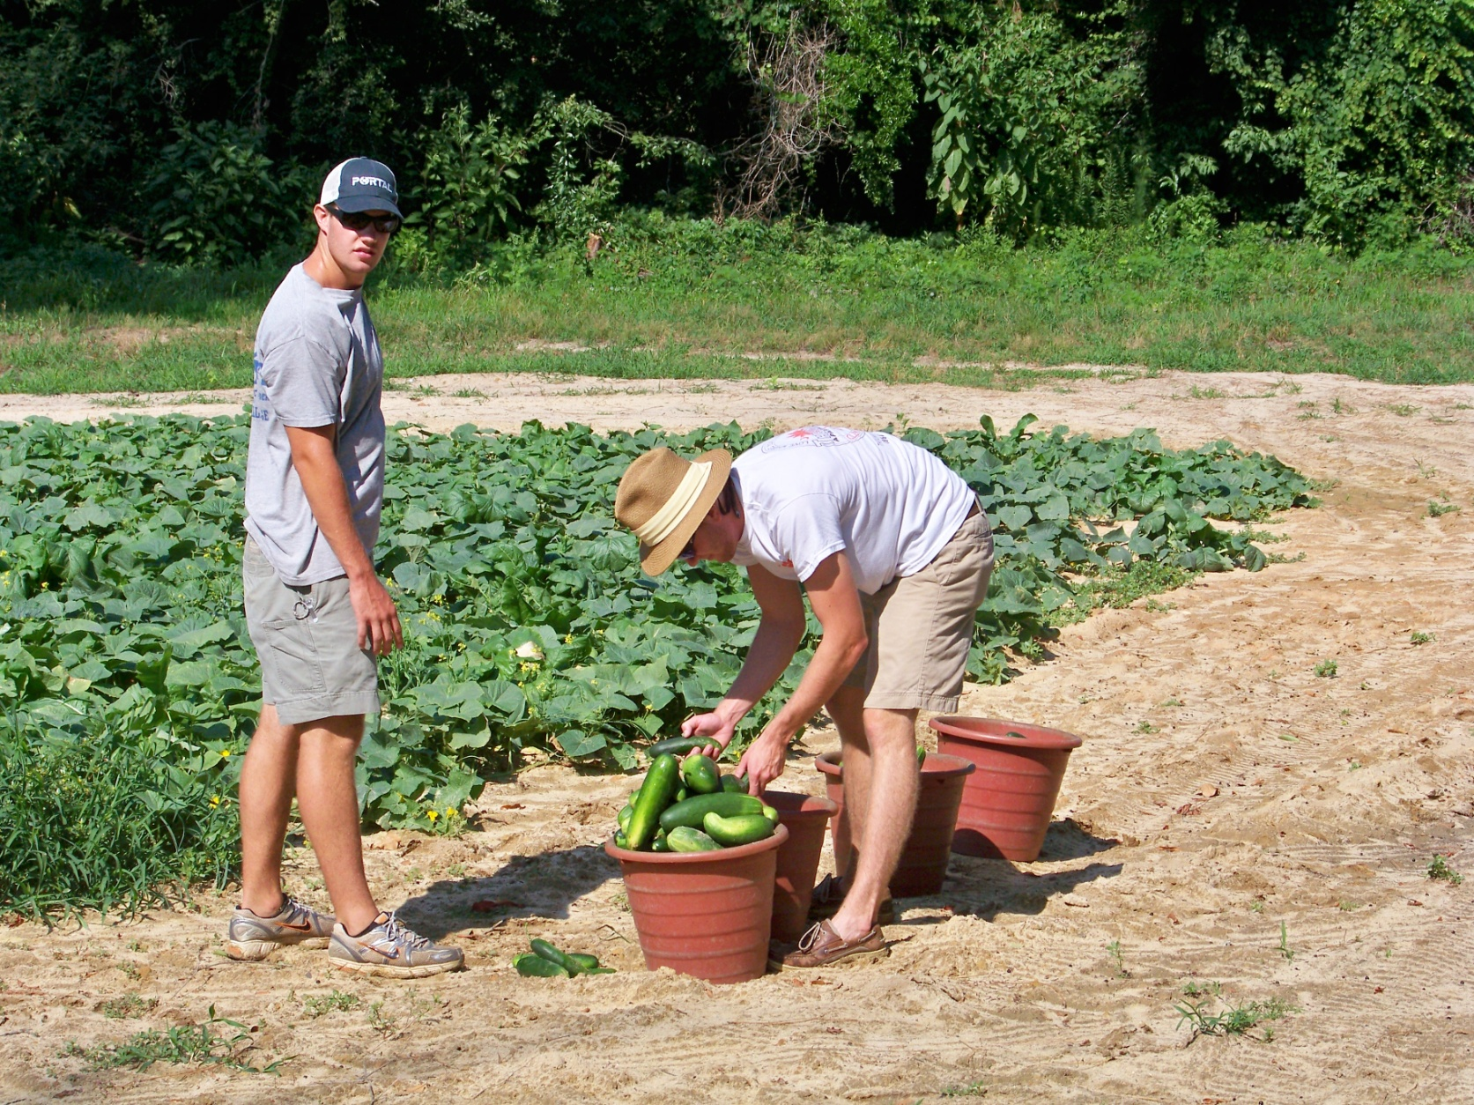
Figure 13: Collecting the test harvest in the upper “honey bee” field

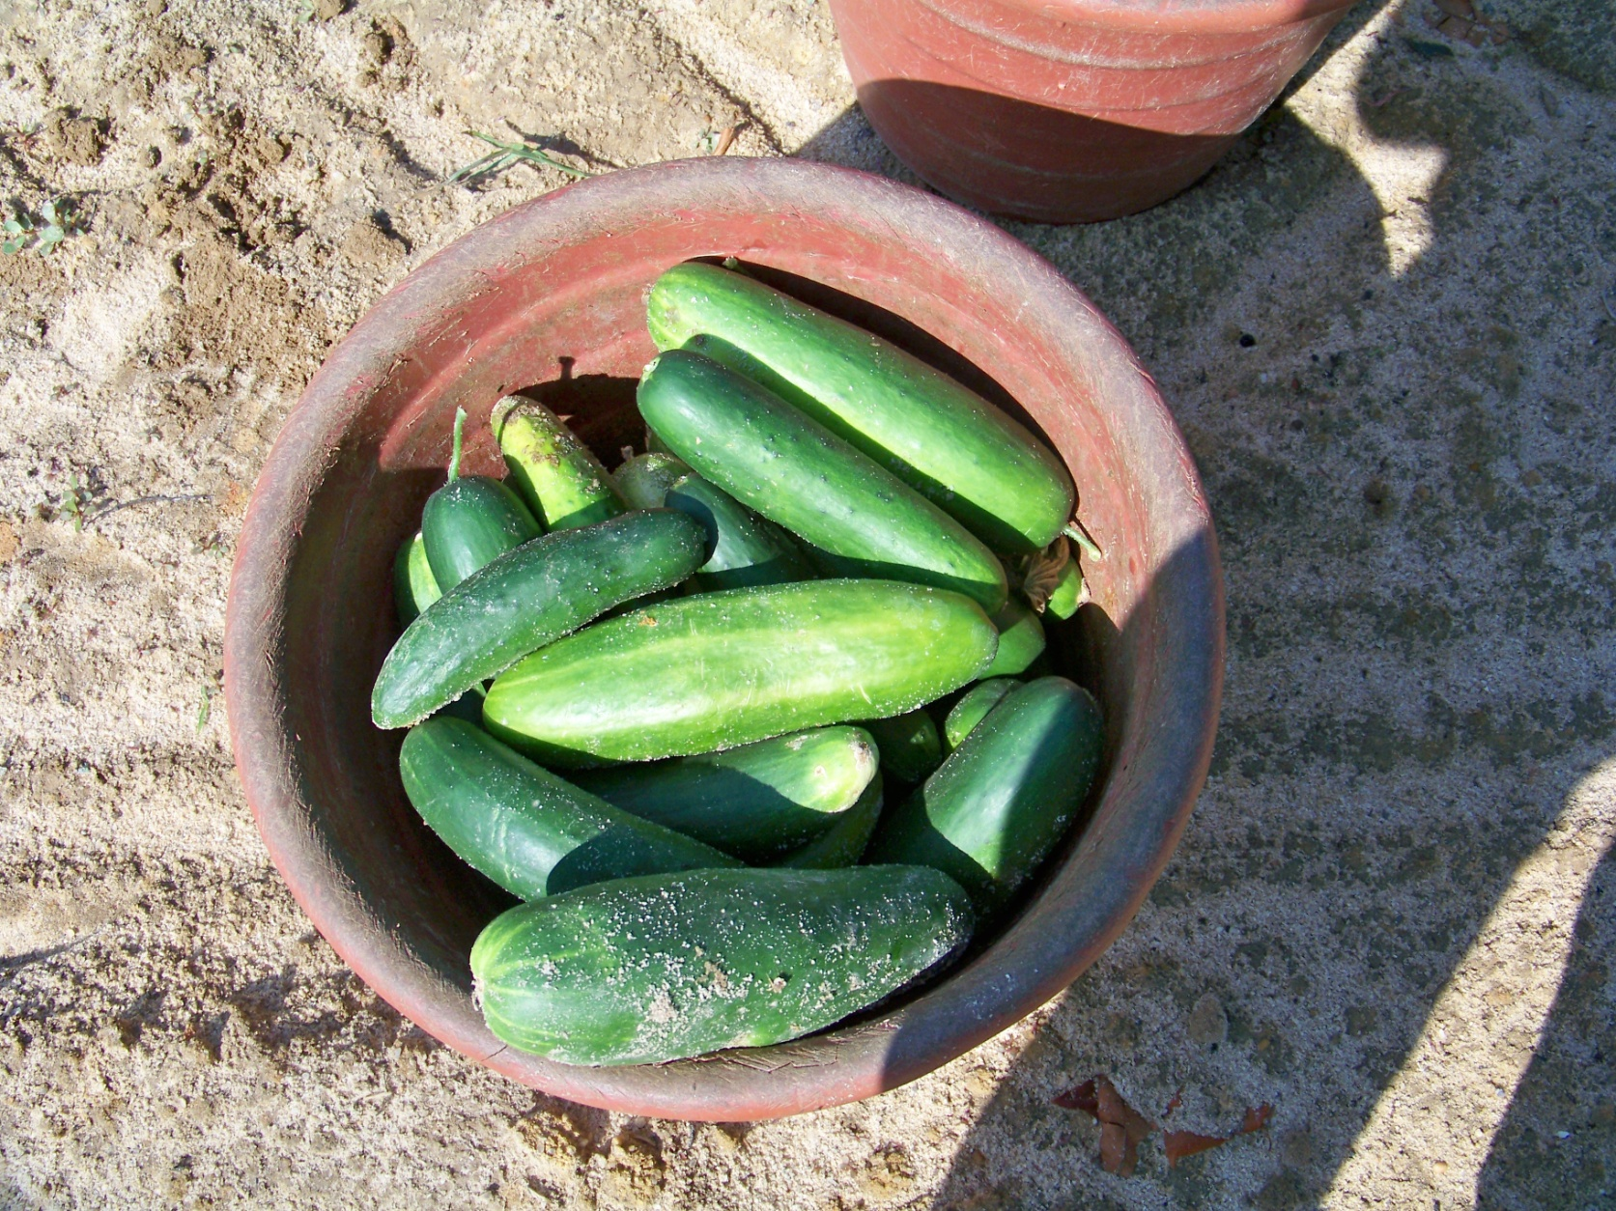
Figure 14: Cucumber (Cucumis sativus) yield from one test plot in the upper “honey bee” field

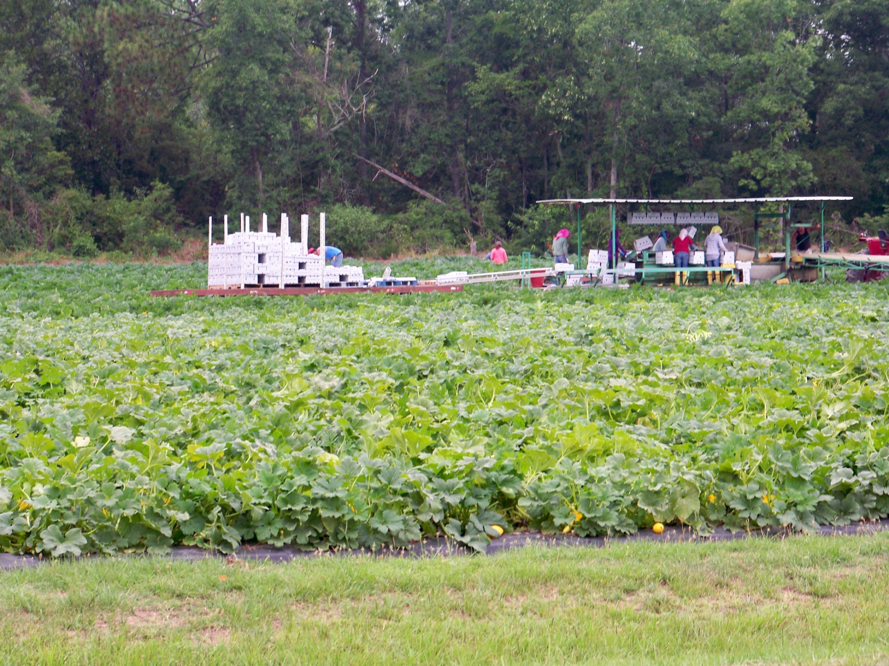
Figure 15: Typical harvesting methods in a squash field. This was the way the cucumber fields were picked on a commercial basis.

Financial Analysis

Planting and harvesting cost between the two fields were basically the same except for the variable cost of honey bees and bumble bees. Hence, the financial analysis focuses on the variable bee cost with respect to the yield. Yield data for one to 1.5 honey bee colonies per acre from previous years was not available.

There are on average one to three cucumbers per pound. These cucumbers are the large slicer cucumbers which average 1-2 cucumbers per pound. For this analysis, we chose a figure of 2.0 cucumbers per pound.

While there was not a statistically significant difference in yields between the two fields (at the α=0.05 level), there was a numerical difference. The honey bee field yielded about twice the yield of the bumble bee field. This is about ( (68.07+82.01+21.61) pounds/(33.36+47.80+5.19)pounds * $0.67 /cucumber * 100% = 198.83% $/cucumber ) more cucumber crop dollars for the honey bee field over the bumble bee field at the current price ( July 1, 2011) of $0.67/average cucumber retail. It should be noted that unaccounted differences in soil and field location may account for part of this yield difference.

Honey bee field
206.85 pounds * (2 cucumbers / pound) * $0.67 average retail price 7/1/2011 per cucumber = $ 275.80 for four 10 foot plots

Cost of honey bees: 6 colonies * $50/colony = $300

Yield for entire honey bee field / cost of pollination for honey bees = insufficient data to determine

Bumble bee field
102.71 * (2 cucumbers / pound) * $0.67 average retail price 7/1/2011 per cucumber = $ 136.95 for four 10 foot plots.

For four bumble bee colonies:
Cost is $250/4 colonies, fob Detroit + $ 120 S&H = $370.

Yield for entire bumble bee field / cost of pollination for bumble bees = insufficient data to determine.

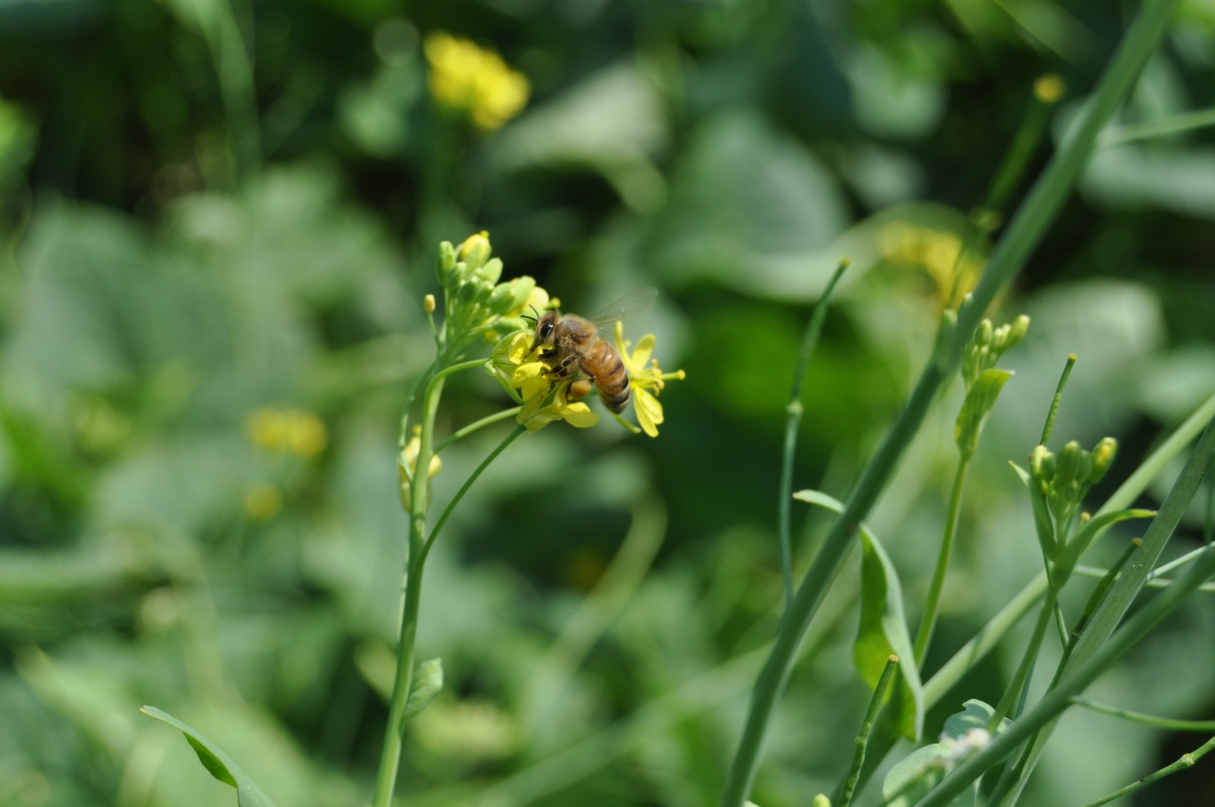

Honey bee on mustard in the upper honey bee field.

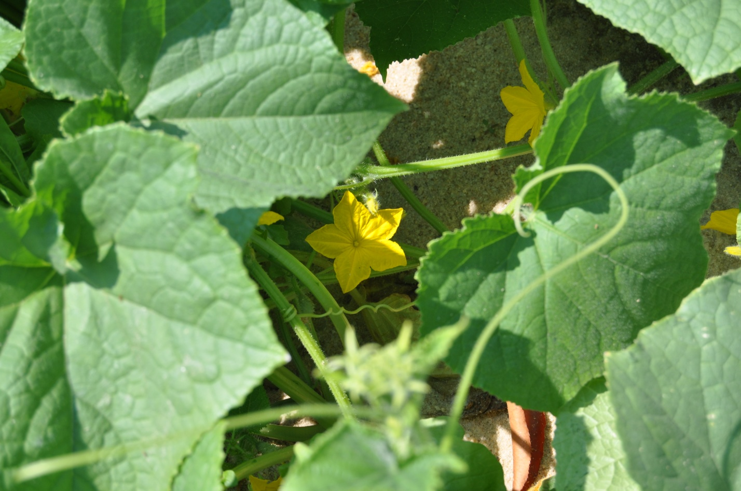

Cucumber bloom in the undercarriage of the cucumber field

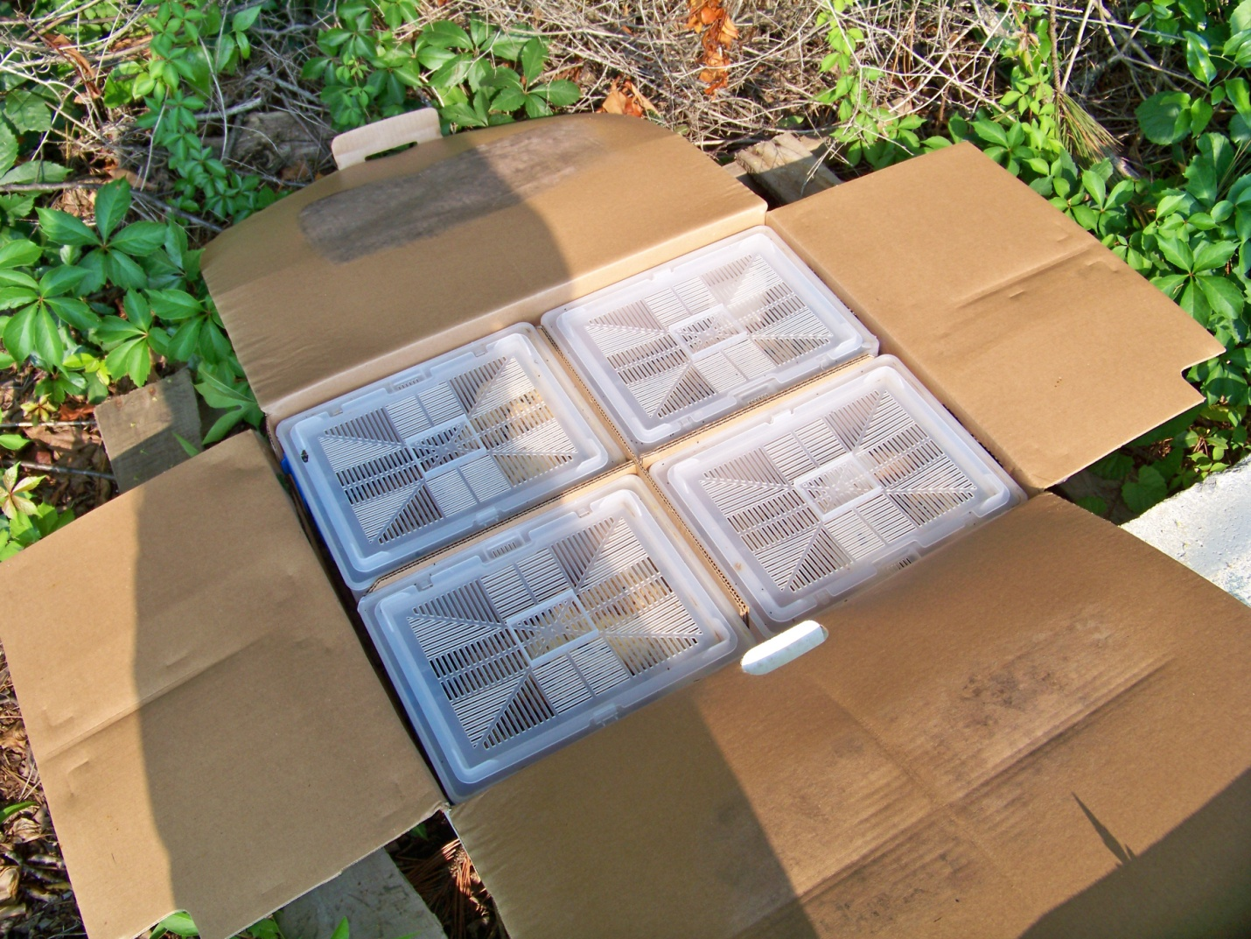

Bumble bee shipper opened showing four bumble bee nests

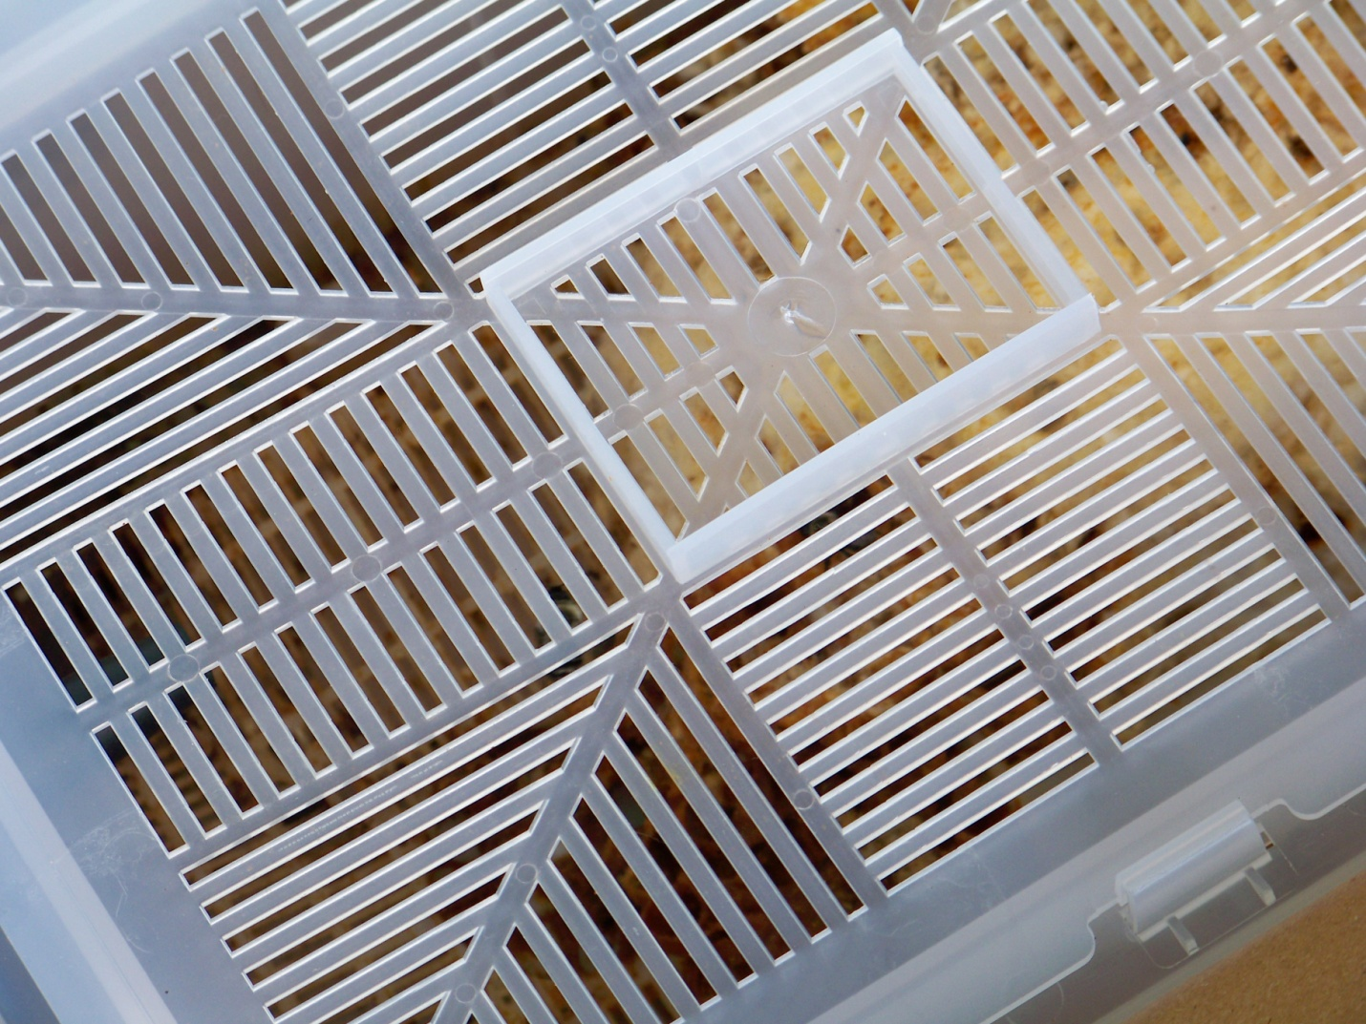

Bumble bee nest

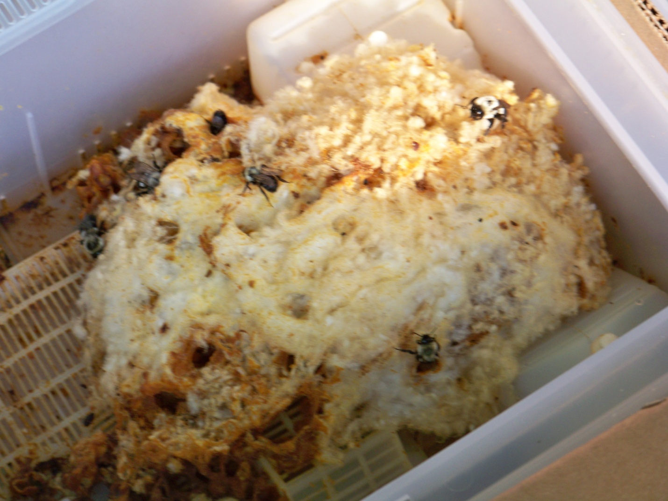

Bumble bee nest.

Appendix A: Average Temperatures in Columbia, SC for June, 2011

Date | Average  Low | Average  High | Record  Low | Record  High | Average  Precipitation | Average  Snow
Jun 1 | 65° | 87° | 44° (1984) | 101° (1953) | 0.14" | NA
Jun 2 | 65° | 87° | 47° (1983) | 101° (2000) | 0.14" | NA
Jun 3 | 65° | 87° | 49° (1953) | 104° (1951) | 0.14" | NA
Jun 4 | 65° | 87° | 52° (1988) | 100° (1985) | 0.15" | NA
Jun 5 | 66° | 87° | 46° (1988) | 104° (1943) | 0.15" | NA
Jun 6 | 66° | 88° | 49° (1976) | 100° (1985) | 0.15" | NA
Jun 7 | 66° | 88° | 50° (1976) | 100° (1899) | 0.15" | NA
Jun 8 | 66° | 88° | 51° (1977) | 102° (1899) | 0.16" | NA
Jun 9 | 67° | 88° | 53° (1913) | 101° (1947) | 0.16" | NA
Jun 10 | 67° | 88° | 45° (1977) | 103° (1899) | 0.16" | NA
Jun 11 | 67° | 88° | 49° (1913) | 100° (1993) | 0.16" | NA
Jun 12 | 67° | 89° | 46° (1972) | 100° (1977) | 0.16" | NA
Jun 13 | 68° | 89° | 52° (1979) | 102° (1958) | 0.17" | NA
Jun 14 | 68° | 89° | 54° (1995) | 102° (1958) | 0.17" | NA
Jun 15 | 68° | 89° | 53° (1959) | 102° (1899) | 0.17" | NA
Jun 16 | 68° | 89° | 55° (1955) | 100° (1943) | 0.17" | NA
Jun 17 | 68° | 89° | 56° (1955) | 101° (1944) | 0.17" | NA
Jun 18 | 69° | 90° | 55° (1961) | 103° (1970) | 0.17" | NA
Jun 19 | 69° | 90° | 51° (1961) | 104° (1970) | 0.17" | NA
Jun 20 | 69° | 90° | 58° (1965) | 102° (1924) | 0.18" | NA
Jun 21 | 69° | 90° | 55° (1966) | 106° (1990) | 0.18" | NA
Jun 22 | 69° | 90° | 58° (2003) | 101° (1988) | 0.18" | NA
Jun 23 | 69° | 90° | 55° (1947) | 102° (1988) | 0.18" | NA
Jun 24 | 70° | 90° | 52° (1972) | 103° (1914) | 0.18" | NA
Jun 25 | 70° | 91° | 54° (1889) | 103° (1952) | 0.18" | NA
Jun 26 | 70° | 91° | 62° (1984) | 104° (1952) | 0.18" | NA
Jun 27 | 70° | 91° | 60° (1979) | 107° (1954) | 0.18" | NA
Jun 28 | 70° | 91° | 54° (1979) | 103° (1945) | 0.18" | NA
Jun 29 | 70° | 91° | 54° (1981) | 103° (1936) | 0.18" | NA
Jun 30 | 71° | 91° | 55° (1962) | 103° (1959) | 0.18" | NA

