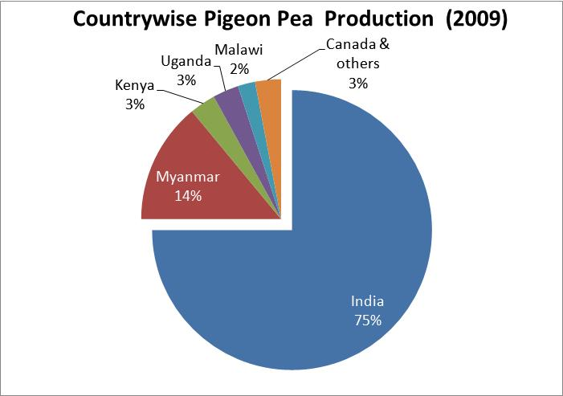

Fig. 1. Major world producers of pigeon pea. (graphic and data supplied by Harry Iyer, Exec Director Greater Dallas Indo-American Chamber of Commerce).

