|  |
| --- |
| Fig. 2. Effect of pigeon pea variety (Georgia-1 vs. Georgia-2) and planting density (124K/ha vs. 247K/ha) on the average quantity of runoff for individual rainfall events. Missing events represents a period from 1-May-2009 to 31-Mar-2010 when data collection was stopped so that plots borders could be repaired and stabilized. |
| Fig. 3. Effect of pigeon pea variety (Georgia-1 vs. Georgia-2) and planting density (124K/ha vs. 247K/ha) on the average cumulative volume of runoff from a Bermuda grass pasture. Missing events represents a period from 1-May-2009 to 31-Mar-2010 when data collection was stopped so that plots borders could be repaired and stabilized. |

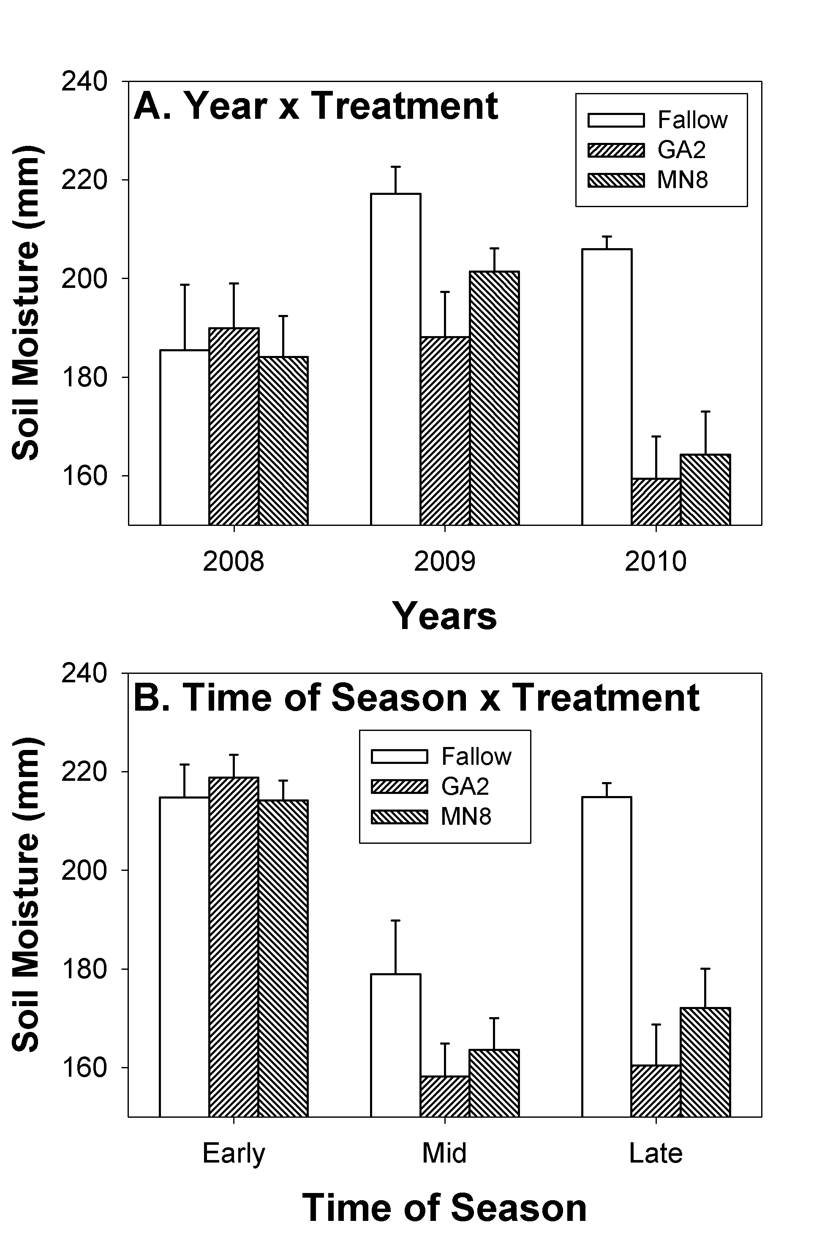

Fig. 4. Year (A), and time of season (B) interactions in moisture in the upper 65 cm of soil in response to two cultivars of pigeon pea and fallow conditions.

|  |  |
| --- | --- |
| Pigeon pea | Soybean |
| Fig. 5. Pigeon pea (left) and soybean (right) emerging from bermuda grass pasture approximately 2 weeks after no-till planting in April 2007. | |

|  |
| --- |
| Fig. 6. Effect of pigeon pea and soybean plants on Bermuda grass biomass in August and October when planted on 0.4-m row spacings using a no-till planter in April. |

|  |
| --- |
| Fig. 7. Photograph of pigeon pea growing in Bermuda grass pasture in mid-September, one month prior to introducing cattle into the area for grazing. Not the onset of flowering in pigeon pea plant in forefront of photograph. |

|  |
| --- |
| Fig. 8. Remaining pigeon pea stems approximately 14 days after cattle were introduced into the pre-flowering study area in August. |

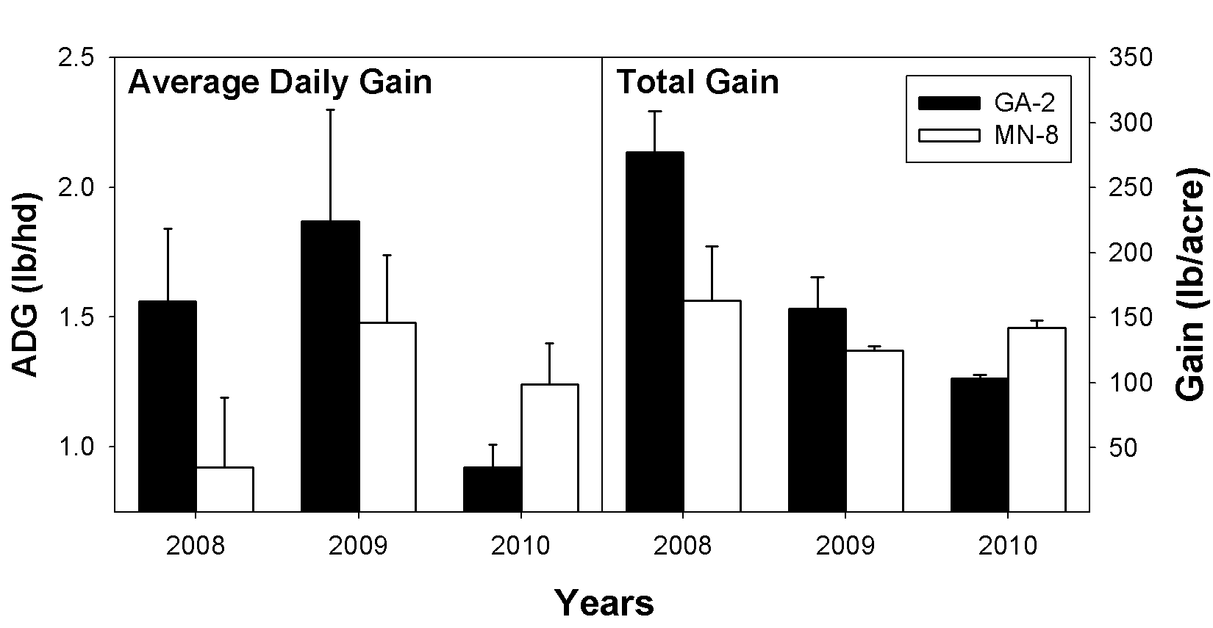

Fig. 9. Average daily gain (left panel) and total gain per acre (right panel) of yearling stocker cattle grazing two cultivars of pigeon pea.