UK Extension Service Header
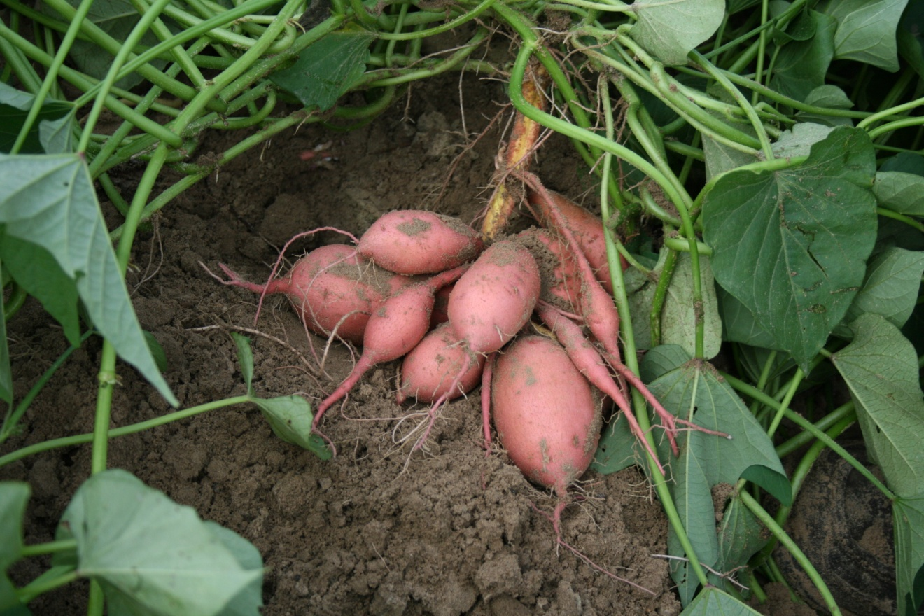Sweetpotato Production for Kentucky

(Inside cover)

Timothy Coolong (ed.), Horticulturist; Kenneth Seebold, Plant Pathologist; Ric Bessin, Entomologist; Timothy Woods, Agriculture Economist; and Sarah Fannin ANR Agent for Morgan County Kentucky.

This publication and the information contained would not have been possible without a Southern SARE On-Farm Research Grant. OS09-047 Sweetpotatoes: A Profitable Crop for Small Farms in Rural Eastern Kentucky. We would like to thank Southern SARE for their continued support of farmers, ranchers, academics, and agriculture professionals.

Origins and Botany

Sweetpotato (Ipomoea batatas L.) is a member of the morning glory or Convolvulaceae family. Sweetpotatoes have their origins in tropical America with early remains having been found in Panama, Peru and Mexico (1). A perennial plant in their native regions, though are typically killed by frost when grown in a temperate climate. Sweetpotatoes are true roots and not tubers as is the case with the Irish Potato (Solanum tuberosum) . Because they are true roots they will continue to grow and enlarge as long as the plant continues to grow. Most modern cultivars consistently produce between 7-10 roots per plant. Average roots, when harvested at the appropriate time, weigh between ½ and ¾ pounds. Sweetpotato roots can exhibit a variety of colors. Though traditionally the market demands an orange-fleshed root, several other colors, including white, red, yellow, and even purple are grown. Sweetpotatoes are very nutritious and are a good source of carotenoids, vitamin A and vitamin C.
Sweetpotatoes will produce trumpet like flowers similar to a morning glory though it is not very common in temperate areas. The reason for this is that sweetpotatoes produce flowers in response to short days, and generally will flower when day lengths are 11 hours or less. When they are grown during the summer months in the U.S. day lengths are typically longer than 11 hours. Occasionally plants will produce an odd flower here or there, but they should be of no concern to growers.
Although often used interchangeably, sweetpotatoes and yams are in fact quite different vegetables. Yams refer to root crops in the Dioscorea genus and are traditionally grown in tropical areas outside of the continental U.S. Yams are typically much starchier and larger than sweetpotatoes, with roots for sale weighing between 4-20 pounds on average, with some weighing upward of 100 pounds.

Cultivation

Producing cuttings or slips

Sweetpotatoes are vegetatively propagated for commercial production. Seed production is only utilized as part of breeding programs. Most growers plant slips or cuttings. Slips are shoots containing some roots which are pulled from growing plants, while cuttings contain no roots and are removed 1-2 inches above the soil line. Seed sweetpotatoes (roots) are planted in beds in early spring, 6-8 weeks prior to the planting season. After sufficient vines are produced, cuttings are taken and planted in the field. Most producers selling slips or cuttings utilize certified disease free seed potato stock. Sweetpotatoes have a high mutation rate. Because plants are vegetatively propagated, mutations are easily passed on from one generation to the next. After several years of using the same genetic stock mutations can build to the point where off-types are propagated resulting in reduced yields. In addition, vegetative propagation can easily pass disease-causing pathogens on from one generation to another. Therefore it is advised that growers replace their seed stock after a few seasons with new certified disease free stock. Certified disease free seed potatoes are the product of tissue culture of somatic embryos and are not only disease free, but contain few mutations. To offset the cost of utilizing completely new seed stock every 2-3 years growers can replace a small portion of their plants every year.
The cost of buying cuttings or slips remains the single biggest expense for the production of sweetpotatoes. Slips or cuttings can be grown successfully in Kentucky during late April and May for planting in early to mid June. Although slips have traditionally been the method of transplant production for sweetpotatoes, cuttings are now preferred. Although lacking roots and the fleshy base often associated with slips, cuttings reduce the risk of spreading disease. This is because cuttings of sweetpotato shoots are taken 1-2 inches above the soil line. By keeping an open wound away from soil and preventing the mixture of soil with cuttings, the risks of transferring soil-borne diseases such as scurf, are reduced.
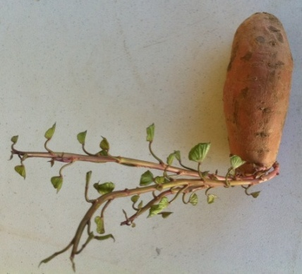
When planting seed sweetpotatoes, growers should not cut the roots as one would when seeding out Irish potatoes. There are several reasons for this. With Irish potatoes a seed potato may be cut into halves, thirds, or quarters resulting in two or more plants from one seed potato. However, cutting a sweetpotato in half will not generate twice as many slips. One can expect to get ten or more shoots per single sweetpotato. Cutting the sweetpotato in half would simply generate two roots with five shoots each. Sweetpotatoes also produce the vast majority of shoots from the proximal end of the root. If the root were cut longitudinally in half, one piece would have several shoots and the other would have few if any. In addition, cutting the seed roots of sweetpotatoes exposes them to soil-borne diseases. The high sugars in sweetpotatoes make them a favorable environment for colonization by soil bacteria and fungi.
Shoots emerging from the proximal end of a sweetpotato
On average 10-12 bushels (55 pounds each) of sweetpotato roots are required to produce one acre worth of slips depending on row spacing and plant population per acre. Growers should utilize medium and large sweetpotatoes when producing slips. Although small roots have been shown to produce more shoots per unit weight; growers might be selecting inferior sweetpotatoes if they plant only small (<3-4 oz) roots. Growers must also take into consideration that sweetpotatoes harvested in September can lose 10% or more of their weight during winter storage. Further storage losses due to disease can also occur. If 550-660 pounds of roots are required to produce an acre’s worth of slips they should plan to store at least 2 extra bushels per acre to accommodate storage losses.
Cut seed roots infected with Rhizopus soft rot.
Sweetpotatoes do not have a natural dormancy period and if conditions are correct they can sprout shortly after harvest. However, after a long period of cool storage, sprouting can be encouraged by warming sweetpotatoes to 70-80ºF prior to planting. Seed roots can also be treated with fungicides prior to planting to discourage soil-borne diseases. Growers in Central and Eastern Kentucky can generally plant sweetpotatoes for cutting production during the last week of April, with growers in Western Kentucky typically able to go into the field up to a week earlier. Temperatures should not be below 50ºF on the day of planting so that sweetpotatoes are not subjected to cold damage. However, once seed potatoes are planted and covered with soil they can typically withstand much cooler temperatures. Cuttings can be produced through a variety of methods. The homeowner may want to simply place a root in a small pot and cover with soil, while the market grower can utilize a small raised bed structure. Larger growers will want to grow slips from ground beds.

Cuttings on a small scale
The following method has successfully been used to produce approximately ½ acre (6,500) of slips.

A 6’ x 12’raised bed for cutting production

Many growers choose to construct a raised bed for small scale slip production; this example utilizes a 6’ x 12’ raised bed to produce slips. The raised bed structure is put in place and disease free seed potatoes are placed end to end to fill the bed. The bed pictured required approximately 500 sweetpotatoes, weighing approximately 250 pounds to fill. This resulted in an average of seven seed potatoes per square foot.

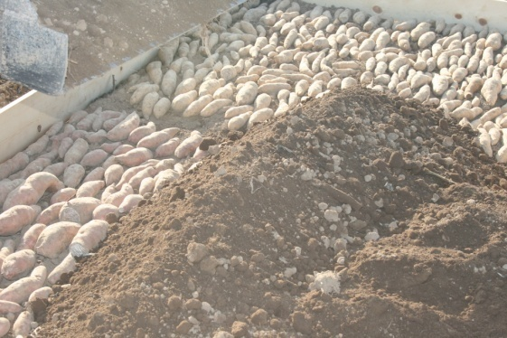
Then soil is added to the bed to cover the seed potatoes to a depth of three inches.

Devrinol (napropamide) preemergent herbicide can be applied to the soil surface with a backpack sprayer after sweetpotatoes are covered to prevent weeds. However, given the small area being considered one or two hand weedings would be sufficient as well. The raised bed structure can then be covered with clear plastic to form a mini cold frame.

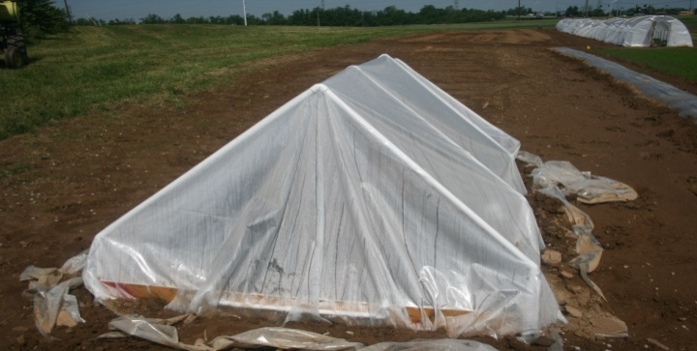
The sweetpotato bed should be monitored to ensure that it does not dry out. Plants should begin sprouting within three weeks. After approximately four weeks the plastic covering should be removed as temperatures increase. Once plants start sprouting one or two applications of a general purpose fertilizer will spur growth. Plants will grow vigorously from this point and will be ready for harvest about six weeks after planting, typically the first or second week of June.
Mini cold frame for slip production

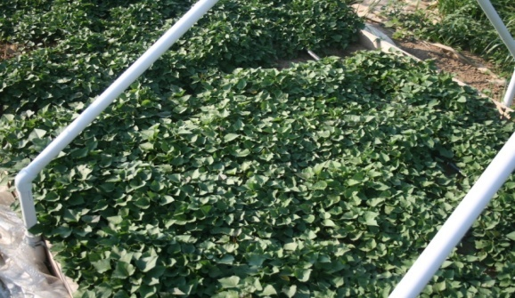
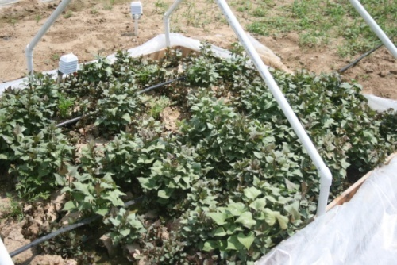

Sweetpotato sprouting four weeks after planting (left) and six weeks after planting (right).

When cuttings are taken, prune sweetpotato shoots approximately 1-2 inches above the soil line. This will allow for plants to resprout for additional cuttings to be taken. Allow two weeks for resprouting to occur for a second cutting.

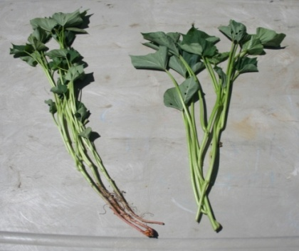
Sweetpotato slips (left) with some small roots and cuttings (right) with no roots

Cuttings on a larger scale
The following method has successfully been used to produce approximately 1 acre (13,000) of slips.
Sweetpotatoes placed end to end in a well prepped field (left) and covered with 3-4 inches of soil (right).

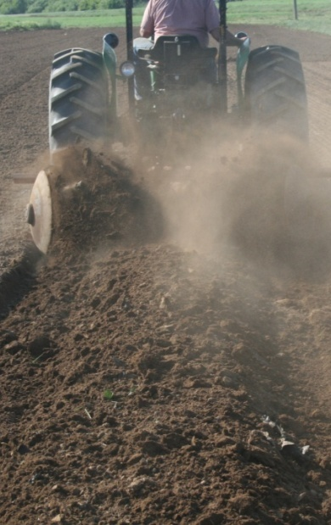
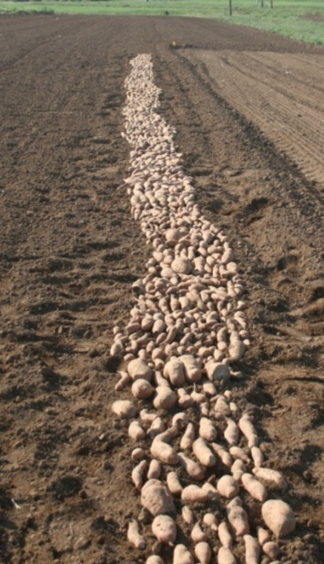
For growers wanting to produce cuttings for larger plantings raised beds are not practical. On a larger scale sweetpotatoes can be laid end to end in a row approximately two feet wide (it can be wider or narrower based on the available equipment). The row can be as long as necessary. Approximately 550 pounds of sweetpotatoes were used to produce one acre of slips. After slips are placed in the ground they are covered with soil. Devrinol (napropamide) preemergent herbicide can be applied to the soil surface after sweetpotatoes are covered to prevent weeds.

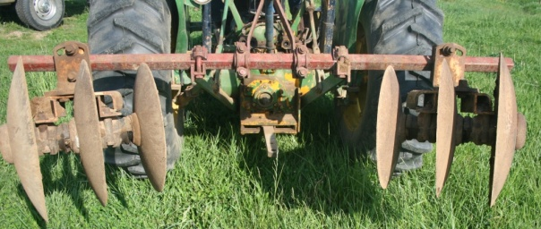
A gang of disks used to form the bed. Any implement that will push dirt over the sweetpotatoes will suffice.

Clear plastic mulch should be placed over beds to increasing soil temperatures, which encourage sprouting. In Kentucky plastic should be used in order to have cuttings for planting by early to mid June. Drip irrigation tubing should be placed under the plastic mulch in order to irrigate and provide fertility if necessary. After a week or so punch some holes in the clear plastic mulch to ensure that there is enough oxygen in the soil so that roots will not rot. One can use almost anything to punch holes though waterwheel setters work well as long as the spikes on the wheel do not punch deeply enough to harm the buried roots. After about three weeks initial sprouts should appear under the plastic mulch. Be careful to frequently monitor the bed as the clear plastic will burn sprouts that emerge beneath it. When sprouts are consistently breaking through the soil cut the plastic away from the bed to allow the plants to continue growing. After two more weeks sprouts should be 8-10 inches long allowing for cutting. During this time supplemental fertility and water can be applied through the drip irrigation if desired. An application of 5-10 pounds nitrogen per acre with a general purpose fertilizer should be sufficient.

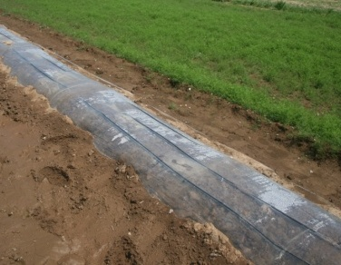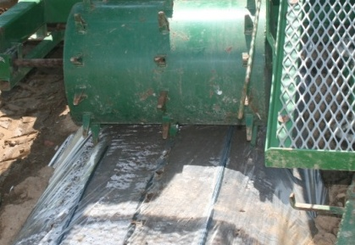
Clear plastic mulch over the sweetpotato bed (left), punching holes with a waterwheel (center), and sprouts damaged due to the heat under the clear plastic (right). When sprouts consistently appear it is time to remove the plastic.

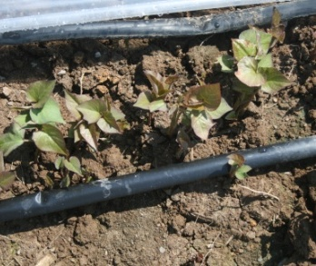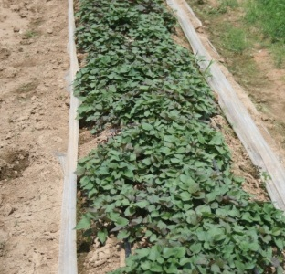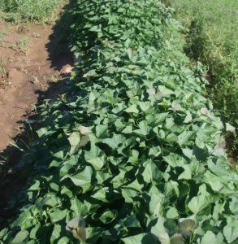
Sweetpotato sprouts at plastic removal (left), approximately one week (center) and two weeks (right) after plastic removal. Cuttings are ready for harvest two weeks after plastic removal.

After cuttings are taken they can be stored for short periods. Do not store cuttings in a refrigerator or a cooler below 50 ºF or they will suffer cold injury. Commercially, slips are often bundled in bunches of 1000 and packed in cardboard boxes. Growers often wait 1-2 days after taking cuttings before planting in the field.

Variety selection
Variety selection is crucial for commercial sweetpotato production. Although growers may have traditional favorites, newer varieties should be selected for their superior yield potential. Maturation time is an important criterion when choosing varieties. Some varieties such as Beauregard, mature in only 90-95 days, much sooner than many traditional varieties. This is important since sweetpotato roots will continue to grow even after they have reached marketable size. Varieties that should be harvested at 90 days will be too large for wholesale markets if left in the field for 110-120 days. It is not uncommon to harvest 5-7 lb sweetpotatoes that have been left in the field too long. Growers in the eastern portion of Kentucky should consider varieties that mature earlier since it is not uncommon for this region to experience early frosts.

Variety | Photo | Comments
Beauregard | 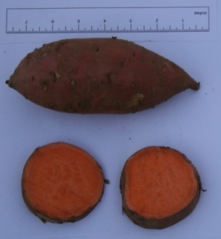 | Highest yield potential in Kentucky. Yields have surpassed 500 boxes/acre. Matures in 90-95 days. Copper-red skin with orange flesh. Most common variety grown. Must harvest on time or roots will get too large. (Commercial/farmers market)
Hernandez | 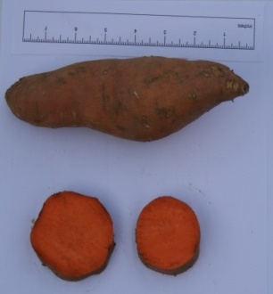 | Good yield potential, longer more tapered root than Beauregard. Orange skin with exceptionally deep orange flesh. Matures in 100 days. (Commercial/farmers market)
Covington | 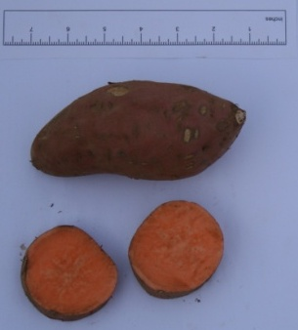 | Highest quality, but with lower yield potential than Beauregard. Yields in Kentucky approach 400 boxes/acre. Rose-colored skin with orange flesh. Matures in 100 days. Uniform roots with exceptionally strong vines. (Commercial/farmers market)
O’Henry | 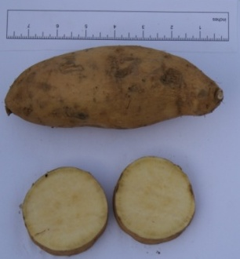 | Best performing white-fleshed variety. Tan-colored skin. High yield potential of 400-500 boxes/acre. Similar shape and growth habit as Beauregard. Matures in 95 days. (Commercial/farmers market)
Murasaki | 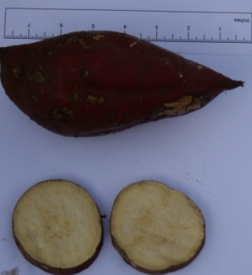 | Dark purple skin with bright white flesh. High yielding variety matures in 100 days. Slightly drier flesh than others. Thick skin with larger blockier roots. (Farmers market)
Centennial | 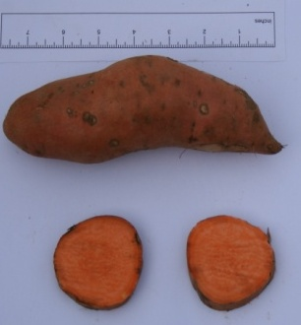 | Copper skin with orange flesh. Older variety but still a good yielder. Longer and tapered. Matures in 100-110 days. (Farmers market)

Field preparation and planting
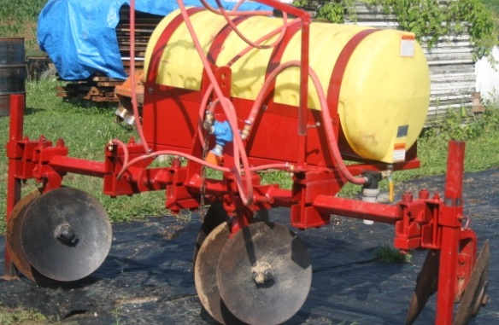
Field preparation should begin with a soil test the fall prior to growing sweetpotatoes. Sweetpotatoes do not require a lot of nitrogen fertility but do require significant potassium and phosphorous. Sweetpotatoes will grow well in a soil with pH of 6.0-6.8. Lime should be added during fall or winter so that it can adequately react with the soil prior to planting. It is suggested that applications of phosphorous and potassium are made during field preparation. Generally sweetpotatoes require approximately 50-80 pounds of nitrogen per acre. It is suggested that 50 pounds be put out preplant with a side dress of an additional 20-30 pounds four weeks after transplant or before vines begin to fill in rows. Despite requiring less nitrogen than most vegetable crops, sweetpotatoes do remove a significant amount of potassium from soils.
A two-row disk set up to form raised beds for sweetpotatoes. A spray tank and pump has been added to apply insecticide during bed formation.

Fertilizer requirements for sweetpotato
Soil Test (lb/A) |  | Fertilizer Required (lb/A)
Phosphorous |  | Phosphate (P₂O₅)
Low | < 31 | 180
Medium | 31-60 | 120
High | 61-80 | 60
Very High | >80 | 0
Potassium |  | Potash (K₂O)
Low | <201 | 275
Medium | 201-300 | 100-250
High | 301-450 | 50-100
Very High | >450 | 0
Nitrogen |  | N
Apply 50-80 lbs/A of actual N
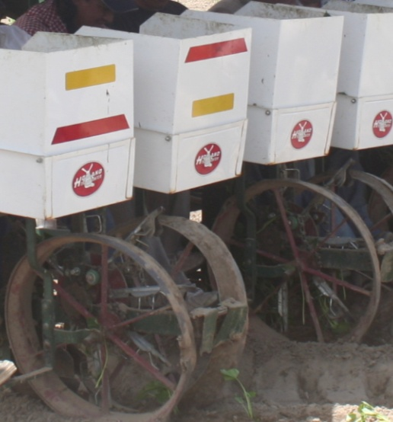
Sweetpotatoes perform best on a sandy, well-drained soil; however, they have been grown successfully on a wide range of soils across Kentucky. Heavy clays, excessively shallow, rocky, or poorly drained soils should be avoided for good results. Sweetpotatoes can be planted on ridges or on flat ground and each method has benefits and drawbacks. Traditionally sweetpotatoes are grown on 8-10-inch tall ridges. This will improve drainage and root quality particularly on heavier soils. Growing sweetpotatoes on ridges allows for substantially easier harvest. The principal drawback to growing sweetpotatoes on ridges is that they will dry out very quickly during the summer. If growers do not have access to irrigation they may want to seriously consider growing sweetpotatoes on very shallow ridges or flat ground. Although this will make harvest more difficult, soil moisture will be more available to plants grown on flat ground. In years of drought, growing sweetpotatoes on tall ridges without access to irrigation can result in significant (up to 30%) losses of yield. On very heavy soils or fields with hard pans, growers will likely have to use ridges to produce sweetpotatoes, regardless of irrigation. Growers will plow and disk soil to prepare a fine planting bed and then use lister plows or gangs of disks to prepare ridges. When planting sweetpotatoes many growers in Kentucky transplant slips on rows with 42-inch centers. This is a common spacing for tobacco and works very well for sweetpotatoes, allowing growers to use readily available tobacco-type transplanters and cultivation equipment. A 40-44-inch row spacing will allow for vines to completely cover row middles about 5-6 weeks after transplanting, which will improve weed control. Although many growers have successfully planted sweetpotatoes on a narrower 36-inch spacing, mechanical harvesting can be difficult as harvest equipment often has to run over the top of a planted row of sweetpotatoes to harvest the adjacent row. Growers should try to match row spacing to the available equipment to ensure more efficient production. Sweetpotatoes are often successfully transplanted using a finger-type tobacco transplanter or skid-type transplanter. Carousel transplanters are far less effective since sweetpotato slips typically do not weigh enough to fall through the transplanter quickly and often become hung up, resulting in frequent skips. In-row spacing is very important for
Planting using a tobacco finger-type tranplanter.
How many slips do I need to plant an acre?
 | Within-row spacing (inches)
Row spacing (inches) | 10 | 12 | 14
36 | 17,420 | 14,520 | 12,450
40 | 15,840 | 13,200 | 11,310
42 | 14,940 | 12,450 | 10,670
44 | 14,280 | 11,900 | 10,200
48 | 13,180 | 10,890 | 9,330
This assumes completely planted acre with no drive rows.
sweetpotato production. When growing an aggressive variety such as Beauregard, a closer in-row spacing of 10 inches is used to discourage the production of excessively large roots. A wider in-row spacing of 12-14 inches is often used on less aggressive varieties.
Although many producers do not use irrigation, having water available at transplant significantly improves stand establishment. A starter solution, though not necessary is often preferred. Adding approximately 3 pounds of 10-52-17 or similar to 50 gallons of transplant water is common practice. With adequate water and quality slips stand survival rates of 95% have been achieved in Kentucky.

Irrigation
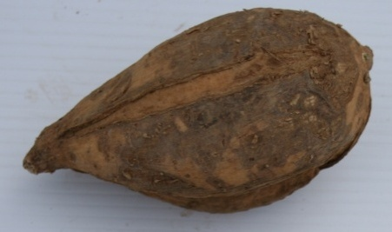
Studies conducted at the University of Kentucky in Lexington have shown that drip irrigation significantly increased yields when growing Beauregard sweetpotatoes on raised beds in dry years. However in “typical” growing seasons drip irrigation did not increase yields significantly, although slip establishment was improved. On-farm demonstrations in Kentucky have suggested that yields suffer significantly in dry years when sweetpotatoes are grown without irrigation, particularly when growing on sandy soils. Growers must calculate the risk of yield loss in a dry season versus the cost of irrigation; however, for the greatest chance of success on a large scale, it is recommended that growers have access to some form of irrigation in case of persistent drought and to improve stand establishment after transplant. Irrigation of sweetpotatoes need not be as frequent as for other vegetable crops such as tomatoes, but is helpful during bulking stages. Growers should be aware that many older varieties may be prone to splitting and cracking when excessive irrigation is applied.
Splitting in a sweetpotato grown under excessive irrigation
Drip irrigation, though efficient, is fairly expensive to install and requires clean, filtered water. A well-managed drip irrigation system can be 95% efficient in putting water where it is available to plants, whereas overhead systems may only be 70% efficient. If sweeetpotatoes are to be part of a mixed vegetable production system where drip irrigation is already being employed then it would make economic sense to use drip irrigation. If growing only sweetpotatoes producers may consider using overhead irrigation. Growers have effectively used traveling-gun irrigation systems for sweetpotato production in Kentucky. Traveling guns are cost-effective and require less maintenance than a typical drip irrigation system.

Plasticulture
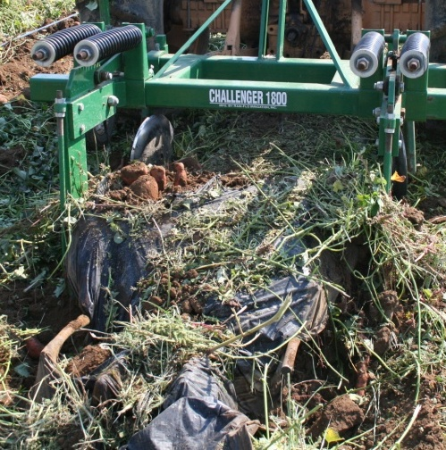
Plastic mulches are widely used for vegetable crop production in Kentucky. They generally improve yields, particularly of warm-season crops, through reducing in-row weed pressure, improving water retention, and warming soils in the spring. However, with a few exceptions, plastic mulches have not proven to be a particularly suitable option for growing sweetpotatoes. Generally plastic-mulch layers and bed shapers require wider row spacing then traditional bare ground production. This wide row spacing reduces the number of plants per acre and subsequently can reduce yields. Typically, raised beds with black plastic mulches are formed on 6 foot centers. This results in approximately 7200 row-feet per acre. Bare-ground production, when using 42-inch row spacing, results in over 12,400 row-feet per acre. Results from research conducted at the University of Kentucky comparing single and double-row plantings on black plastic mulches showed a 26% increase in yields when going from a single to double-row planting, despite requiring twice as many slips per row. One of the biggest issues with growing sweetpotatoes, particularly ‘Beauregard’, on plastic mulch is that they tend to get too large, given the growing conditions and additional growing space the plastic mulch system affords. Plastic mulches also increase the difficulty of harvest. Plants must be mowed completely and mulch removed prior to using mechanized harvesters. The additional step of removing the mulch can add significant labor costs to for larger plantings.
Removing plastic mulch with a mulch lifter prior to digging sweetpotatoes. The sweetpotato vines make plastic mulch removal difficult.
Despite drawbacks, there are times when plastic mulches have proven effective for sweetpotato production. Plastic mulches have been successfully used for organic sweetpotato production. The mulches provide excellent in-row weed control for organic production. In addition, many small-scale growers that dig sweetpotatoes by hand prefer the ease of digging in the non-compacted soils under plastic mulches.

Weed Management
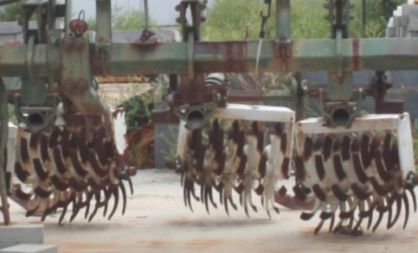
Sweetpotatoes are an aggressive crop that can quickly form a canopy, shading out weeds. Most successful weed management programs combine timely mechanical cultivation and/or herbicide applications. There are a limited number of herbicides for sweetpotato production in Kentucky and most have fairly lengthy pre-harvest intervals. Some growers have successfully produced quality sweetpotatoes relying solely on mechanical cultivation. Typically three cultivations are required for weed control in sweetpotatoes. For best results, mechanical cultivation should be combined with stale seed-bedding techniques prior to planting. Because sweetpotatoes are often transplanted in early June in Kentucky, there is generally sufficient time to stale seed-bed fields prior to planting. Cultivations should begin within ten days after and continue until plants are beginning to cover the areas between beds. The final cultivation may result in cutting the tips of vines, which is generally not a problem. On fields with very high weed seed banks mechanical cultivation may not be sufficient to reduce weeds within rows. Some farmers may use plastic mulches to reduce within-row weed pressure, though there are limitations to using mulches for sweetpotato production.
Gangs of rolling cultivators are typically used to cultivate sweetpotato beds.

Chemical weed control in sweetpotato
Preplant or preemergent | Product (Amount/Acre) | Active ingredient (lb/A) | Comments
 | Roundup WeatherMax 16-22 fl oz. | glyphosate-salt 0.69-0.94 | For non-selective post-emergence control of annual and perennial grasses and broadleaf weeds. Use only AMS 1 to 2% v/v. Adding a non-ionic surfactant can reduce weed control effectiveness.
 | Valor 2-3 oz | flumioxazin 0.062-0.094 | Apply 2-5 days prior to transplanting for preemergent control of sedges, annual grasses, and broadleaf weeds. Do not use on greenhouse-grown transplants or on transplants harvested more than two days prior to transplant. Do not apply posttransplant or serious crop injury may occur. Refer to label when using on varieties other than ‘Beuregard’.
 | Command 3ME 1.3-4 pt | clomazone 0.48-1.5 | For preplant incorporated preemergence control of annual grasses and broadleaf weeds. When using posttransplant apply at a maximum rate of 1.5 pt/acre prior to weed emergence. PHI of 95 days or 125 days if more than 3.3 pt/acre applied. Weak control of pigweed.
 | Dacthal W-75 6-14 lb | DCPA 4.5-10.5 | For pre-emergence control of annual grasses and small-seeded broadleaves. May be sprayed over transplants. Layby applications can be made up to 6 weeks after transplanting for late season control. Do not use in transplant beds or injury may occur.
 | Devrinol 50 DF 2-4 lb | napropamide 1-2 lb | Apply to soil surface immediately after transplanting. If rainfall does not occur within 24 hours shallowly incorporate or apply sufficient irrigation to wet the soil 2-4 inches. Transplant production beds. Apply to soil surface after sweetpotato roots are covered but prior to plant emergence.
Postemergence
 | Aim 1.9 EW 0.5-1.5 fl oz | carfentrazone ethyl 0.008-0.023 | Apply post directed using shielded sprayers for control of emerged weeds. Will burn crop if contact occurs. Will not control grasses. Good covered is essential for weed control. Spray when weeds are less than 4 inches tall.
 | Roundup WeatherMax 16-22 fl oz. | glyphosate-salt 0.69-0.94 | For non-selective post-emergence control of annual and perennial grasses and broadleaf weeds. Can be applied to row middles using a shielded sprayer or as a wick-application in row middles. Do not allow to come in contact with crop or severe injury may result.
Grasses only | Select 2EC 6-16 fl oz | clethodim 0.09- 0.24 | For selective post-emergence of actively growing annual grasses and suppression of perennial grasses. Add crop oil 1% v/v. Using crop oils at very high temperatures may increase risk of crop injury. PHI = 30 days.
 | Fusilade-DX 2E 6-16 fl oz | fluazifop-p 0.1-0.25 | For selective post-emergence control of annual grasses and suppression of perennial grasses. Include 1% v/v crop oil or 0.25% v/v non-ionic surfactant/A. Do not apply on days that are unusually hot or humid PHI of 55 days.

Insect Management (Ric please add here)
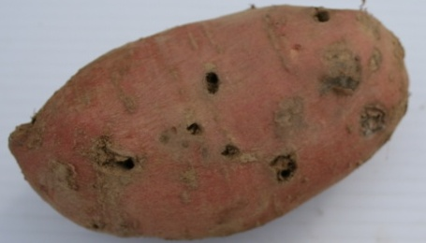
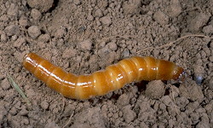
Soil borne insect pests are the most important insect pests of sweetpotatoes in Kentucky. Wireworms and grubs can be challenging to control as they can attack over an extended period of time. Although economic wireworm damage to field crops is rare, when they are a problem they can be very destructive and difficult to control. However, with sweetpotatoes, economic damage by wireworms can be common in some areas and may result in more than 40 percent damaged roots. While wireworms can be found in soils following any type of rotation, are usually more severe when crops follow established sod, or the second year following sod. Wireworms feed upon the small roots of sweetpotatoes throughout the season. Most wireworm larvae are hard, chestnut brown, smooth, varying from 1/2 to 1-1/2 inches in length when grown. Some species are soft, and white or yellowish in color. Most wireworms have lifecycles that last two or more years, so recent history of wireworms in a field often indicates increased risk. Generally, wireworms are managed with soil insecticides applied pre-planting and incorporated, at planting, and/or during cultivation.
Wireworm and typical damage to roots. Damage is characterized by 1/8 inch circular holes in the roots.
As with wireworms, white grubs are soil insects that attack the developing roots. White grubs are the larval stage of May and June beetles. While wireworms produce small holes in the roots, white grub damage results in large feeding sites of half an inch to more than an inch in diameter. White grubs numbers in the soil are influenced by past rotations, proximity to wooded areas, and levels of organic matter in the soil. Fields previously in sod or with high organic matter are more likely to have high grub numbers. Control of grubs in sweetpotatoes is through the use of soil applied insecticides before or during planting.
There are a few insects that feed in the foliage of sweetpotatoes, but economic infestations, while they do occur, are not common. Tortoise beetles chew round holes in the leaves and may be found on the undersides of the leaves. Spotted cucumber beetles may also feed on vines and leaves. These insects are controlled with foliar insecticides on an as needed basis.

INSECT CONTROL: Sweetpotatoes
Insect/Insecticide | Product Amt/A | Comments and Seasonal Limits
SOIL APPLICATION
Wireworms
Belay 2.13 SC | 6 to 12 fl oz | Limit 12 fl oz of total use/A. At planting or at cultivation. 14 day PHI
Brigade 2 EC | 3.2 to 9.6 fl oz | At cultivation. 21 day PHI
Brigade 2 EC | 9.6 to 19.2 fl oz | Preplant only. 21 day PHI
Lorsban 15 G | 13.5 lb | Limit 1 application. Preplant incorporated. 125 day PHI
Lorsban 4 E | 4 pt | Limit 1 application. Preplant incorporated. 125 day PHI
FOLIAR APPLICATION
Flea Beetles, Tortoise Beetles
Baythroid XL | 1.6 to 2.8 fl oz | Limit 2.8 fl oz per 5-day interval. Limit 16.8 fl oz/A. For flea beetles. 0 day PHI
Brigade 2 EC | 2.1 to 6.4 fl oz | Limit 32 fl oz of total use/A. 21 day PHI
Endosulfan 3 EC | 0.67 qt | Limit 3 applications. 1 day PHI
Mustang Max | 1.76 to 4 fl oz | Limit 24 fl oz/A. Allow 4 days between applications. 1 day PHI
Sevin XLR | 1 to 2 lb | Limit 8 applications. Allow 7 days between sprays. 7 day PHI
Leafhoppers
Actara 25 WDG | 1.5 oz | Limit 3 oz/A. Allow 7 days between applications. 14 day PHI
Baythroid XL | 0.8 to 1.6 fl oz | Limit 2.8 fl oz per 5-day interval. Limit 16.8 fl oz/A. 0 day PHI
Malathion 8 | 1 to 1.75 pt | 3 day PHI
Mustang Max | 1.76 to 4 fl oz | Limit 24 fl oz/A. Allow 4 days between applications. 1 day PHI
Provado 1.6 F | 3.5 fl oz | Limit 10.5 fl oz/A. Allow 7 days between applications. 7 day PHI
Sweetpotato Weevil (Prior to planting, dip sweetpotato cuttings in suspension of Sevin XLR at a rate of 2.6 fl oz/gal water.)
Baythroid XL | 1.6 to 2.8 fl oz | Limit 2.8 fl oz per 5-day interval. Limit 16.8 fl oz/A. 0 day PHI

Disease Management
Transplant production beds. Purchase either certified transplants or produce your own plants. Start with certified, disease-free roots planted in a commercial growing mix or in new sand for best results. If this is not possible, consider the following measures: Sanitize beds or greenhouses; if bedding material is reused or if soil is used, then work up the material to a depth of 8 to 10 inches and steam-sterilize (180°F for 30 minutes) or fumigate. Fumigants for this use include chloropicrin and metam-sodium applied as a drench or injected.
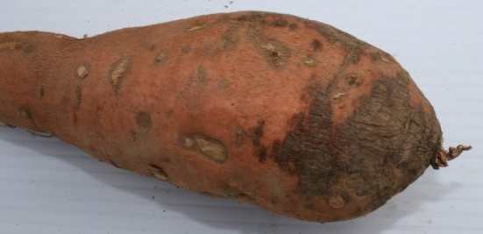
Before bedding, dip “seed” roots for two minutes into a solution of Mertect 340F or Botran 75W and plant immediately. See tables for rates and use directions. Soil or media temperatures in the beds should be maintained at around 80°F to encourage rapid plant growth and reduce rotting. Using sprouts that are cut above the soil line is a great aid in reducing certain transplant-borne diseases.
Black rot, Sclerotinia blight, and scurf. Removing slips above the soil line and re-rooting will adequately control scurf but not black rot. Use crop rotations of three to four years away from sweetpotatoes. Carefully handle roots during harvest to avoid bruising. Follow all harvesting and post-harvest handling guidelines, including proper curing, to reduce the incidence of the post-harvest phases of these diseases.
Scurf will appear as grey-black patches on the skin of sweetpotatoes

Fusarium wilt. Use resistant varieties and only nitrate forms of nitrogen on problem fields. High soil pH will improve control of Fusarium wilt but will also favor soil pox. Rotation for three years away from sweetpotatoes is also helpful. Use certified, disease-free seed roots and transplants. Sweetpotatoes and tobacco are thought to be susceptible to the same strains of Fusarium, so avoid growing them in rotation. If they must be grown in rotation, use Fusarium wilt-resistant varieties for both crops and control nematodes if present.
Nematodes. Use rotation for two or more years to tall fescue. Pre-plant fumigant materials are options, although these are expensive and require specialized training and equipment for proper application. Most growers will find it more cost-effective to use crop rotation as a tool to manage nematodes. For more information on soil fumigants, refer to ID-36 (Vegetable Production Guide for Commercial Growers) or contact your local Cooperative Extension office.
Pox. To prevent pathogen buildup, practice crop rotation as recommended for black rot and maintain acid soils (below pH 5.5) for fields routinely used for sweetpotatoes. Use disease-free roots and transplants. Soil fumigation may be necessary for serious cases—see Nematodes in this section for information on fumigants.

DISEASE CONTROL: Sweetpotatoes
Product | Amt/A | Seasonal Limits/A | Comments
Damping-off (Pythium)
Ridomil Gold SL | 1 to 2 pt | 1 app | Apply to soil as a broadcast spray or in a 7-inch band; incorporate into the upper 2 in of soil mechanically (pre-plant) or with irrigation (pre- and at-planting) if rainfall is not expected within 24 hours of treatment.
Ultra Flourish | 2 to 4 pt
MetaStar 2EC AG | 4 to 8 pt
Leaf Diseases
Quadris¹ | 6 to 15.5 fl oz | 4 apps | Apply before disease onset, continue on a 7- to 14-day schedule. User higher rates when pressure is severe
Evito 480 SC¹ | 3.8 fl oz | 6 apps | Apply before disease onset, continue on a 7- to 10-day schedule.
Headline¹ | 6 to 9 fl oz | 2 apps | Apply before disease onset, continue on a 7- to 14-day schedule as needed. User higher rates when pressure is severe.
Reason¹ | 5.5 to 8.2 fl oz | 16.4 fl oz | Apply before disease onset, continue on a 5- to 10-day schedule.
Scala | 7 fl oz | 35 fl oz | Apply before disease onset, continue on a 7- to 14-day schedule.
Scurf, Black Rot, Sclerotinia Blight, Post-harvest Rot
Botran 75 W | 2 lb/15 gal water | 1 app | Seed dip. For control of scurf, dip seed in solution for 10 to 15 seconds and plant immediately. Discard unused solution daily.
 | 3 to 3.75 lb/1,000 sq ft |  | Plant bed application. For control of Sclerotinia blight, spray or sprinkle solution over bedded seed before covering.
 | 0.5 to 1 lb/100 gal water |  | Post-harvest dip. Dip harvested tubers in solution, or spray; do not rinse after treatment. Use low rate for dip. For suppression of rhizopus rot.
Maxim 4 FS | 0.08 to 0.16 oz/cwt | 1 app | Dip seed pieces in a water-based slurry; spread and allow to dry.
Mertect 340 F | 3.3 qt/100 gal water | 1 app | Dip seed pieces in solution for 1-2 minutes; plant immediately afterward. Discard solution when it becomes dirty or volume becomes too low to treat.
Scholar SC | 16 to 32 fl oz/100 gal | 1 app | Use as a post-harvest dip and low volume application. Dip for approximately 30 seconds and allow root to drain. Add 8 fl oz of Scholar SC to 100 gals. Of treating suspension after 500 bushels are treated. After each 1,000 bushesl treated, drain and flush the tank and refill with a fresh dip suspension.
¹Do not make back-to-back applications or rotate with fungicides with the same mode-of-action (FRAC Group 11). Fungicides with the same group number have the same mode of action. Do not tank-mix products with the same group number, and rotate among fungicides with different group numbers to discourage resistance development.

Harvesting
Proper care while harvesting can make a significant difference in yield marketable yields and returns for growers. It is estimated that up to 20-25 percent of the sweetpotato crop in the United States is lost during harvest, curing, storage operations. Sweetpotatoes have a very delicate skin that is easily damaged during harvest operations. Avoid irrigating immediately prior to harvest. Allowing soil and plants to dry slightly prior to digging promotes a more durable skin. Sweetpotatoes can be dug by hand, with traditional potato plows, with chain diggers, or sweetpotato flip-plows. Regardless of harvest method, on-farm demonstration projects in Kentucky suggest that harvest efficiencies are improved when using raised bed production. Although not necessary, mowing sweetpotato vines prior to digging improves ease of harvest.
Many growers who are only producing a few hundred pounds of sweetpotatoes for market sales prefer to dig by hand. This certainly is acceptable and if done carefully can result in less damage to roots than mechanical methods. However, when larger plantings are considered other harvest methods must be utilized.
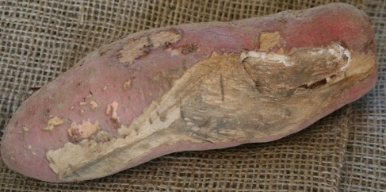
Some growers have successfully used potato plows to harvest sweetpotato roots. Although single-row potato plows are inexpensive and easy to locate, harvesting roots this way often leads to significant damage to the skin which can lead to storage losses. Other harvesting methods include using chain diggers. Chain diggers are typically PTO-driven harvesters that will either pull roots up to a packing station on the digger or let them fall back to the ground to be picked up by a harvest crew. Care must be taken to match ground speed with PTO speed so that roots are not skinned while being harvested. Vines should be cut prior to harvesting with a chain digger otherwise they may catch on the chain apparatus causing roots to “hang-up” and be skinned by the chain. Rubber or plastic guards over the metal chain to prevent damage.
A severely damaged root due to careless harvest and handling. Although the correct size and weight this root will be culled due to improper harvest techniques. Growers should be careful during harvest as careless mistakes can result in serious losses.
Specially designed flip-plows are also used for sweetpotato harvest. These plows can be made to fit a variety of production styles, though are usually made to harvest two or four rows at a time. These plows are essentially large disks that move through the soil flipping the sweetpotatoes out of the ground to be picked up by a harvest crew for packing. A single flat disk is also attached to the plow to prevent the tractor/harvester from being pulled off the row. If used correctly these plows will result in little damage to the roots. However, rows should be straight otherwise large numbers of roots can be cut and damaged. Whichever harvest method is utilized, be sure to match row spacing to the harvest implement prior to planting.
After roots are dug they should be picked up and moved from the field to prevent sunscald. Care should be taken with roots at this time. The skin of uncured roots is very fragile. Throwing roots into harvest bins or walking on roots will damage them, leaving them susceptible to disease during storage. Harvest bins typically will hold 20 bushels of sweetpotatoes, though typically are only filled with 18-19 bushels to prevent crushing. Pallet bins can either be made of wood or plastic. Plastic bins have advnatages of being able to be clean and sterilized easily after use. Also, plastic harvest bins will tend to last longer than wood bins. However, wood bins are typically cheaper and can be constructed locally. A typical bin dimension is 42 x 48 inches with a height of 35 inches (including the pallet base for forks).
If harvesting in the fall is delayed there may a risk of frost injury to roots during harvest. If there is danger of a frost, sweetpotatoes are best left in the ground where the ambient soil temperature should protect them. Harvests should resume as soon as possible after frosts since the vines will have been killed. In addition it should be noted that sweetpotato roots experience chilling injury when exposed to temperatures below 50 ºF. Therefore, even when frost is not expected, sweetpotatoes can be injured by cool night temperatures if left in the field. Chilling injury may take several weeks before it is noticed on roots, but can lead to serious losses in storage.

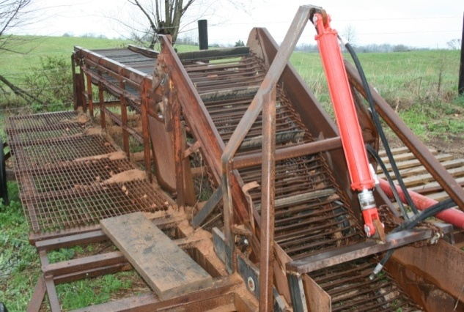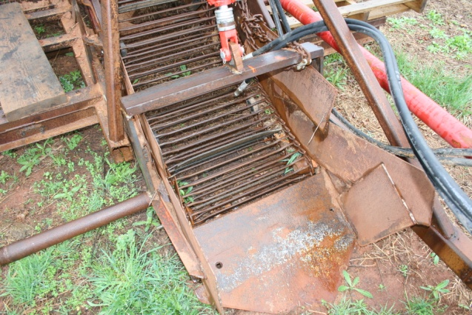

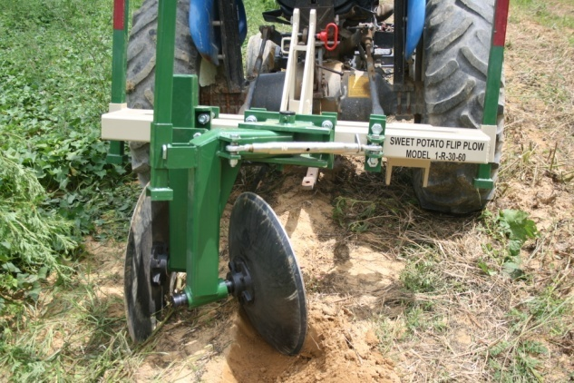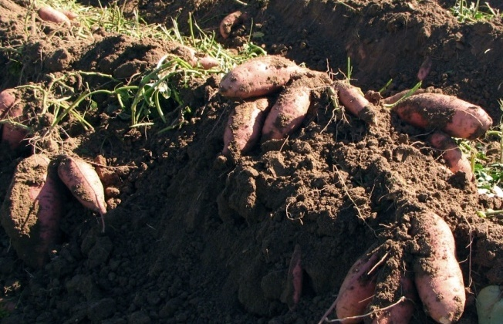
Top: A sweetpotato chain digger with packing station. A blade is located on the front of the device which lifts roots on the chain where they are pulled from the ground to be separated and packed. Bottom: A sweetpotato flip plow. Roots left on top of the soil from the plow.

Curing
When subjected to ideal curing and storage conditions, sweetpotatoes can be stored for 6 months or more with minimal losses. However significant losses routinely occur for sweetpotatoes in Kentucky. This may be the result of damage incurred while roots are dug, improper curing, or a general lack of adequate storage facilities. One of the simplest practices growers can perform that will improve the storage life and quality of sweetpotato roots, curing enhances flavor by increasing sugars while decreasing starch in sweetpotatoes. Curing greatly improves storage life by drying the outside of roots thereby strengthening the fragile skin. Selling roots shortly after harvest without first curing them is discouraged. Ideal curing conditions for sweetpotatoes are 85 ºF with 85-90% relative humidity for 3-5 days. Proper curing facilities should also allow for adequate ventilation.
Generally roots are picked from the field and cured prior to washing and removing soil. When soil that may be tightly adhered to roots is removed prior to curing damage may be incurred. Instead, sweetpotatoes should be cured shortly (within 12 hours) after harvest then either stored or washed and packaged for sale.
To successfully store and market large acreages of sweetpotatoes a dedicated curing and storage facility should be planned. However, most growers will not have the resources or the need to build such a facility. In these situations an area of a barn or covered structure can be converted to a temporary curing facility. Bins or boxes can be stacked with 4-6 inches between stacks to allow for air circulation. The area should be heated so that the sweetpotatoes in the boxes actually reach 85 ºF for 3-5 days. Humidity can be increased by adding a humidifier, though often the release of water from curing roots will increase humidity somewhat. An inexpensive hygrometer can be purchased to monitor humidity. Do not exceed the recommended curing period as significant weight loss can result from extended exposure to high temperatures. After curing, place roots in cool storage of 55-60 ºF and 85% relative humidity. Remove roots from storage as necessary to wash and pack.
For smaller quantities of sweetpotatoes a variation of field curing that is often used in the tropics has been successfully attempted by some growers in Kentucky. A high tunnel or similar type structure can be used where temperatures in the fall are elevated but not in excess of 85-90 ºF. Then boards or straw can be placed on the ground 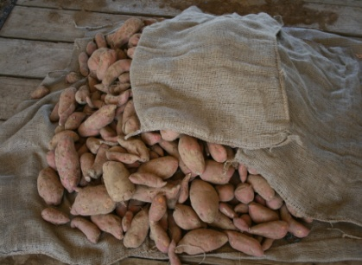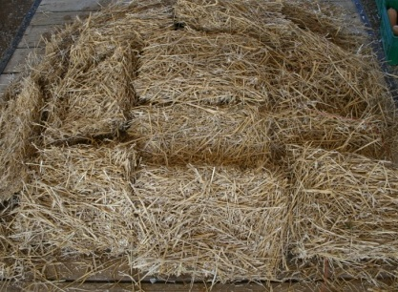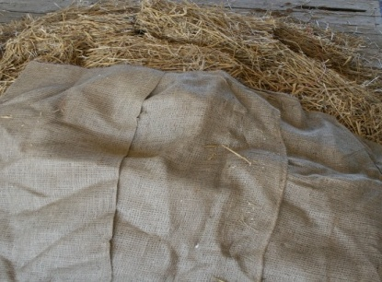 and sweetpotato roots stacked in a pile and covered with straw (6-10 inches) and burlap (not plastic). The straw will trap heat and moisture from the roots, yet still allow some ventilation. After 4-5 days the straw can be removed and roots put in storage. On-farm trials of this type of curing have shown that roots should be placed on or close to the ground to better trap heat. Placing roots on a wagon subjects them to temperature fluctuations which does not allow for proper curing. Growers should avoid wet areas and be aware of rodents which may also be attracted to roots.
Sweetpotatoes being covered with burlap, six inches of straw, and more burlap to simulate a low cost curing pile. Be sure to keep conditions at high humidity (85%) but not wet dry and well insulated during the curing process.

Storage
Sweetpotatoes should be stored at 85-90% relative humidity and 55 ºF. Care must be taken to avoid chilling injury which will occur at temperatures below 50 ºF. Often sweetpotatoes subjected to chilling injury will not show symptoms until 2-3 weeks after the initial injury. During winter months it is important to have heating capabilities for storage facilities as during cold weather temperatures can easily drop to below 50 ºF, damaging the crop. After curing, sweetpotatoes should go into storage and be graded and washed prior to packing. Grading typically follows USDA guidelines unless otherwise specified by the purchaser. Although there are five specific grades most wholesale buyers in Kentucky have typically chosen to purchase U.S. No. 1. Specially designed dunk tanks are used for large pallet-size bins. Typically a high-volume water spray is used to initially clean roots and then roots are sorted according to size and graded. Roots can then be sprayed or dunked to apply fungicides. Sweetpotatoes should not be dropped more than a few inches otherwise internal damage can result. Packing lines should have padding on metal surfaces to prevent damage.

USDA Grade | Size Specifications (inches) |  | Comments
 | Diameter | Length | All grades must be free from physical damage, insect damage, sprouting, freeze damage, wet rots, diseases and be firm and of fairly good shape. Tolerances for the percentage of roots that fail to meet specifications vary between grades.
U.S. Extra No. 1 | 1.75-3.25 | 3-9
U.S. No. 1¹ | 1.75-3.5 | 3-9
U.S. No. 1 Petite | 1.5-2.25 | 3-7
U.S. Commercial | 1.75-3.5 | 3-9
U.S. No.2² | > 1.5
¹Can weigh no more than 20 oz
²Can weigh no more than 36 oz
The information in this table adapted from United States Standards for Grades of Sweetpotatoes, effective April 21, 2005. The complete standards can be found at:
http://www.ams.usda.gov/AMSv1.0/getfile?dDocName=STELPRDC5050330. Producers are encouraged to read the complete grading guidelines.

Sweetpotatoes are typically packed in 40 pound boxes. A traditional bushel of sweetpotatoes weighs either 50 or 55 pounds depending if they are green (fresh) or dry (cured). When selling sweetpotatoes on a wholesale market, be sure to clarify what unit of measurement is expected. Other packaging options include polyethylene bags or shrink-wrapped individual packages. Market growers often sell sweetpotatoes loose, either individually or by the pound.
Although prices tend to rise after the typical harvest season growers must determine the cost of running a storage facility and potential losses to disease and abiotic disorders during storage.

Storage Diseases
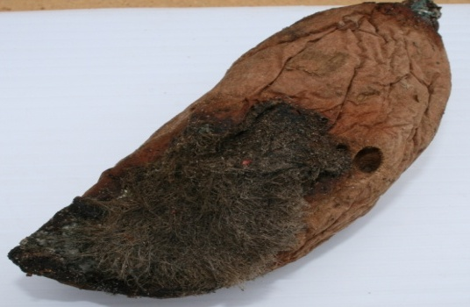
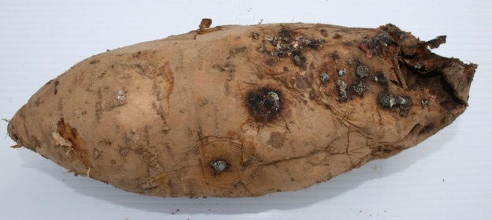
Harvest and handling conditions greatly influence susceptibility to post-harvest decays. A common disease of storage is Rhizopus soft rot caused by the fungus Rhizopus stolonifer. This disease appears as a “hairy” fungal rot and typically invades sweetpotatoes through wounds caused at harvest or in the curing process. Follow proper curing protocols to ensure adequate wound healing. Store only blemish-free roots; discard damaged or rotted roots. Botran 75 WP at 1 lb/100 gal is labeled as a post-harvest dip or spray (after cleaning roots but before packing) to control these rots (see tables for specific information). Calcium hypochlorite 65% at 10 oz/100 gal is also labeled as a post-harvest spray for general sanitation.
Rhizopus soft rot on a sweetpotato root
Bacterial root rot can cause losses during storage

Marketing/Budgets

Sweetpotatoes have steadily grown in popularity in the U.S.. Consumption has grown steadily to its recent peak of 5.2 pounds per capita. The market for sweetpotatoes remains strong for product produced and sold locally for retail prices. When selling smaller quantities, generally prices per pound increase significantly. Farm market prices have run around $0.75-$1.00/pound. Surveys of Kentucky and Ohio consumers have shown greater willingness-to-pay for local sweetpotatoes and also when nutrition information is provided. Generally, older consumers consume more sweetpotatoes than younger consumers, although younger consumers showed stronger interest in value-added products such as sweetpotato fries and chips. Some consumers show particular interest in white and purple varieties, especially in farmers markets. Consumer interest in organic sweetpotatoes is also fairly strong, although production costs need to be weighed carefully against any price premiums.

There are a handful of growers who are successfully producing for the wholesale market. These prices are lower than for direct markets, typically around $0.20-$0.25/pound, but involve much larger volumes. North Carolina produces almost half the acreage of sweetpotatoes in the U.S. Weather and production outcomes there have a significant bearing on wholesale market opportunities for Kentucky. Exports have grown slightly in recent years, but the vast amount of production in the U.S. is consumed in the domestic market.

A number of producers also sell sweetpotatoes at produce auctions located throughout the state. Prices can be variable when selling at the auctions, although they have generally run about 10% above general wholesale prices. Generally those growers who obtain the best prices at auctions have established relationships during the course of one or more growing seasons and routinely bring products to the auction. Those who do not carefully grade their sweetpotatoes or only bring a large load of product one or two times during the season may not see good prices. Demand for different types of sweetpotatoes varies across Kentucky. White-fleshed sweetpotatoes are generally most popular in Eastern Kentucky and seldom grown in the Western portion of the Commonwealth.

There are a number of active regional and national trade associations that continue to support generic promotion and the development of value-added products, including the North Carolina Sweet Potato Commission and the Louisiana Sweet Potato Commission. These associations make many of their product and marketing material openly available.

Budgets

Enterprise budgets for sweetpotatoes have been prepared for Kentucky, assuming typical yields, markets, drip irrigation, and input rates. Revenues and costs are summarized in the budget below.

Growers are encouraged to use this framework to estimate their own returns, breakeven costs, and sensitivity of returns to changing prices or other variables. Returns to land, capital, and management under fairly pessimistic market/input cost conditions would be around $740/acre; a conservative measure of around $2,895, and an optimistic scenario of $3,775.

Other financial decisions that could impact profitability would relate to the scale of operation. Larger growers can capture scale economies associated with growing their own slips, buying input costs in bulk, and setting up curing facilities on site in an effort to manage costs and market opportunities.

SWEETPOTATOES: FRESH MARKET, Irrigated
Kentucky Estimated per Acre Costs and Returns for 2011
 | Quantity | Unit | $/Unit | Total
GROSS RETURNS
US #1 | 275 | box | $ 20.00 | $ 5,500.00
US #2 | 150 | box | $ 12.00 | $ 1,800.00
TOTAL | 425 | box |  | $ 7,300.00
VARIABLE COSTS
Production
Lime | 0.5 | ton | $ 20.00 | $ 10.00
Fertilizer: Starter |  |  | $ - | $ -
Spread |  | lbs | $ - | $ 200.00
Plants | 13 | thousand | $ 50.00 | $ 650.00
Transplant Labor | 10 | hrs | $ 9.00 | $ 90.00
Herbicides | 1 | acre | $ 75.00 | $ 75.00
Pesticides | 1 | acre | $ 125.00 | $ 125.00
Drip Lines | 1 | acre | $ 382.00 | $ 382.00
Machinery Variable Costs | 1 | acre | $ 71.48 | $ 71.48
Total Preharvest Variable Costs |  |  |  | $ 1,603.48
HARVESTING AND MARKETING
Variable Machine Costs | 1 | acre |  | $ 28.27
Boxes | 425 | boxes | $ 1.00 | $ 425.00
Hired Labor: Harvest | 40 | hrs | $ 9.00 | $ 360.00
Sorting/Grading/Packing | 425 | boxes | $ 1.00 | $ 425.00
Marketing Costs (10% of Gross) | 10.0% | gross |  | $ 730.00
Total Harvesting and Marketing Cost |  |  |  | $ 1,968.27
Interest on Variable Costs |  |  |  | $ 116.44
TOTAL VARIABLE COST |  |  |  | $ 3,688.20
RETURN ABOVE VARIABLE COSTS |  |  |  | $ 3,611.80
FIXED COSTS
Machinery and Equipment |  |  |  | $ 100.19
Depreciation on Irrigation System |  |  |  | $ 200.00
Taxes on Land |  |  |  | $ 5.00
Insurance |  |  |  | $ 36.50
TOTAL FIXED COSTS |  |  |  | $ 341.69
TOTAL EXPENSES |  |  |  | $ 4,029.89
RETURN TO OPERATOR LABOR, LAND, CAPITAL, & MGT. |  |  |  | $ 3,270.11
Operator and Unpaid Family Labor | 25 | hrs. | $ 15.00 | $ 375.00
RETURN TO LAND, CAPITAL, AND MANAGEMENT |  |  |  | $ 2,895.11

Rubatzky, V.E. and M. Yamaguchi. 1997. World vegetables: Principles, production, and nutritive values. 2nd ed. Chapman and Hall, New York, NY.
Edmunds, B., M. Boyette, C. Clark, D. Ferrin, T. Smith, and G. Holms. 2008. Postharvest handling of sweetpotatoes. North Carolina State University and Louisiana State University Cooperative Extension Services.

