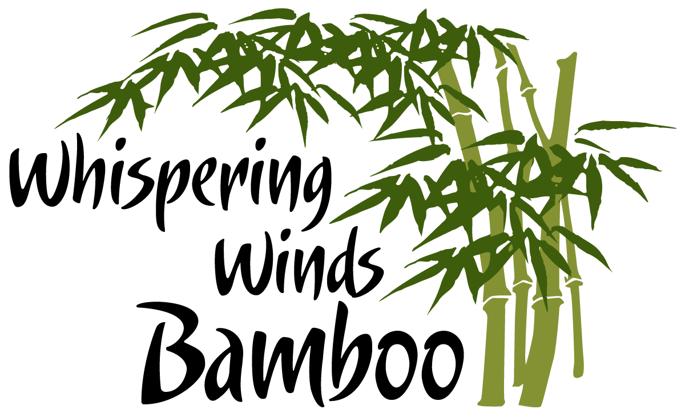
Creating a Bamboo Culture
www.whisperingwindsbamboo.com
WSARE project FW09-025:
Maximizing the Utilization of Bamboo in the Hawaiian Islands.
Final Report

Aloha Kakou;

This is a final report for a WSARE Farmer/Rancher Grant (#FW09-025), which is named: Maximizing the Utilization of Bamboo in the Hawaiian Islands. With the submission of this final report we are requesting the balance of funds awarded us under this grant.

The attached documents and supporting items are the entire final report of this grant.

Thank-you so much for your support of our efforts to ‘create a culture of bamboo’ here on the Hawaiian Islands.

Sincerely,

Rich von Wellsheim
.

HC1 Box 180 Hana, Hawaii 96713 Tel: 808-248-7561 Email: info@whisperingwindsbamboo.com

WSARE regional office
Attention: Kristie Jensen
Re: Final Report FW09-025
October 18, 2011

