**Semiochemicals Workshop Photos**

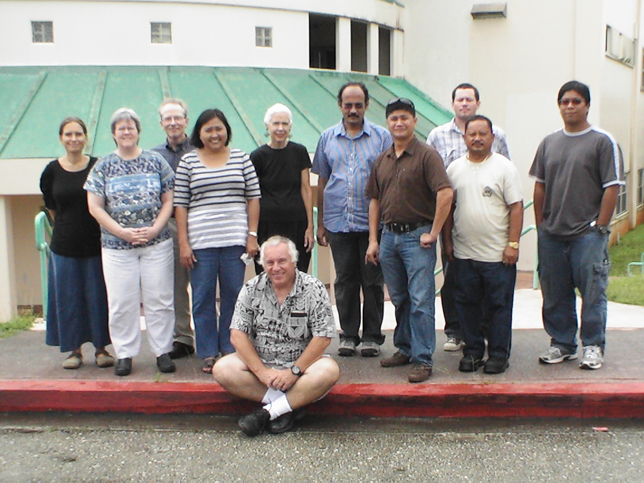

February 16, 2011 1

Project # EW09-012

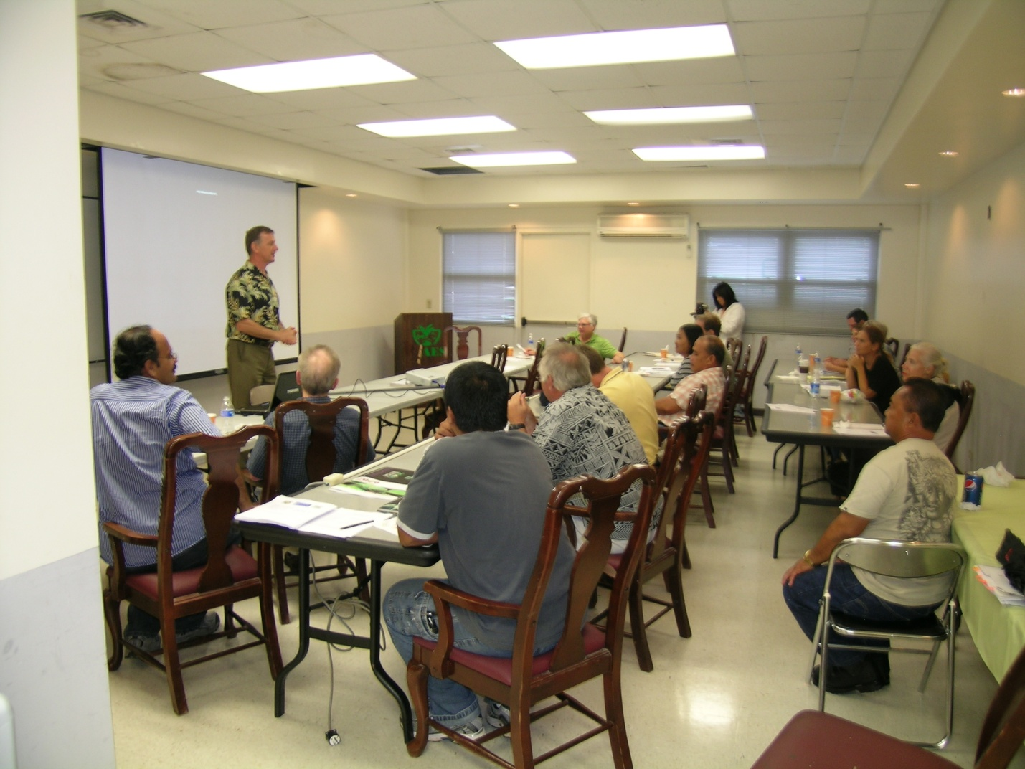

February 16, 2011 2

Project # EW09-012

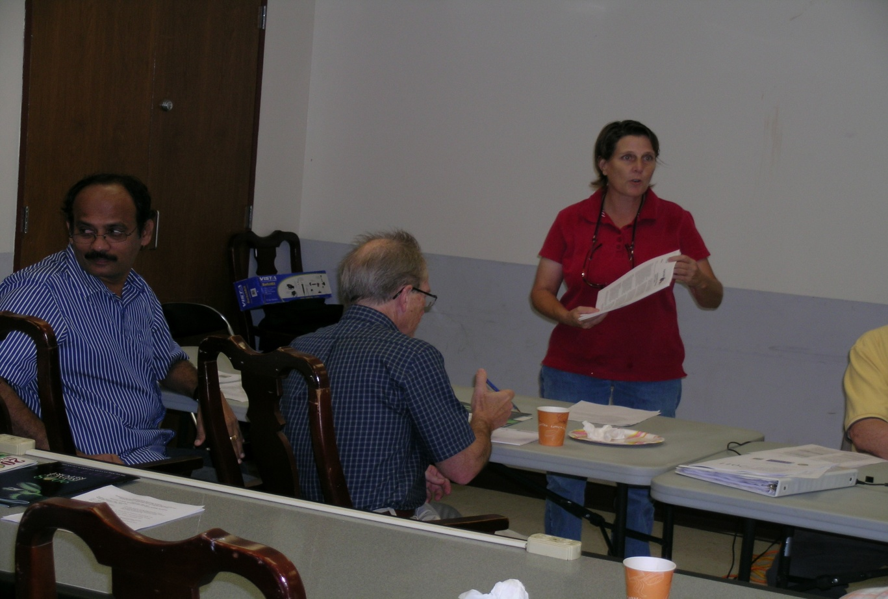

February 16, 2011 3

Project # EW09-012

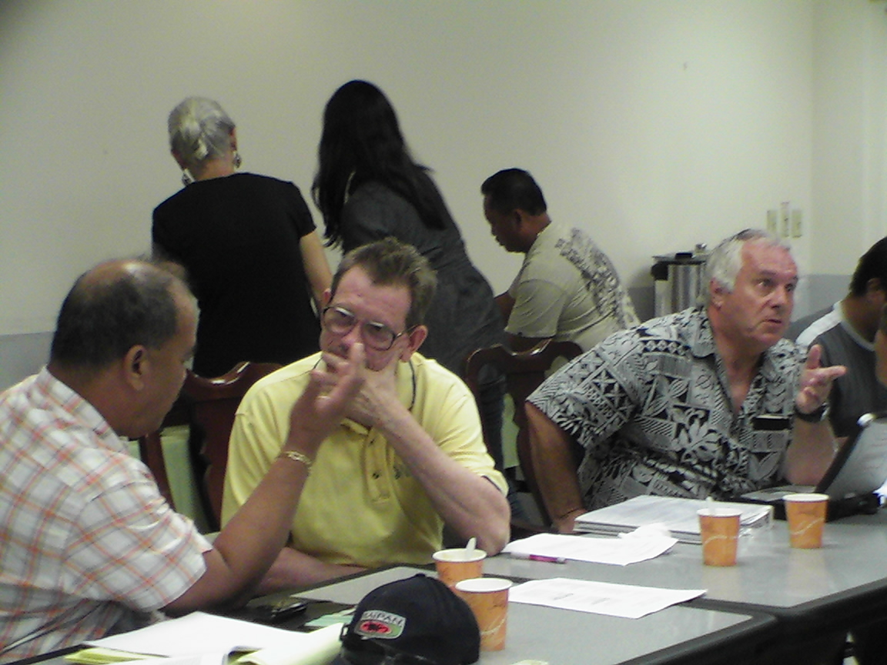

February 16, 2011 4

Project # EW09-012

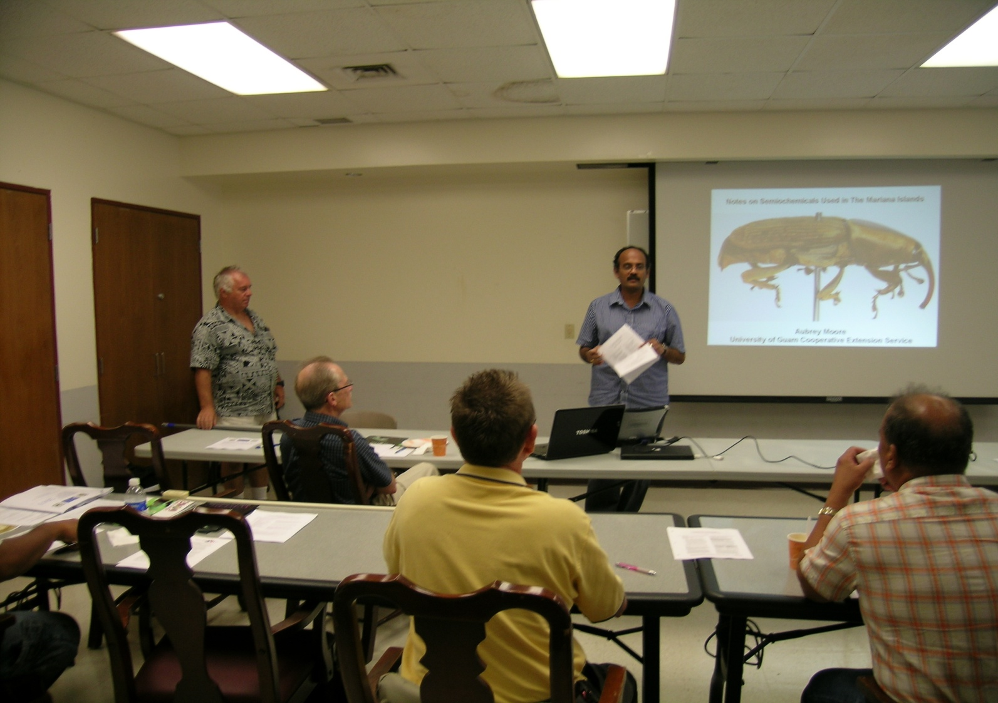

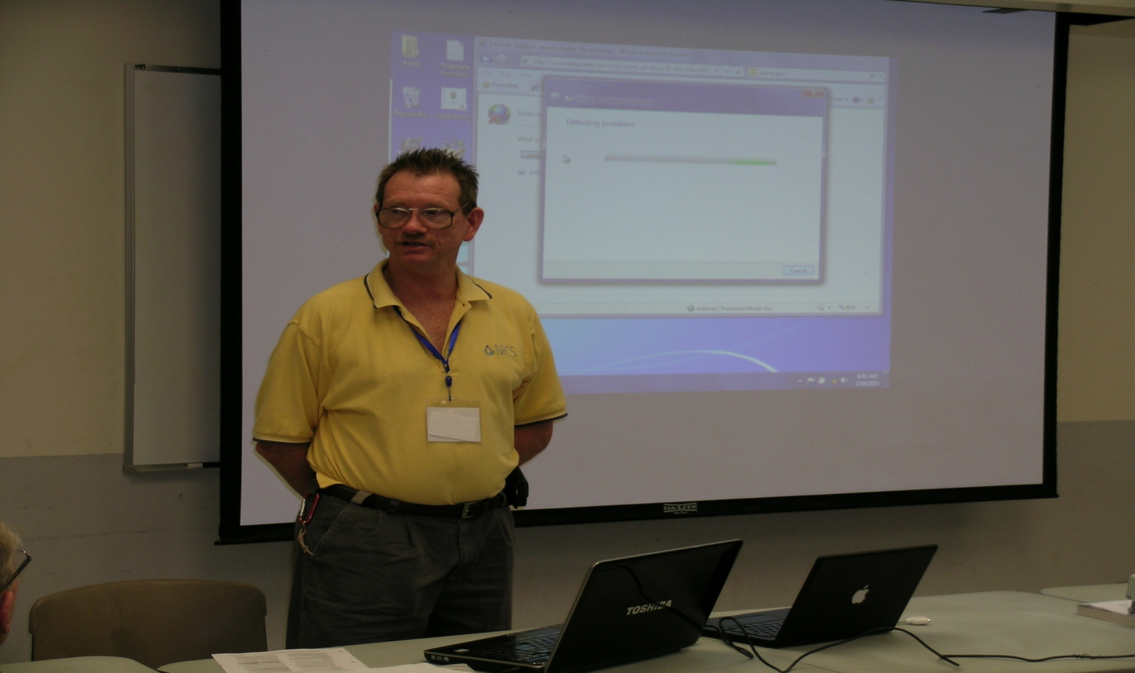

February 16, 2011 6

February 16, 2011 5

Project # EW09-012

Project # EW09-012

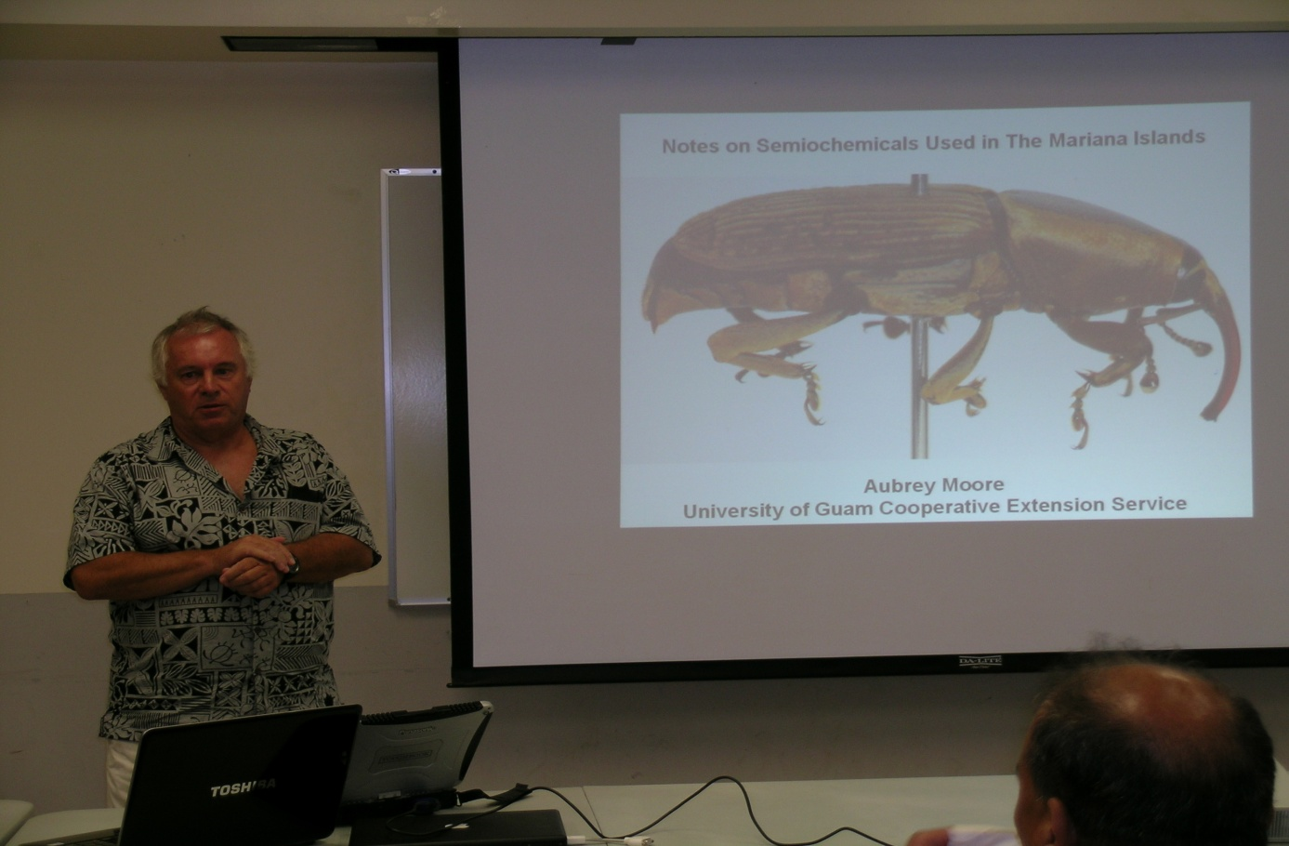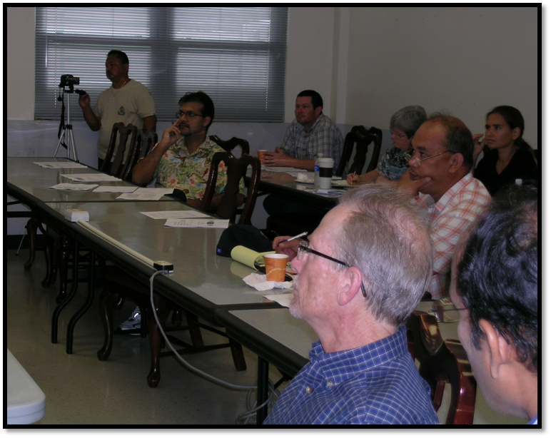

February 16, 2011 8

February 16, 2011 7

Project # EW09-012

Project # EW09-012