http://www.pacificnewscenter.com/index.php?option=com_content&view=article&id=11510:uog-semichemicals-workshop-february-16&catid=56:community-events

Wednesday, February 16, 2011

UOG SemiChemicals Workshop February 16
Last Updated on Monday, 14 February 2011 19:55 Written by News Release Monday, 14 February 2011 19:46
Guam News - Community Events
Guam - University of Guam researchers and extension agents in collaboration with USDA Professional Development Program (PDP) of the USDA-Western SARE and Natural Resources Conservation Service (NRCS) will be holding a semiochemicals workshop on February 16.
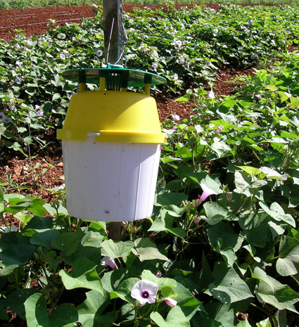
[Photo by: Gadi V. P. Reddy; Sweet potato weevil trap in the field.]
Insects secrete semiochemicals to find mates, set boundaries, warn of predators, and to call their friends when they find a food source. Semiochemicals have been widely studied for their effective use in controlling insect pests in agriculture.
Western Pacific Tropical Research Center scientist, Gadi V.P. Reddy is a chemical ecologist and entomologist. He has been working with semiochemicals for much of his career finding environmentally safe methods to control invasive plants and insects. Dr. Reddy will present his recent research using semiochemicals with trapping techniques for banana root borer, New Guinea sugarcane weevil and sweet potato weevil.
There will be also presentations by off-island scientists including research leader and chemist, Dr. Robert K. Vander Meer, USDA-ARS, Gainesville, Florida and entomologist/nematologist Dr. Marisol Quintanilla, Northern Marianas College, Saipan.
UOG extension entomologist Dr. Aubrey Moore and extension associate Mr. Jesse Bamba, will also be presenting at the workshop. This workshop is open to agriculture professionals. For more information, contact Dr. Reddy, email: reddy@uguam.uog.edu or 735-2142.
Semiochemicals Workshop
Wednesday, February 16th, 2011
University of Guam, Agriculture and Life Sciences Building, Room#104
8:30am to 3:15pm

© 2010 Pacific News Center | Sorenson Media Group All Rights Reserved
Custom Web 2.0 Site By AINA MEDIA

