Results and Discussion

Average Daily Feed Intake

Table 2. Effect of DCAD treatment on gilt performance and diet digestibility.
Item |  | Control |  | -225 |  | -450 |  | PSEM
ADFI (kg) |  | 3.09ª |  | 2.86^{b} |  | 2.33^{c} |  | 0.06
Weight (kg) |  | 143.44ª |  | 141.69ª |  | 134.15^{b} |  | 17.37
Gain (kg) |  | 4.87ª |  | 4.60ª |  | 2.47^{b} |  | 0.95
G:F |  | 0.22 ª |  | 0.23ª |  | 0.12^{b} |  | 0.02
Backfat (mm) |  | 16.94 |  | 17.30 |  | 15.71 |  | 0.72
Urine pH |  | 6.63ª |  | 5.56^{b} |  | 5.81^{c} |  | 0.04
Blood pH |  | 7.40 |  | 7.32 |  | 7.32 |  | 0.04
Dry matter digestibility (%) |  | 92.54 |  | 92.93 |  | 91.74 |  | 0.61
Energy digestibility (%) |  | 76.98 |  | 76.46 |  | 74.35 |  | 1.39
Nitrogen digestibility (%) |  | 71.89ª |  | 75.76^{b} |  | 78.32^{b} |  | 1.00
^{a,b,c}Within a row, means with different subscripts differ, P ≤ 0.05.

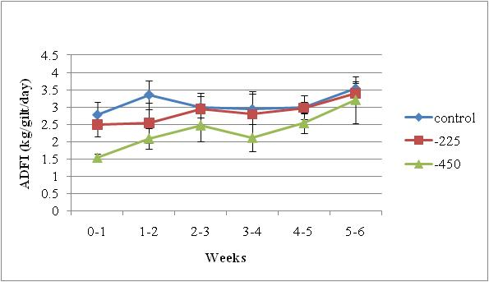
Figure 1

