Results and Discussion

Gilt Performance

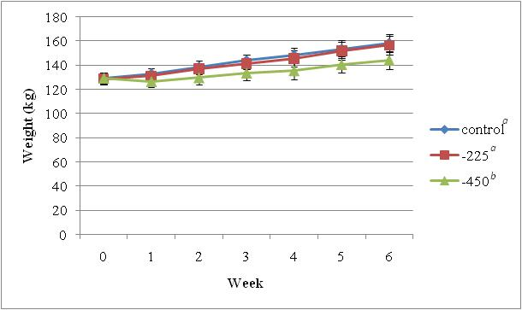

Figure 2. Treatment effect on gilt BW across week.
^{ab} Treatments with different superscripts differ significantly P < 0.05.

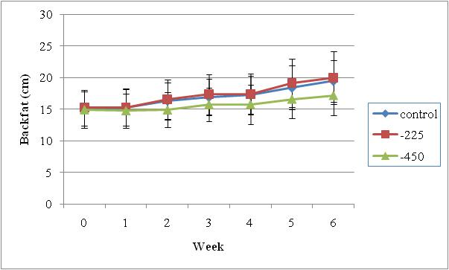
Figure 3. Treatment effect on backfat across week.

