Results and Discussion

Urine pH
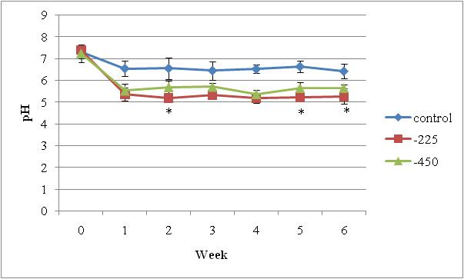

Figure 4. Treatment effect on urine pH across week.
*Indicates weeks where -450 and -225 treatments differed significantly.

