Results and Discussion

Blood pH

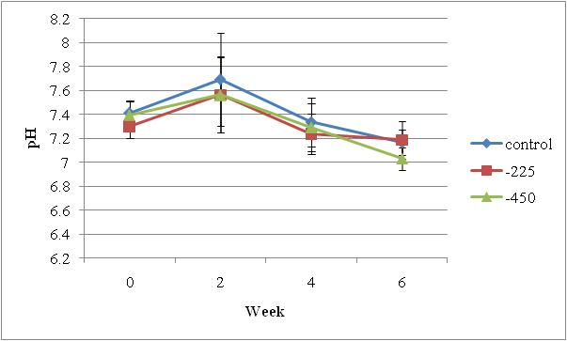

Figure 5. Blood pH averaged per treatment across week.

Nutrient Digestibility