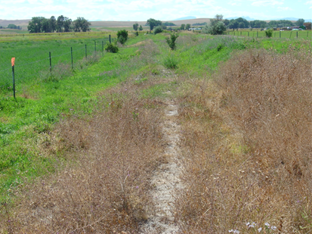
3 days after second vinegar application to spotted knapweed

