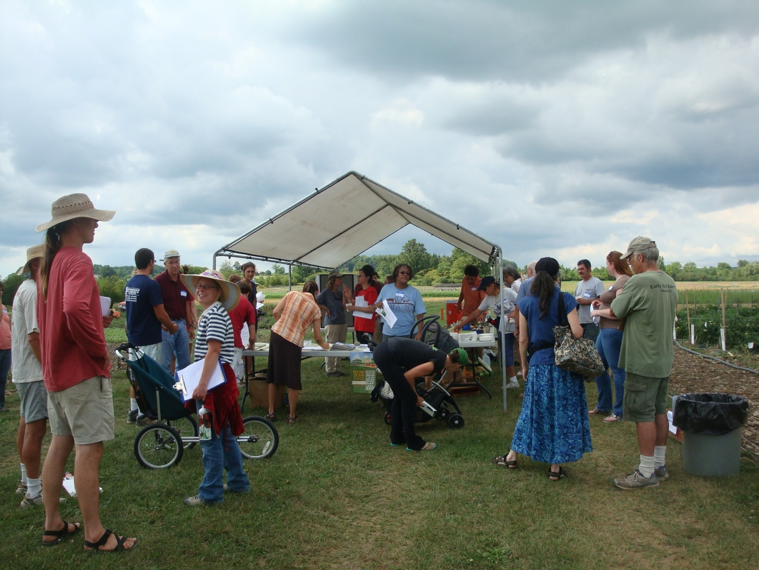
Figure 1: Conventional and Organic Growers collect at the main tent after a demonstration at the Twilight Organic Field Day (Aug. 4, 2011).

