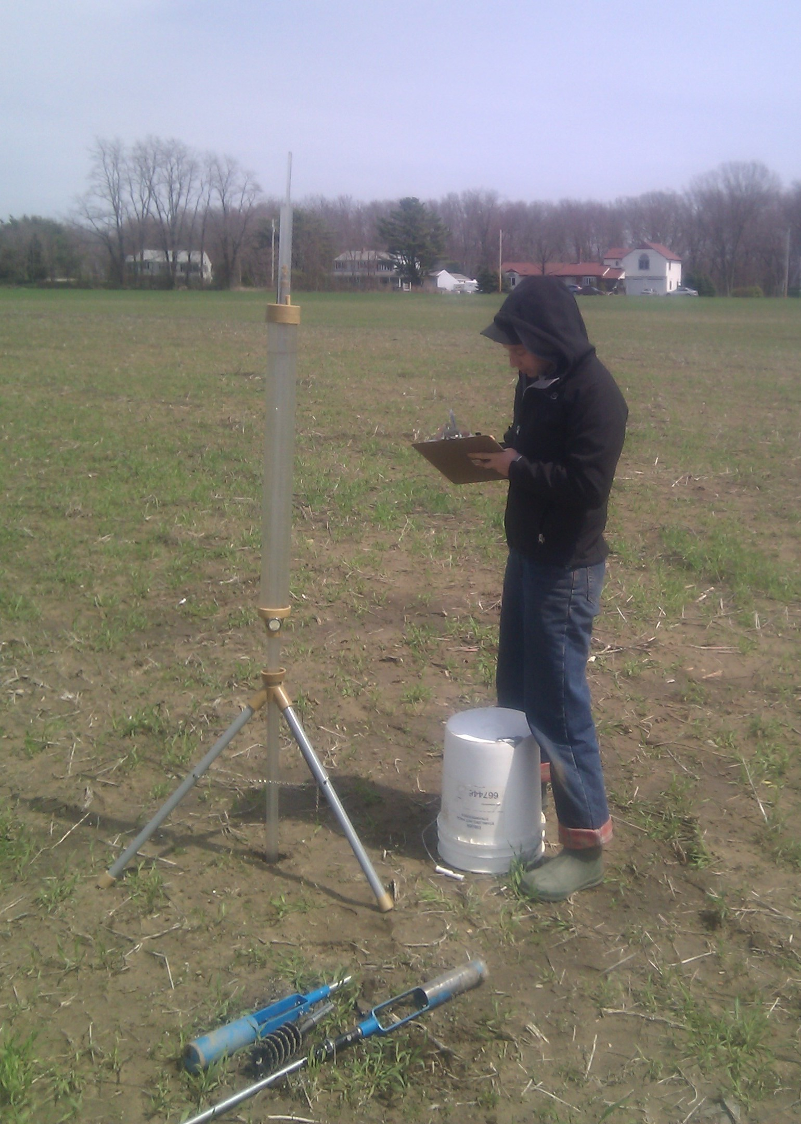
Figure 2: Infiltrometer tests at Grower 15’s farm.

