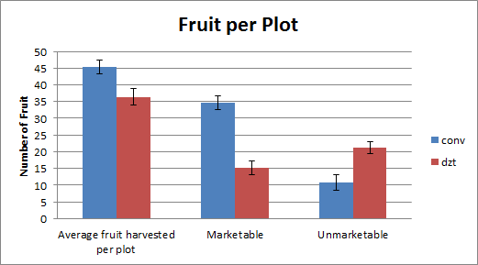
Figure 3: Yield Counts – Conventional vs DZT, by Average Number of
Total Fruit (marketable and unmarketable), Average Numbers of
Marketable and Unmarketable Fruit

