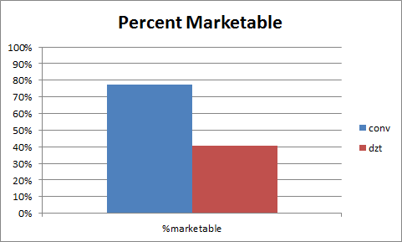
Figure 4: Conventional vs DZT, percent of marketable heads produced

