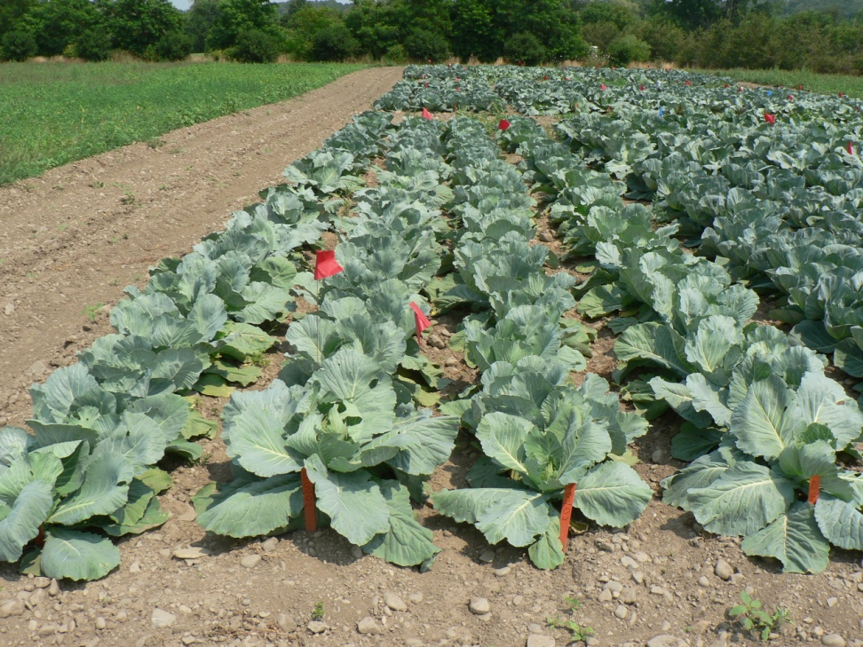
Figure 5: Long-term deep zone tillage plot of cabbage.

