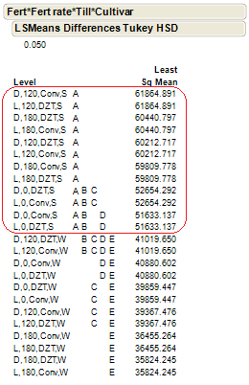
Figure 6: Analysis of Cabbage yield between conventional and DZT treatments. The analysis shows that some of the DZT treatments produced similar yields to the Conventional treatments (not significantly different –circled in red).

